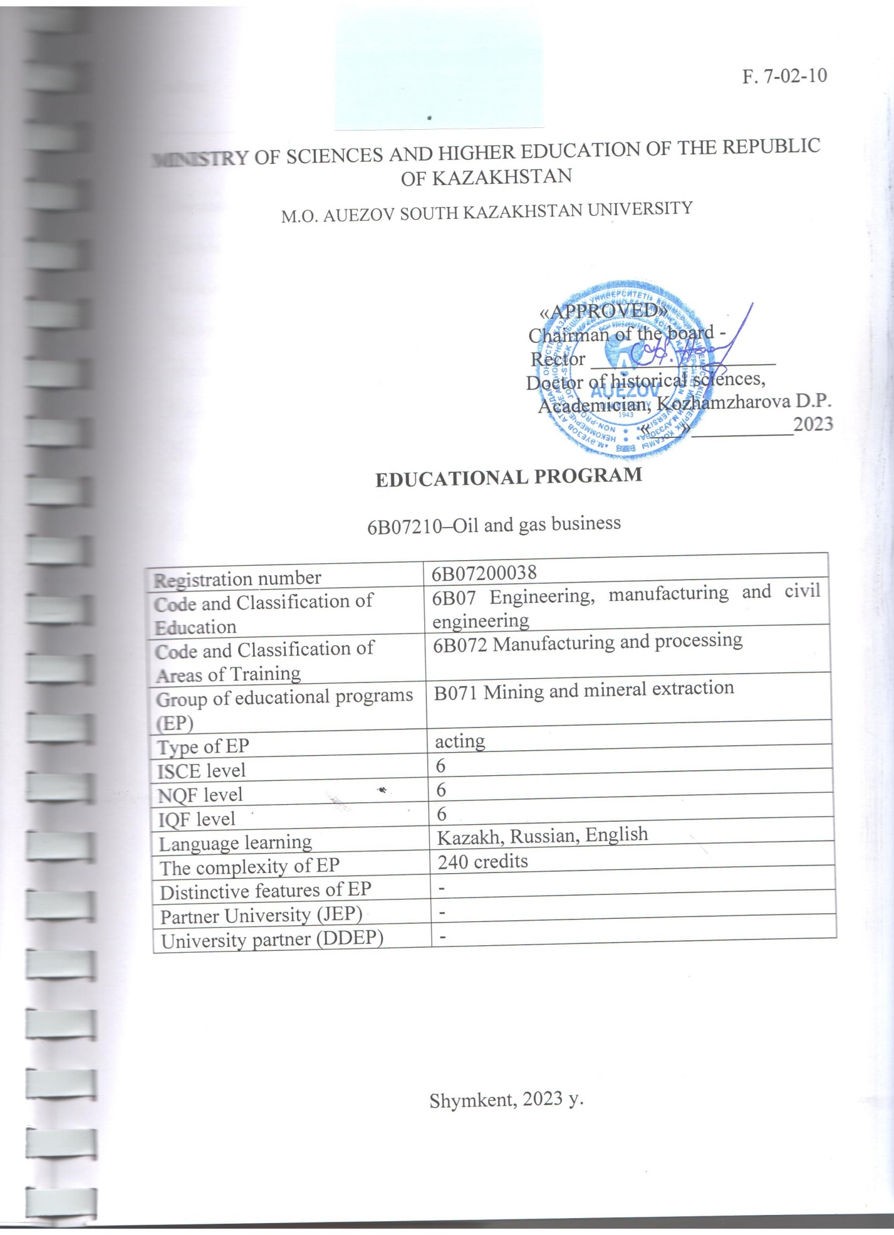

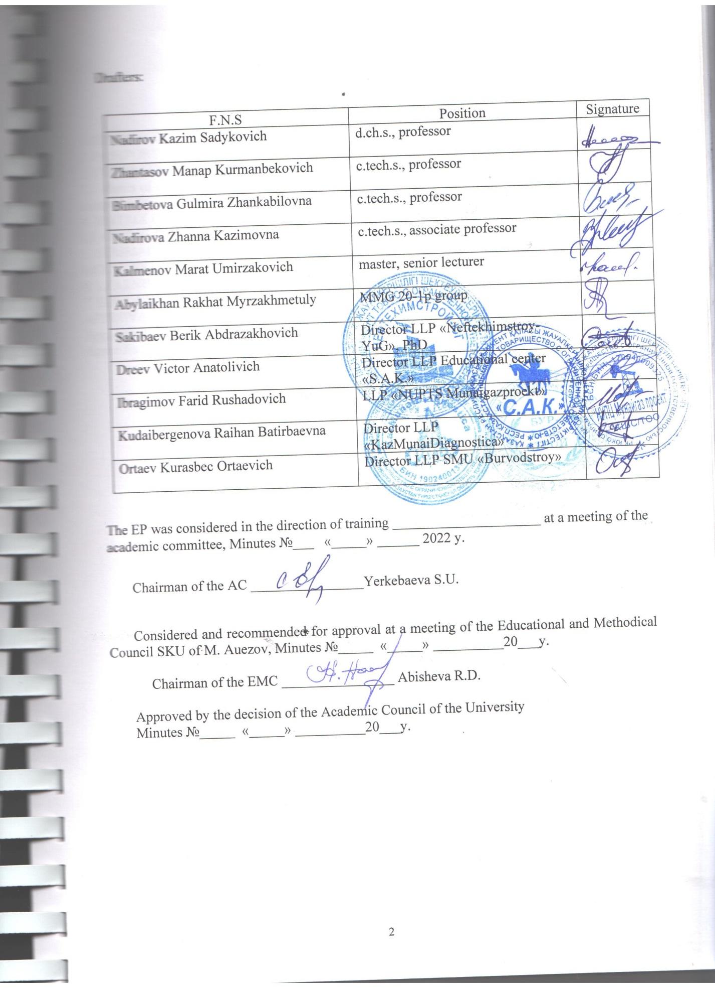
CONTENT

1.CONCEPT OF THE PROGRAM………………………………………………………... | 4
2. PASSPORT of the Educational program………………………………………….….… | 6
3. COMPETENCIES OF A GRADUATE OF THE OP………………………………….. | 8
3.1 Matrix of correlation of the results of training in the OP as a whole with the formed competencies of the modules………………………………………………………………. | 10
4. MATRIX OF THE INFLUENCE OF DISCIPLINES ON THE FORMATION OF LEARNING OUTCOMES AND INFORMATION ABOUT LABOR INTENSITY…….. | 11
5. SUMMARY TABLE REFLECTING THE VOLUME OF LOANS DISBURSED BY MODULES OF THE EDUCATIONAL PROGRAM…………………………………..… | 48
6. LEARNING STRATEGIES AND METHODS, MONITORING AND EVALUATION | 49
7. EDUCATIONAL AND RESOURCE SUPPORT OF THE PLO……………………… | 50
АPPROVAL SHEET………………………………………………………………………. | 51
Аppendix 1. Review from the employer………………………………………………….. | 52
Аppendix 2. Expert opinion…………………………………………………………..……
Аppendix 3. Professional standards

1. CONCEPT OF THE PROGRAM

University Mission | Generation of new competencies, training of a leader who translates research and entrepreneurial thinking and culture
University Values | • Openness–open to change, innovation and cooperation.  • Creativity – generates ideas, develops them and turns them into values.  • Academic freedom – free to choose, develop and act.  • Partnership – creates trust and support in a relationship where everyone wins.  • Social responsibility – ready to fulfill obligations, make decisions and be responsible for their results.
Graduate Model | • Deep subject knowledge, their application and continuous expansion in professional activity.  • Information and digital literacy and mobility in rapidly changing conditions.  • Research skills, creativity and emotional intelligence.  • Entrepreneurship, independence and responsibility for their activities and well-being.  • Global and national citizenship, tolerance to cultures and languages.
The uniqueness of the educational program | • Orientation to the regional labor market and social order through the formation of professional competencies of the graduate, adjusted to the requirements of stakeholders  • Practical orientation and emphasis on the development of critical thinking and entrepreneurship, the formation of a wide range of skills that will allow to be functionally literate and competitive in any life situation and be in demand in the labor market
Academic Integrity and Ethics Policy | The University has taken measures to maintain academic integrity and academic freedom, protection from any kind of intolerance and discrimination:  • Rules of academic integrity (Minutes of the Academic Council No. 3 dated 30.10.2018);  • Anti-Corruption Standard (Order No. 373 n/k dated 27.12.2019).  • Code of Ethics (Protocol of the Academic Council No. 8 dated 31.01.2020).
Regulatory and legal framework for the development of EP | 1. Law of the Republic of Kazakhstan "On Education";  2. Standard rules of activity of educational organizations implementing educational programs of higher and (or) postgraduate education, approved by Order of the Ministry of Education and Science of the Republic of Kazakhstan dated October 30, 2018 No. 595 with amendments and additions dated December 29, 2021 No. 614  3. State obligatory standards of higher and postgraduate education, approved by order of the Ministry of Education and Science of the Republic of Kazakhstan dated July 20.2022 No. 2;  4. Rules for organizing the educational process on credit technology of education, approved by order of the Ministry of Education and Science of the Republic of Kazakhstan dated April 20, 2011 No. 152;  5. Qualification directory of positions of managers, specialists and other employees, approved by order of the Minister of Labor and Social Protection of the Population of the Republic of Kazakhstan dated December 30, 2020 No. 553.  6. Guidelines for the use of ECTS.  7. Guidelines for the development of educational programs for higher and postgraduate education, Appendix 1 to the order of the Director of the Center for the Bologna Process and Academic Mobility No. 45 o / d dated June 30, 2021
Organization of the educational process | • Implementation of the principles of the Bologna Process  • Student-centered learning  • Availability  • Inclusivity
Quality assurance of the Educational program | • Internal quality assurance system  • Involvement of stakeholders in the development of the Educational Program and its evaluation  • Systematic monitoring  • Actualization of the content (updating)
Requirements for applicants | It is established according to the Model Rules for admission to training in educational organizations, implementing educational programs of higher and postgraduate education, Order of the Ministry of Education and Science of the Republic of Kazakhstan No. 600 dated 31.10.2018
Conditions for the implementation of educational programs (EP) for persons with disabilities and special educational needs(SSN) | For students with SEN (special educational needs) and persons with disabilities (PSI), tactile PVC tiles, specially equipped toilets, a mnemonic diagram, and shower bars have been installed in educational buildings and student dormitories. Special parking spaces have been created. Crawler lift installed. There are desks for people with limited mobility (PLM), signs indicating the direction of movement, ramps. In the educational buildings (main building, building No. 8) there are 2 rooms with six working places adapted for users with disorders of the musculoskeletal system (DMS). For visually impaired users, the SARA™ CE Machine (2 pcs.) is available for scanning and reading books. The library website is adapted for the visually impaired. There is a special NVDA audio program with a service. The JIC website http://lib.ukgu.kz/ is open 24/7.  An individual differentiated approach is provided for all types of classes and in the organization of the educational process.

2. PASSPORT of the Educational program
Purpose of the EP | Training of specialists in demand, possessing theoretical and practical skills in the oil and gas industry, as well as the ability to formulate and make effective decisions of industrial problems in the drilling of oil and gas wells
Tasks of the EP | - formation of socially responsible behavior in society, understanding the importance of professional ethical standards and following these standards;  - providing basic undergraduate training to enable them to continue their studies throughout their lives, to adapt successfully to changing conditions throughout their professional careers;  - providing conditions for the acquisition of a high General intellectual level of development, mastering competent and developed speech, culture of thinking and skills of scientific organization of labor in the oil and gas sector;  - creation of conditions for intellectual, physical, spiritual, aesthetic development to ensure the possibility of their employment in the specialty or continuing education at subsequent levels of education.
Harmonization of EP | • 6th level of the National Qualifications Framework of the Republic of Kazakhstan;  • Dublin descriptors of the 6th level of qualification;  • 1 cycle of a Framework for Qualification of the European Higher Education Area);  • 6thLevel of European Qualification Framework for Life long Learning).
Connection of EP with the professional sphere | Professional standards: Professional standards: "Derrick installation works" (Provision of services that contribute to the extraction of oil and natural gas) No. 224 dated 06.12.2022, Appendix No. 1), "Preparation of washing liquids." No. 224 dated 06.12.2022, Appendix No. 29), "Well cementing" No. 224 dated 06.12.2022, Appendix No. 30), "Рulling a well" dated December 27, 2019 No. 266, Appendix No. 44), "Underground well repair" dated December 27, 2019 No. 266, Appendix No. 48), "Drilling operations (Driller)" dated December 26, 2019. No. 263, Appendix No. 83), "Drilling Management" (Provision of services facilitating the production of oil and natural gas) No. 224 dated 06.12.2022, Appendix No. 9).
Name of the degree awarded | After the successful completion of this EP, the graduate is awarded "Bachelor of Engineering and Technology on Educational Program "6В07210 – Oil and Gas Business""
List of qualifications and positions | Engineer for derrik construction, engineer for clay solutions, engineer for combating accidental oil and petroleum product spills in the sea, engineer for filling wells, engineer for complex work in drilling (major repairs) of wells. well maintenance engineer, drilling engineer, senior drilling engineer, occupational health and safety engineer, drilling fluids engineer, drilling process engineer, well fastening engineer, engineer for complex work in drilling wells, drilling engineer without presenting work experience requirements in accordance with the qualification requirements of the qualification handbook positions of managers, specialists and other employees approved by the order of the Acting Minister of Labor and Social Protection of the Population of the Republic of Kazakhstan dated December 30, 2020 No. 553.
Field of professional activity | Technical area for drilling oil and gas wells.
Object sof professional activity | Enterprises of the oil and gas complex, regardless of their forms of ownership, technical devices and means for drilling oil and gas wells on land and at sea.
Subject sof professional activity | Technological processes of drilling oil and gas wells, rig work, preparation of washing liquids, well cementing, pulling a well, underground well repair, drilling operations, drilling management
Types of professional activity | Organizational and technological, production and management, settlement and design
Learning out comes | LO1 Communicate freely in the professional environment and society in Kazakh, Russian and English, having the skills of subject-language integrated learning and writing academic writing, in compliance with the principles of academic integrity.  LO2 Demonstrate natural science, mathematical, social, socio-economic and engineering knowledge in professional activities, using methods of mathematical data processing, scientific and experimental research, as well as regulatory documents and elements of economic analysis.  LO3 Possess information and computational literacy in the generalization and analysis of the information received.  LO4 Provide the necessary level of technical preparation of production and technical documentation with the development of organizational and technical measures to save material and technical resources.  LO5 To ensure the performance of production and technological indicators during drilling of wells and control of construction, repair of wells in accordance with the project documentation.  LO6 Coordinate the work of production and technical units, in compliance with the applicable environmental standards and regulations, rules and instructions on labor protection, labor safety standards in the production process  LO7 To provide maintenance of drilling equipment and tools, prevention, accident prevention, elimination of complications and repair work during well drilling.  LO8 Justify the organization and conduct of drilling, fastening and development of wells, taking into account mining and geological conditions during the construction of wells.  LO9 To ensure the organization and conduct of drilling, rig installation works on taking into account the features of the equipment used, drilling technology, type and purpose of the well.  LO10 To carry out the organization of work on the preparation, selection of formulations of washing liquids and liquids for fixing, silencing wells, taking into account the requirements of geological and technical orders.  LO11 To implement research and entrepreneurial skills for the introduction of new equipment and technology in the operation of drilling equipment and drilling tools, having the ability to work in conditions of uncertainty.  LO12 Perform individual work and as a team member, demonstrating self-education and healthy lifestyle skills.
3. COMPETENCIES OF A GRADUATE OF THE OP

GENERAL COMPETENCIES (SOFT SKILLS). Behavioral skills and personal qualities
GC 1. Competence in managing one's literacy | GC1.1. The abilitytoself-study, self-developand constantlyu ChD atethei know ledge within the chosen trajectory and in an interdisciplinary environment.  GC 1.2. Ability to express and understand concepts, thoughts, feelings, facts and opinions in the oil and gas field in written and oral forms (listening, speaking, reading and writing).  GC 1.3. The ability to mobility in the modern world and critical thinking.
GC2. Language competence | GC 2.1. Ability to build ommunication programs in the state, Russian and foreign languages.  GC 2.2.The ability to interpersonal social and professional communication in the context of intercultural communication.
GC3. Mathematical competence and competence in the field of science | GC 3.1.The ability and willing nesstoapplytheeducational potential, experience and personal nesat the university to solve professional problems.
GC 4. Digital competence, technological literacy | GC 4.1. The ability to demonstrate and develop information literacy through the mastery and use of modern information and communication technologies in all areas of their lives and professional activities.  GC 4.2. The ability to use various types of information and communication technologies: Internet resources, cloud and mobile services for the search, storage, protection and dissemination of information.
GC 5. Personal, social and educational competencies | GC5.1.Ability to observe social and ethical values, tolerance to traditions, customs, norms and focus on them in their professional activities;  GC 5.2. The ability to socio-cultural development based on the manifestation of citizenship and morality.  GC 5.3. Ability to comply with the fundamentals of the legal system and legislation of Kazakhstan, trends in social development of society;  GC 5.4. The ability to adequately navigate in various social situations; to find compromises, to correlate their opinion with the opinion of the team;  GC 5.5. The ability to build a personal educational trajectory throughout life for self-development, career growth and professional success.  GC 5.6. The ability to success fully interact in a variety of socio-cultural contexts during study, at work, athomean datleisure.
GC6. Entrepreneurial competence | GC6.1. The ability to be creative and enterprising in different environments.  GC6.2. Ability to work in the mode of uncertainty and rapid change of taskcon ditions, creativity and an activelife style;  GC6.3. Ability to manage projects to achieve professional goals, manage staff, demon strate entrepren eurial skills.
GC 7. Cultural awareness and self-expression | GC7.1. The ability to show ideological, civicand moral positions.  GC7.2. The ability to be tolerant of the traditions and culture of other peoples of the world, topossess high spiritual qualities.
GC 8. Additional ompetencies | GC 8.1. The ability to show personal competencies of organization, initiative and responsibility, the desire to improve the professional level, the choice of methods of physical education and health promotion,  GC 8.2. The ability to make professional decisions in conditions of uncertainty and risk.
PROFESSIONAL COMPETENCIES (HARDSKILLS).
Theoretical knowledge and practical skills specific to this field | PC1.to be in accordance with the requirements of the model design, engineering and working documents.
 | PC2. implement and adjust processes in the construction, repair and maintenance, as well as completing wells for various purposes, and the profile of the gun on land and at sea.
 | PC3. operate and maintain technological equipment used in the construction, repair, reconstruction and rehabilitation of oil and gas wells.
 | PC4. to collect the data for performance of works on designing of drilling
 | PC 5. assess risks and determine measures to ensure the safety of technological processes in oil and gas production.

3.1Matrix of correlation of the results of training in the OP as a whole with the formed competencies of the modules

 | LO1 | LO2 | LO3 | LO4 | LO5 | LO6 | LO7 | LO8 | LO9 | LO10 | LO11 | LO12
GC1 | + |  |  | + |  | + |  |  | +
GC2 | + |  |  |  |  |  |  | +
GC3 |  | + | + |  | + |  |  | +
GC4 |  | + | + |  |  |  |  |  | + |  | +
GC5 | + | + | + |  |  | + |  |  |  |  |  | +
GC6 |  | + |  |  |  |  |  |  |  |  | + | +
GC7 |  |  |  |  |  | + |  |  | +
GC8 |  |  |  | + | +
PC1 |  | + | + | + | + | + | + | + | + | + | + | +
PC2 |  |  |  | + | + | + | + | + | + | + | + | +
PC3 |  |  | + | + | + | + | + | + | + | + | + | +
PC4 |  |  |  | + | + | + | + | + | + | + | + | +
PC5 |  | + |  | + | + | + | + | + | + | + | + | +

4. MATRIX OF THE INFLUENCE OF DISCIPLINES ON THE FORMATION OF LEARNING OUTCOMES AND INFORMATION ABOUT LABOR INTENSITY
№ | The name of the module | CYCLE | ВК/КВ | Component name | Brief description of the discipline | Number of credits | Generated learning out comes (codes)
 |  |  |  |  |  |  | LO 1 | LO 2 | LO 3 | LO 4 | LO 5 | LO 6 | LO 7 | LO 8 | LO 9 | LO 10 | LO 11 | LO 12
1 | Fundumentals of the Public Sciences | GED | ОС | Нistory of Kazakhstan | Purpose: the discipline isformation of an objective idea of the history of Kazakhstan based on a deep understanding and scientific analysis of the main stages, patterns and originality of the historical development of Kazakhstan.  Content. Ancient people and the formation of nomadic civilization. Turkic civilization and the great steppe. Kazakh Khanate. Kazakhstan in the era of modern times. Kazakhstan as part of the Soviet administrative-command system. Declaration of Independence of Kazakhstan.  State system, socio-political development, foreign policy and international relations of the Republic of Kazakhstan. Methods and techniques of historical description for the analysis of the causes and consequences of events in the history of Kazakhstan. | 5 | Ѵ | Ѵ
 |  | GED | ОС | Philosophy | Purpose: The formation of a holistic idea among students about philosophy as a special form of knowledge of the world, about its main sections, problems and methods of studying them in the context of future professional activity. And also the formation of philosophical reflection, introspection and moral self-regulation among students.  Content. Emergence of a culture of thinking. Subject and method of philosophy. Fundamentals of philosophical understanding of the world: questions of consciousness, spirit and language. Being. Ontology and metaphysics. Cognition and creativity. Education, science, technology and technology. Human philosophy and the world of values. Ethics. Philosophy of values. The subject of aesthetics as a field of philosophical knowledge. Philosophy of freedom. Philosophy of art. Society and culture. Philosophy of history. Philosophy of religion. "Mangіlіk El" and "Modernization of Public Consciousness" are a new Kazakhstan philosophy | 5 | Ѵ | Ѵ
2 | Socio-Political knowledges | GED | ОС | Social and Political Studies | Purpose: forming knowledge about social and political activities, explaining social and political processes and phenomena.  Content. Consideration of the system of socio-ethical values ​​of the society. Ways to use social, political, cultural, psychological institutions, features of youth policy in the modernization of Kazakhstani society and solve conflict situations in society and professional environment based on them.To study the methods of analysis and interpretation of political institutions and processes, ideas about politics, power, state and civil society, to understand and use the methods and methods of sociological, comparative analysis, to understand the meaning and content of the political situation in the modern world. Analysis and classification of the main political institutions. | 4 | Ѵ |  |  |  |  |  |  |  |  |  |  | Ѵ
 |  | GED | ОС | Cultural Studies and Psychology | Purpose: the formation of scientific knowledge of history, modern trends, current problems and methods for the development of culture and psychology, the skills of a systematic analysis of psychological phenomena.  Content. Morphology, language, semiotics, anatomy of culture. Culture of nomads, proto-Turks, Turks. Medieval culture of Central Asia. Kazakh culture at the turn of the XVIII - XIX centuries, XX century. Cultural policy of Kazakhstan. State Program "Cultural Heritage". National consciousness, motivation. Emotions, intellect. The will of man, the psychology of self-regulation. Individual typological features. Values, interests, norms are the spiritual basis. The meaning of life, professional self-determination, health. Communication of the individual and groups. Socio-psychological conflict. Models of behavior in conflict. | 4 | Ѵ | Ѵ
3 | Socio-ethnic Development | GED | HSC | Ecosystem and law | Purpose: Formation of integrated knowledge in the field of economics, law, anti-corruption culture, ecology and life safety, entrepreneurship, scientific research methods.  Content. Fundamentals of safe human-nature interaction, ecosystem and biosphere productivity. The entrepreneurial activity of society in conditions of limited resources, increasing the competitiveness of business and the national economy. Regulation of relations in the field of ecology and human life safety. Knowledge and compliance of Kazakhstan’s law, obligations and guarantees of subjects, state regulation of public relations to ensure social progress. Application of scientific research methods. | 5 | Ѵ | Ѵ
4 |  | BD | EC | Actual Problems and Modernization of Public Consciousness | Рurpose: the discipline is the restoration of spirituality, deformed during the periods of tsarist and Soviet reality, the formation of a creative personality based on the modernization of the public consciousness of young people.  Content. Оrigin and background. Modern national identity. Pragmatism and competitiveness. National identity and national code. Experience and prospects of evolutionary development. The triumph of knowledge and openness of consciousness. Alphabet Reform: Experience and Priorities. Fatherland is the basis of the state. Education through nationwide sacred places and history. Modern Kazakh culture is the cornerstone of spiritual revival. New humanitarian education and the future national intelligentsia. Abai Kunanbaev and Kazakh society. | 3 | Ѵ |  |  |  |  |  |  |  |  |  |  | Ѵ
5 |  | BD | EC | MukhtarStudy | Purpose: Formation of a historical, literary idea of M. Auezov's work in the context of literary history, patriotism and cultural and spiritual position. Development of artistic thinking, skills of independent research activity.  Сontent. The life and creative path of M. Auezov Semipalatinsk, Tashkent, St. Petersburg periods. M. Auezov's activity in the magazines «Sholpan», «Abai». M. Auezov's journalism. An artistic review of the short stories "Korgansyzdyn kuni", "Kyr suretteri", "Okagan azamat", "Kokserek", the play Enlik-Kebek and the stories "Kili Zaman", "Karash-Karash" okigasy", the monograph "Abai Kunanbayev", the epic novel "Abai Zholy". | 3  3 | V  V |  |  |  |  |  |  |  |  |  |  | Ѵ
6 |  | BD | EC | Abai Study | Purpose: based on the reativity of A.Kunanbayev, the reservation of the «national code» and in the project «Kazakhtanu»  Contents: historical overview of the history of Kazakhstan and Kazakh literature of the XIX-XX centuries. Studies of Abai's legacy of the XX-XXI century. Chronology of Abai's creativity. Abai is a great poet, ethnographer, founder of Kazakh written literature. Abai is the compiler of the code of laws «The Position of Karamola», social significance. Abai is a thinker, religious scholar, philosopher. The role of Abai in education and science, the concept of a «Holistic person». «Words of Edification»by Abai, an epic novel by M.Auyezova «The Way of Abai» . K. Tokayev «Abai and Kazakhstan in the XXI century», role, significance. |  |  |  |  |  |  |  |  |  |  |  |  | Ѵ
7 |  | BD | EC | Service to Society | Purpose: the formation of socially significant skills and competencies in students based on the assimilation of academic programs, carrying out socially useful activities related to the disciplines studied at the university.  Content. The concept and meaning of Service learning, the history of the formation and development of the concept of Service Learning. Key components of Service Learning, socially useful activities in the children's and youth environment, organization of volunteer movement in the world and Kazakhstan practice, profile orientation of Service Learning. International practice of learning through socially useful activities. General principles and methodology for the development of social projects. Methods of analysis of implemented social projects. | 3 | Ѵ |  |  |  |  |  |  |  |  |  |  | Ѵ
 |  | BD | EC | Foundations of Anticorruption Culture | Purpose: formation of an anti-corruption worldview, strong moral foundations of a personality, civic position, stable skills of anti-corruption behavior.  Content: Overcoming legal nihilism, formation of the basics of students' legal culture in the field of anti-corruption legislation. Formation of a conscious perception/attitude towards corruption.Moral rejection of corrupt behaviour, corrupt morality and ethics.Development of skills necessary to fight corruption.Development of anti-corruption standards of conduct.Anticorruption propaganda, dissemination of lawfulness and respect for the law. Activities aimed at understanding the nature of corruption, awareness of social damage caused by its manifestation, ability to defend one's position with arguments, seeking ways to overcome manifestation of corruption. | 3 | Ѵ |  |  |  |  |  |  |  |  |  |  | Ѵ
7 | Module of Communication and Physical Training | GED | ОС | Kazakh (Russian) Language | Purpose: formation of communicative competence using the Kazakh (Russian) language in the socio-cultural, professional and public life, improvement of the ability to write academic texts.  Сontents. Levels А1, А2, В1, В2-1, В2-2 (В2, С1 Russian language ) are presented in the form of cognitive-linguocultural complexes, consisting of spheres, themes, sub-themes and typical situations of communication of the international standard: social, social - cultural, educational and professional, modeled by forms: oral and written communication, written speech works, listening. Demonstration of understanding of the language material in the texts on the educational program, knowledge of terminology and development of critical thinking. | 10 | Ѵ
 |  | GED | ОС | Foreign Language | Purpose: formation of students' intercultural and communicative competence in the process of foreign language education at a sufficient level A2 and a level of basic sufficiency B1. Student reaches B2level of common European competence if the language level at the start is higher than B1level of common European competence  Сontent. Levels A1, A2, B1, B2 are presented in the form of cognitive-linguocultural complexes, consisting of spheres, themes, sub-themes and typical situations of international standard’scommunication: social, social - cultural, educational and professional, modeled by forms: oral and written communication, written speech works, listening. Demonstration of language aterial’sunderstanding in texts on educational program, knowledge of terminology and critical thinking development. | 10 | Ѵ
 |  | GED | ОС | Physical Training | Purpose: the formation of social and personal competencies and the ability to purposefully use the means and methods of physical culture that ensure the preservation and strengthening of health in preparation for professional activity; to the persistent transfer of physical exertion, neuropsychic stresses and adverse factors in future work.  Сontent. Implementation of physical culture and health and training programs. A complex of general development and special exercises. Sports (gymnastics, sports and outdoor games, athletics, etc.). Control and self-control during classes, insurance and self-insurance. Refereeing competitions, Means of professionally applied physical training. Modern health-improving systems: the breathing system according to A. Strelnikova, K. Buteyko, K. Dinaiki, joint gymnastics according to Bubnovsky. | 8 |  |  |  |  |  |  |  |  |  |  |  | Ѵ
 |  | BD | HsC | Professional Kazakh (Russian) Language | Purpose: to provide professionally oriented language training of a specialist who is able to competently construct communication in professionally significant situations and speak the language norms for special purposes.  Content. Professional language and its components. Professional terminology as the main feature of scientific style. Scientific vocabulary and scientific constructions in educational-professional and scientific-professional spheres. Algorithm of work on the analysis and production of scientific texts on specialty. Producing scientific and professional texts. Basics of business communication and documentation within the framework of future professional activity. | 3 | Ѵ
 |  | BD | HsC | Professionally Oriented Foreign Language | Purpose: formation of students' skills of mastering the necessary professional terminology in a foreign language, development of communicative skills in speech activity, in the fields of professional and scientific communication.  Content. Structure of a foreign language, grammatical and lexical structure of a foreign language; foreign terminology in the field of professional activity (rocks, deposits, geophysical research, methods of oil extraction and transportation, oil and gas extraction, types of well drilling, collection and preparation of well products, transportation and preparation of oil), commonly used and academic vocabulary, speech formulas to carry out professional activities and intercultural communication. | 3 | Ѵ
 |  | GED | ОС | Information and Communication Technologies | Purpose: formation of the ability to critically evaluate and analyze processes, methods of searching, storing and processing information, methods of collecting and transmitting information through digital technologies. Development of new "digital" thinking, acquisition of knowledge and skills in the use of modern information and communication technologies in various activities  Content. Introduction and architecture of computer systems. Software. Operating systems. Human-computer interaction. Database systems. Data analysis. Data management. Networks and Telecommunications.Cybersecurity. Internet technologies. Cloud and Mobile technologies. Multimedia technologies. Smart technology. E-technologies. Electronic business. Electronic government. | 5 |  | Ѵ | Ѵ | Ѵ
8 | Fundamentals of Mathematics and Natural Sciences | BD | HsC | Higher Mathematics | Purpose: to perform the necessary measurements and related calculations, apply theorems, formulas and mathematical methods to solve professional problems.  Content. Matrices. Determinants. Inverse matrix. Methods for solving systems of linear equations. Vectors. Various equations of a straight line on a plane and a straight line and a plane in space. Curves and surfaces of the second order. Function. Function limit. Remarkable limits. Differential and integral calculus of one variable function. Derivatives and differentials of higher orders. Investigation of function and sketching the graph. Indefinite and definite integrals. Multivariable function. Differential equations of the first and second orders. Series. | 5 |  | Ѵ | Ѵ
 |  | BD | HsC | Physics | Purpose: formation of knowledge of physical laws and skills of their application in engineering and production technology, development of skills for conducting and evaluating the results of theoretical and experimental research, development of scientific thinking based on an interdisciplinary approach.  Content. The laws of classical and modern physics (mechanics, molecular physics, thermodynamics, electromagnetism, optics, quantum and atomic physics). Application of knowledge of physical phenomena and processes to solve applied, technical and technological problems based on an interdisciplinary approach. Scientific methods of research, methods of planning, conducting, processing and analyzing the results of theoretical and experimental research. | 6 |  | Ѵ | Ѵ
 |  | BD | HsC | Chemistry | Purpose: formation of students' experimental skills in the structure and properties of substances, theoretical foundations and general patterns of chemical and electrochemical reactions.  Content. The structure of the atom. Periodic law of D. I. Mendeleev and the periodic system of elements. Chemical bond. Covalent bond. Energy of chemical reactions. Chemical kinetics. Solutions. Hydrolysis of salts. Redox reactions. Complex connections. Methods of qualitative and quantitative analysis. Provides experimental substantiation of theoretical issues of inorganic and analytical chemistry. Uses the laws of thermodynamics to predict the direction of the flow of chemical processes, conducts a chemical experiment in laboratory conditions, correctly conducts the results of the experiment. | 4 |  | Ѵ | Ѵ
9 | Basics of the specialty | BD | EC | Fundamentals of Oil and Gas Business | Purpose: to form students' general understanding of the methods of drilling oil and gas wells, methods of transportation and preparation of well products, methods of their extraction and processing.  Content. Development of the oil and gas industry of the Republic of Kazakhstan. The concept of a well, the ground drilling equipment used, preparation, preparation and cleaning of drilling mud. Catalytic cracking, pyrolysis, methods of purification of petroleum products.  The main stages of prospecting and exploration; physical and chemical properties of oil; types of well drilling; development and operation of oil and gas fields, field collection and preparation of oil, gas and water; major and underground well repairs; transportation and storage of oil and gas. | 3 |  |  |  |  | Ѵ |  |  |  |  | Ѵ
 |  | BD | EC | Fundamentals of acadimic writing | Purpose: formation of students' skills of structured presentation of their own ideas, linguistic and pragmatic thinking, the ability to create scientific and scientific-informational texts of various types.  Content. Genres and features of academic writing, the main types of scientific ethics and scientific texts when describing methods of operation and maintenance of oil and gas facilities: glossary, essays, reviews, reviews on the topic, term papers, theses and projects, scientific articles. Principles and skills of self-expression of one's own thoughts in scientific language using critical thinking, objectivity and communication, respect for other ideas and other people's texts. | 3 | Ѵ
 |  | BD | EC | Technology and Technique of Oil Production | Purpose: formation of students' theoretical knowledge and practical skills in the technique and technology of impact on an oil deposit, preparation of a well for operation.  Content. The main methods of oil production, sources of reservoir energy. The technology of maintaining reservoir pressure with the injection of water, gas, thermal methods of impact on the formation, impact on the bottom of the well, the equipment of the bottom of the well. Well research, the basic theory of fluid lifting from wells, fountain, gas lift, pumping method of well operation. | 4 |  |  |  |  |  |  | V | V
 |  | BD | EC | Technological and hardware support for hydrocarbon production | Purpose: to form students' theoretical knowledge and practical skills in the technique and technology of gas and gas condensate production. | 4 |  |  |  |  |  |  | V | Ѵ
 |  |  |  |  | Contents: Modern achievements of science and technology for hydrodynamic studies of wells, regulation of the operation of fountain, gas lift and pumping wells, general principles of operation of gas condensate fields.Information about the design of gas lift lifts, equipment of rod pumping wells, principles of balancing the rocking machine, operation of wells with rod pumps in complicated conditions, the general scheme of installation of a submersible centrifugal electric pump, submersible pumping unit
 |  | BD | EC | Development of Oil, Gas and Gas-Condensate Field | Purpose: formation of students' theoretical knowledge and practical skills in the development of oil, gas and gas condensate fields.  Contents: Basic properties, composition, and classification of natural gases. Information about the density of hydrocarbon condensate, the viscosity of natural gas, thermal and hazardous properties of natural gases. Equations of the state of real gases, features of the development of gas condensate deposits, phase transformation diagram, classification of gas condensate deposits and the methodology of development in the depletion mode.  Characteristics of reservoirs of oil, gas, reservoir fluids, economic indicators of the development of oil deposits. | 5  5 |  |  |  | V |  |  |  |  | Ѵ
 |  | BD | EC | Development of horizontal wells in the fields | Purpose: formation of students' theoretical knowledge and practical skills in the development of hydrocarbon deposits using horizontal wells  Content. Information about innovative technologies for the development of hydrocarbon reserves.  Problems and solutions for the development of oil rims based on the generalization of field experience; new technologies for drilling, opening horizontal wells, and completion of wells, intensification of production, integrated field development design, computer technologies in the design and monitoring of the development of directional profiles of wells. |  |  |  |  | V |  |  |  |  | V
 |  | РD | EC | Development of Technique and Technology for Oil and Gas Transportation and Storage | Purpose: formation of students' knowledge on modern technologies and equipment for transportation and storage of oil and gas.  Content. General characteristics and main trends in the development of equipment and technology in the oil and gas industry as the main method of transportation of oil, petroleum products and gas.  Storage tanks for hydrocarbon raw materials.  Pipeline transportation and pumping of oil, petroleum products and gas. The main types of preparation of oil, well products for transport. Safety requirements for transportation and storage of raw materials. The search for solutions to complex situations in the transportation and storage of oil and gas using modern methods. | 5  5 |  |  |  |  |  |  |  |  |  |  | Ѵ
 |  | РD | EC | Modern Technologies and Equipment for Transportation of Hydrocarbon Raw Materials | Purpose: to form students' knowledge of global trends in the field of preparation and transportation of hydrocarbon raw materials, as well as the necessary equipment for these operations.  Content. Information about modern technologies and equipment for transportation of hydrocarbon raw materials.  Designs of pumping and compressor stations of gas and oil pipelines and storage facilities. Equipment of head and intermediate oil and gas pumping stations. Warranty work. Carrying out repair work and training of repair personnel for maintenance of main and auxiliary pipelines. Basic concepts of logistics, definitions, tasks and its functions. |  |  |  |  |  |  |  |  |  |  |  | V
 |  | BD |  | Educational practice | Purpose: to consolidate the theoretical knowledge gained in the educational program, to expand ideas about the future profession; to form professional adaptation and competence in extracurricular activities. Content. To instill the skills of searching for a patent and literary review on the basis of the university and the department.  Study of issues of occupational safety and health, structure and logistics of the enterprise. Regulatory, technical and regulatory documents. Main and auxiliary equipment for the operation of gas and oil pipelines and gas and oil storages. General information about the profession, work experience in a team. Methods of organizing labor activity. Theoretical knowledge and practical skills in the field of practical training. | 1 |  |  |  | V |  | V |  |  |  |  |  | V
10 | General geology of oil and gas | BD | EC | GeneralOil Geology | Purpose: to provide students with basic knowledge about the composition, properties and origin of oil and gas, as well as about the conditions of formation, formation processes and patterns of placement of their accumulations.  Content. The internal structure of the Earth, the geological effect of the main factors of its external and internal dynamics, the formation of rocks, tectonic movements and methods for their study, types of tectonic and lithospheric structures and the history of the development of the world. Reconstruction of the history of the development of the inorganic and organic nature of the Earth. Determination of the nature of rock formation. | 5  5 |  |  |  |  |  |  |  | V |  |  |  | V
 |  | BD | EC | Geologyof oil and gas | Purpose: formation of ideas about the composition and properties of oil and natural gases, technological, geochemical, genetic classifications, geological factors in the formation of hydrocarbon deposits, existing concepts of oil and gas formation.  Content. Factors that determine the internal structure of oil and gas deposits, types of reservoirs, types of voids, their ratio and role in reservoirs of various lithological types, oil and gas saturation and its dependence on reservoir types.  Information programs for geological research. Migration processes of oil and gas. Methods for studying the initial oil-water, gas-oil and gas-water contacts, oil and gas contours and methods for determining their position. |  |  |  |  |  |  |  |  | V |  |  |  | V
 |  | BD | EC | Petrophysics | Purpose: formation of modern ideas about the physical processes occurring in oil and gas layers.  Content. Collector properties of rocks. Rocks-types of reservoirs. Porosity. Permeability of rocks. Darcy's law. Radial filtration of oil and gas in a porous medium. Mechanical and thermal properties of rocks. Composition and physico-chemical properties of natural gases. Solubility of gases in oil and water. Physical and chemical properties of layered waters. Hydrocarbons phase conditions of systems the physical basis for the displacement of oil, condensate and gas from a porous medium. Layered energy sources. | 4  4 |  |  |  |  |  |  |  | Ѵ | V
 |  | BD | EC | Physico-Chemical Structure of the Reservoir | Purpose: formation of modern ideas about the physical and chemical structure of the formation.  Content. Methods of rock destruction used in mining, in particular, when drilling a well, rocks as objects of destruction. Movement of oil, gas and water in a porous medium, wetting of rocks, adhesion, cohesion. Generalization and analysis of the received information about the formation structure. The hypothesis of the continuity of solids and the possibility of its extension to sedimentary rocks, the forces of interaction between particles in solids, elastic and strength characteristics of rocks. |  |  |  |  |  |  |  |  | V | V
 |  | РD | EC | Environment Protection in Oil-and-Gas Industry | Purpose: formation of students' knowledge in the field of environmental safety and rational use of natural resources in the oil and gas industry  Content. Information about legal and organizational questions in the field of environmental protection. The concept of the natural environment, its state and problems, assessments of the impact of oil producing and oil refineries on the environment. Measures to protect the environment during oil production. Environmental safety in the oil and gas sector. Methods of environmental management in the Republic of Kazakhstan. | 5  5 |  |  |  |  |  | Ѵ
 |  | РD | EC | Environmental problems in oil and gas fields | Purpose: formation of students' theoretical knowledge about the impact of the activities of oil and gas industry enterprises on ecology and the environment.  Content. The impact of the oil and gas industry on the components of the environment. Characterization of oil fields as sources of environmental pollution. Methods for preventing environmental pollution in the preparation, transport and storage of oil and gas. Oil spill response, features of oil pollution in the waters of the Caspian Sea, the main sources of pollution in offshore oil production. Technical supervision, environmental monitoring during oil and gas production on land and at sea. |  |  |  |  |  |  | V
 |  | РD |  | І Productionpractice | Purpose: to consolidate knowledge in the study of theoretical and practical skills acquired by students in the study of general professional and special disciplines of the educational program and gain skills in the field of transportation and storage of oil and gas.  Content. Organizational and managerial activities in problem solving, operation and maintenance of process equipment used in the transportation and storage of oil and gas products. Designs of pumping and compressor stations of gas and oil pipelines and gas and oil storage facilities. Working conditions and environmental protection. Theoretical knowledge and practical skills in the course of industrial practice at enterprises. Application of innovations in the practical activities of production. | 4 |  |  |  | V | V |  |  |  |  |  |  | V
11 | Fundamentals of Engineering and Technical Sciences | BD | EC | Appliedmechanics | Purpose: formation of professional competencies and stable understanding in field of applied mechanics, necessary for development and operation of technical products, elements of technological equipment in oil and gas industry.  Content. main provisions of statics, kinematics, dynamics.  Basic concepts of theory of mechanisms and machines, classification of kinematic pairs, kinematic chain. Main types of mechanisms, structural analysis and synthesis of mechanisms. General purpose machine parts: gears, gearboxes, bearings, couplings, shafts, axles, joints. Determination of their performance criteria and kinematic parameters. | 4  4 |  | Ѵ
 |  | BD | EC | Theoretical Foundations of Mechanical Engineering | Purpose: formation of professional knowledge of future technologist in field of operation of modern machines, equipment, purpose, operation principle, operating modes optimization in specified operational conditions of oil, gas industry to achieve maximum efficiency.  Content. machines mechanisms theory: structure, mechanisms classification, planar mechanisms kinematics. Theoretical mechanics: statics, kinematics, dynamics. General information about forces, conditions, force system equilibrium equations. Point movement kinematic elements. Relative motion. Machine parts: connections, gears, gearboxes, shafts, axles, couplings, bearings. General information about strength calculations. Design fundamentals. |  |  | V
 |  | BD | EC | Strengthof Materials | Purpose: formation of set of knowledge in field of engineering calculations for simple, complex resistance to strength, rigidity, stability of structural elements providing the required reliability, safety of products under static and dynamic loads.  Content: main hypotheses and assumptions of resistance of materials - axial tension and compression, geometric characteristics of planar sections, transverse bending, shear, torsion, complex types of deformations, stress state at body point, deformed state at body point, stability of compressed rods. Fatigue strength of materials. Hit. | 4  4 |  | Ѵ
 |  | BD | EC | Basics of Calculating the Strength of Machine Parts | Purpose: formation of professional knowledge, skills, practical skills for future specialists studying special disciplines, professional activities in equipment design, operation in oil gas industry.  Content: strength calculation fundamentals. Stress state, stress, deformation main types. Stretching compression, bending, shear, torsion, stability. Mechanical characteristics of concentration materials, evaluation of strength-news. strength calculating methods for various joints, gears, springs, shafts, bearings, reciprocating engines parts, turbomachines, compressors. Calculation methods of contact stresses, parts calculation for fatigue, thermal resistance, stability. Machine parts strength reliability evaluation. |  |  | Ѵ
 |  | РD | EC | Drillingmachinesand complexes | Purpose: formation of students' theoretical knowledge and practical skills in the operation of drilling machines and complexes.  Content.The history of the development of drilling techniques, designs and parameters of drilling rigs, a telemetry system for monitoring the wiring of wells, classification of rock-breaking tools. Purpose, classification, basic requirements for the drives of drilling rigs, chain drives, the device of drilling structures, the composition of anti-blowout equipment, technological equipment of the drill string, winches and pumps, equipment of the circulation complex. Reliability of drilling machines and equipment, diagnostics of the technical condition of machines and mechanisms. | 4  4 |  |  |  |  | Ѵ |  | Ѵ
 |  | РD | EC | Systems of drilling machines and mechanisms | Purpose: formation of students' theoretical knowledge and practical skills in the operation of drilling machines and mechanisms.  Content.Purpose, classification, basic requirements for drilling machine drives, kinematic, hydraulic circuits and power transmission. Information on the installation of drilling structures, requirements, designs and purpose of blowout equipment. Reliability of drilling machines and mechanisms, diagnostics and technical condition. Types and kinematic schemes of drilling rigs and special purpose machines for drilling wells and wells from underground workings. Methods of technological and hydraulic calculations. |  |  |  |  |  | V |  | V
 |  | ВD | EC | Underground Mining of Minerals | Purpose: the formation of students' technological knowledge on the types of mine workings, cleaning and preparatory work, auxiliary operations for conducting underground mining operations.  Content. The value of mineral resources. Methods for the extraction of solid minerals. Basic technological properties of rocks and massifs. Information about reserves and losses of minerals. Indicators of the quality of minerals. Methods for the development of mineral deposits. Features of underground mining of mineral deposits. Borehole mining. Autopsy and development systems. The concept of reclamation and complex use of rocks. Restoration of territories disturbed by mining operations. | 5 |  |  |  |  |  |  |  | Ѵ
 |  | ВD | EC | Mine Development of Minerals | Purpose: formation of students' knowledge about existing and prospective methods of developing mineral deposits by the mine method on the basis of knowledge of general engineering and geological disciplines.  Content. Conditions of occurrence of rocks and minerals. Classification of objects of development of mineral resources. Stages of development of reservoir deposits. Ways to control geomechanical and gas-dynamic processes in underground mining. Basic concepts about schemes and methods of opening and preparing mine fields, development systems. Characteristics of underground mining processes in various conditions of occurrence of deposits. Principles of ensuring the safety of mining production. | 5 |  |  |  |  |  |  |  | V
 |  | РD | EC | Design and Exploitation of Gas Distribution Systems | Purpose: providing students with knowledge about the physical foundations of the processes of collection and storage of natural and artificial gases, justification of the choice of calculation methods for the design of gas distribution systems and their subsequent operation.  Content. Physical and chemical properties of gases. The current state of gas supply. Classifications of distribution gas pipelines, general information about their consumers. Fundamentals of design and operation of gas distribution systems, regulatory and regulatory documents. Gas consumption modes, annual and estimated hourly gas consumption. | 5  5 |  |  |  | Ѵ
 |  | РD | EC | Diagnostic maintenance of gas pipeline facilities | Purpose: formation of professional competencies for carrying out activities in the field of diagnostic maintenance of gas pipeline facilities.  Content. Classification of defects in pipeline and tank structures. Sensors for ultrasonic testing, areas (schemes) of application of the acoustic emission method of testing. Principles of operation of equipment for acoustic emission diagnostics of pipelines and tanks. Drawing up a defect list, assessing the degree of danger of defects, drawing up a conclusion on the technical condition of the gas pipeline facility, processing the results of in-line inspection of the pipeline and shutoff and control valves. Systematization of technical supervision data for diagnostics and maintenance of technical objects.Gas pressure regulators, pressure regulator throughput calculation, gas purification, temperature regime of gas distribution systems, gas consumption metering, reliability of gas supply systems. |  |  |  |  | V
 |  | BD | HsC | Engineering and  computer graphics | Purpose: formation of the ability to critically evaluate and analyze processes, methods of searching, storing and processing information, methods of collecting and transmitting information through digital technologies. Development of new "digital" thinking, acquisition of knowledge and skills in the use of modern information and communication technologies in various activities  Content. Introduction and architecture of computer systems. Software. Operating systems. Human-computer interaction. Database systems. Data analysis. Data management. Networks and Telecommunications.Cybersecurity. Internet technologies. Cloud and Mobile technologies. Multimedia technologies. Smart technology. E-technologies. Electronic business. Electronic government. | 4 |  |  | V |  |  |  | V
 |  | BD | EC | Hydraulics, thermodynamics and heat engineering | Purpose: formation of basic knowledge of modern fundamentals of thermodynamics and heat engineering, implementation of systematic study of physical processes and phenomena in energy systems, thermal devices and machines, methods of their mathematical description.  Content: basic concepts and laws of thermodynamics. Thermodynamic system and its state. Basic thermodynamic processes, thermodynamic and phase equilibria. Energy characteristics of thermodynamic systems. General characteristics of thermodynamic cycles, piston engine cycles, compressor machine cycles, multistage compressors. Heat pumps. Basic concepts and definitions of the theory of heat transfer. Heat transfer, thermal insulation. | 4  4 |  | Ѵ
 |  | BD | EC | Oil and Gas Field Business | Purpose: to provide students with knowledge, including information about the characteristics of the processes occurring in the reservoir and well during oil production, with the formation of a methodological and theoretical basis for modern engineering and technical workers in the oil industry.  Content. Fundamentals of geology of oil and gas engineering. Physical properties of oil and gas. Stages and types of exploration work. Drilling of oil and gas wells, their completion and development. Methods for the operation of oil and gas wells, commercial collection. Purification of oil and gas from mechanical impurities, reservoir water, hydrogen sulfide, carbon dioxide, paraffin deposits. Transport and storage of oil, oil products and gas. Oil and gas processing. |  |  |  |  |  |  |  |  | V | V
 |  | BD | EC | Economy, Commercialization and Business Plan | Purpose: to acquire practical knowledge about the forms and methods of production and commercial activities of enterprises, organizational and managerial work in the conditions of entrepreneurship, commercialization of innovative processes, introduction of new equipment and technology into production, business planning.  Contents. Classification of factors of production, fixed assets and working capital of the enterprise. Determination of the need for labor resources. Calculation of labor productivity and wages. Economic efficiency of production. The cost of production. Planning of financial resources of the enterprise. Organization of the company's operational activities. Stages of commercialization of innovations and introduction into production. Business plan and its preparation. Forecasting of the business environment and controlling. | 4  4 |  |  |  | Ѵ |  |  |  |  |  |  | Ѵ
 |  | BD | EC | Management, innovation and business | Purpose: formation of theoretical knowledge and practical skills in the organization of management and management of oil and gas industry enterprises in a competitive environment, business efficiency assessment.  Content. the essence and meaning of management, management and management, approaches to the definition of the concept of "management", problems and main categories of management: the object and subject of management, functions and methods of management. Principles of management, the concept and essence of the organization. Risks in decision-making, tasks and stages of the personnel management process, methods of personnel management. The content and structure of the innovation process, the features of the organizational structures of innovative entrepreneurship.  Socio-economic factors for innovation management. |  |  |  |  | Ѵ |  |  |  |  |  |  | Ѵ
 |  | BD | HsC | Standardization, certification and metrology | Purpose: formation of theoretical knowledge and practical skills in the field of standardization, certification and metrology to solve problems of ensuring the uniformity of measurements and quality control of products, services and works in their professional activities  Content. Objects of standardization, certification and metrology. Legislative and regulatory framework for standardization, technical regulation, metrology and conformity assessment systems. General scientific and special methods of standardization. Certification and declaration schemes. Methods and types of measurements. Calculation of errors and uncertainty of measurements. Technical basis of metrology. The role of international management systems in improving the competitiveness of enterprises. | 4 |  |  |  |  | V | V
12 | Oil and Gas Industry and Chemistry | BD | EC | Fundamentals of the oil refining industry | Purpose: formation of students' knowledge about the basics of the oil and gas processing industry and its significance for the energy security of Kazakhstan.  Content. Prospects for the development of the oil refining industry. Composition and physical properties of oil and gas, their origin, classification of oils, carburetor and diesel fuels, petroleum oils and additives to them. Preparation of oil for processing. Analysis of modern problems in the technology of processing oil residues into motor fuels. Main trends and modern problems in the production of high-quality motor fuels. | 6  6 |  |  |  |  |  |  |  |  | Ѵ | V
 |  | BD | EC | Primary and Secondary Refining Processes of Oil | Purpose: formation of students' knowledge about the current state and development trends of the oil refining industry  Content. General principles and purpose of oil refining processes. Modern methods of oil refining. Problems of domestic oil refining.  Catalytic reforming units, Separation of aromatic hydrocarbons and reforming products. Hydrotreating and hydrocracking of petroleum distillates, processing of petroleum gases.  Natural and associated gases. Methods of purification and drying of gases, operation of gas fractionation plants. Production of petroleum oils, petroleum bitumen, petroleum products for various purposes. |  |  |  |  |  |  |  |  |  | V | V
 |  | BD | EC | Anticorrosive Protection of Oil and Gas Equipment | Purpose: To study the theoretical foundations of corrosion processes and methods for protecting oil and gas equipment from corrosion.  Content. Theoretical bases for the classification of corrosion processes, types of corrosion damage, electrochemical corrosion, types of corrosion elements, corrosion indicators, passivity of metals and alloys. Methods for assessing the corrosive aggressiveness of the atmosphere and biochemical corrosion of metals are analyzed. The main methods of protecting equipment from corrosion. Metal corrosion inhibitors. Difficult professional situations in the transportation and storage of oil and gas using modern methods. Methods for studying corrosion phenomena. | 4  4 |  |  |  |  |  |  |  |  | Ѵ
 |  | BD | EC | Corrosion and protection of metals | Purpose: formation of students' knowledge on the theoretical foundations of the process of spontaneous destruction of metals.  Content. Electrochemical corrosion, chemical corrosion, tribochemical corrosion of metals. Methods of corrosion research. Indicators of corrosion destruction of metals and alloys. General information about corrosion inhibitors, cathodic and anodic protection. Corrosion-resistant, metallic and non-metallic materials, their properties, areas of application, the main methods of protecting metals from corrosion, the relationship between the operating conditions of the main and auxiliary drilling equipment with the features of the course of corrosion processes. Difficult professional situations in the preparation of oil and gas. |  |  |  |  |  |  |  |  |  | Ѵ
 |  | РD |  | Industrial practice II | Purpose: to consolidate knowledge and in-depth study of the practical activities of oil and gas industry enterprises.  Content. Consolidation of practical skills in the performance of production operations for the transportation and storage of oil and gas, obtained during training and production practices. Independent research, the study of the processes occurring during the transportation and storage of oil and gas, as well as the equipment used. Fundamentals of planning, production management and technological processes. Theoretical knowledge and practical skills in the workplace of practical training. | 6 |  |  |  | Ѵ | Ѵ |  |  |  |  |  |  | Ѵ
13 | Machines and equipment for drilling oil and gas wells | BD | EC | Oil and Gas Wells Drilling | Know the classification of deposits, the assessment of the amount of oil in barrels, the typification of geological drilling conditions, sedimentary rocks, mechanical characteristics of rocks, the division of the cut into packs, methods of drilling. Have an idea of the stages of field development, thermal properties of hydrocarbons, design and calculation of wells for oil and gas production, methods and modes of drilling. | 4 |  |  |  |  | Ѵ |  | Ѵ
 |  | BD | EC | Drilling Technology of Oil and Gas Condensate Wells | Purpose: to form students' knowledge aimed at mastering disciplinary competencies related to the main technological processes in the construction of oil and gas wells.  Content.  Modern methods of drilling oil and gas wells, technical means and working conditions. Drilling modes, methods of their design, the choice of the drill string layout and its calculation, the influence of the parameters of the drilling mode and the flushing fluid on the performance of the bit  Defining parameters of drilling processes, indicators of their efficiency | 4 |  |  |  |  |  |  | Ѵ | Ѵ
 |  | РD | EC | Equipment of Oil industry | Purpose: to provide students with knowledge of the physical foundations of the process of transportation and storage of liquefied gas, substantiation of calculations of the technology of transportation and storage of liquefied gas in the fields, disclosure of the essence of the processes occurring in oil and gas equipment.  Content. Information about the development of the oil and gas industry in Kazakhstan. Designs of volumetric pumps, types of compressors, their application. Equipment for well operation, gas lift, downhole rod pumps. Well repair, lifting winches and aggregates, wellhead and auxiliary equipment, operational packers. Equipment for the transportation of oil, gas and condensate, loops, pipelines and safety devices. | 4 |  |  |  |  |  |  |  |  | Ѵ
 |  | РD | EC | Telemetry Tools and Monitoring in Drilling | Purpose: mastering disciplinary competencies aimed at acquiring students' knowledge in the field of device, principle of operation, technology of application of the main types of equipment used in oil and gas fields, including for oil and gas production, maintaining reservoir pressure  Content. Information on the application and operation of telemetry systems that provide reception, transmission via a communication channel, registration of measuring information about drilling modes, controlled parameters during drilling. | 4 |  |  |  |  | Ѵ
14 | Risks in drilling of Oil and Gas Wells | РD | EC | Wells Repair | Purpose: acquisition by students of knowledge related to the purpose of aggregates, equipment and tools for the overhaul of wells.  Content.Conditions of operation and repair of wells, the main requirements for them.Types of repairs of oil and gas wells, preparation of wells for repair, inspection of wells, correction of defects in the column. Information about the replacement of the damaged part of the column, the overlap of defects in the production column by the descent of an additional column, drilling cement plugs. Casing repair. | 4  4 |  |  |  |  |  |  | Ѵ | Ѵ
 |  | РD | EC | Repair of the Pump-compressor System of the Well | Purpose: students acquire knowledge in the field of well overhaul in the development of oil and gas fields.  Content. Classification of operations performed during their underground repairs. Pumping and compressor system of the well. Strength groups. Size range. Casing strings of wells. Casing shanks. Injection wells of the reservoir pressure maintenance system are packer and packer-free. Utilization wells. Technology and procedure for carrying out various types of repair work. Aggregates, equipment and tools for underground repairs and their maintenance. General principles of repair and insulation works and the sequence of technological operations. |  |  |  |  |  |  |  | Ѵ | Ѵ
 |  | BD | EC | Drilling Washing Solution and Air Foamed Cement Slurries | Purpose: students acquire basic knowledge in the field of flushing and plugging technology of oil and gas wells, the purpose of drilling and plugging solutions and their impact on  the drilling process  Content. Introduction to the theory of drilling and grouting solutions. Well flushing functions. Basic requirements for drilling and grouting solutions. Technological and colloidal-chemical properties of drilling fluids.  Basic properties of dispersed systems. Organization of work on the preparation, selection of washing fluids and fluids for silencing, fixing wells, taking into account mining and geological conditions. Methods for eliminating the absorption of drilling fluids. Circulation systems of drilling rigs.  Justification and execution of works on the selection of drilling, grouting solutions, taking into account the geological and technical order | 4  4 |  |  |  |  |  |  |  |  |  | Ѵ
 |  | BD | EC | Technological basis for the preparation of drilling and cement slurries | Purpose: to gain students' knowledge in the field of technology of preparation and application of drilling and grouting solutions for drilling oil and gas wells.  Content.  General information about drilling and grouting solutions. The purpose of drilling and grouting solutions in the process of well construction. Technology of preparation of drilling fluids on water, polymer and hydrocarbon bases. Systems of drilling fluids on mineralized water. Aerated drilling fluids and technologies for their preparation.  Organization of work on the introduction of new equipment and technology for the preparation of drilling and grouting solutions. Technological schemes for the preparation of drilling fluids. Grouting mixtures. |  |  |  |  |  |  |  |  |  |  | Ѵ
 |  | РD | EC | Prevention and Elimination of Accidents and Complications during Drilling | Purpose: students acquire knowledge in the field of basic technological processes related to the prevention and elimination of complications and accidents during the construction of oil and gas wells, to ensure a high-quality and economical well construction process.  Content. Complications during drilling of oil and gas wells. Absorption of drilling and grouting solutions when drilling wells. Classification of absorption zones. Tools for the elimination of accidents. Tool maintenance, prevention, accident prevention, elimination of complications and repair work during well drilling. | 4  4 |  |  |  |  |  |  | Ѵ | Ѵ
 |  | РD | EC | Measures to prevent and eliminate complications during the construction, operation and repair of wells | Purpose: students gain knowledge and their application in the elimination of accidents and complications in the process of construction, explication and repair of oil and gas wells.  Content. Methods of well operation. Complications arising from fountain and pumping operation of wells. Factors causing complications and accidents. Elimination of complications in case of leakage of the operational column and threaded connections. Elimination of tributaries of reservoir waters. Elimination of asphalt-resin-paraffin deposits in oil wells.  Tool maintenance, prevention, accident prevention, elimination of complications and repair work during the construction, operation and repair of wells. |  |  |  |  |  |  |  | Ѵ | Ѵ
 |  | РD | EC | Installation and Maintenance of Drilling Equipment and Oil and Gas Constructions | Purpose: to prepare students for the organization of installation and operation of equipment in the oil and gas industry, taking into account its individual characteristics.  Content. The concept of the equipment of drilling rigs, drilling rigs, the construction of foundations, soils and their basic properties, installation work. Installation characteristics of column-type towers. Progressive mounting methods, mounting with a small crane, mounting methods by turning around a fixed hinge. The idea of equipment failures and types of failures, types of destruction of drilling and oil and gas processing equipment parts. | 4  4 |  |  |  |  |  |  |  |  | Ѵ
 |  | РD | EC | Installation of technical systems and devices for drilling and production of hydrocarbons | Purpose: students acquire knowledge in the field of theories and principles of operation of the main types of machines and equipment used in drilling oil and gas wells, as well as study the designs and operating experience of these machines and equipment.  Content. Features of installation of equipment for oil and gas production on land and at sea. Information on the main areas of industrialization of work during the laying of pipelines. Information about equipment failures and types of failures. Types of destruction of equipment parts in the oil and gas industry. General information about the wear parameters and the basics of equipment repair. |  |  |  |  |  |  |  |  |  | Ѵ
15 | Well сompletion | РD | EC | Equipment and Technology for the Drilling of Oil and Gas Wells | Purpose: to prepare students to work with technological devices, tools and devices that ensure the drilling process itself and the washing of the well with the extraction of the remnants of drilled rocks from it.  Content.  The structure of hydrocarbon oil and gas fields. The main physical and mechanical properties of rocks that directly affect the drilling process. Rock-breaking tools that ensure the drilling of wells.  Purpose and composition of the drill string. Equipment for rotary drilling and lifting operations, anti-blowout equipment. | 4  4 |  |  |  |  |  |  | Ѵ |  | Ѵ
 |  | РD | EC | Equipment and Technology of Well Drilling | Purpose: to prepare students to work with equipment and to master the basics of technology in drilling oil and gas wells.  Content.  Equipment and technologies for deep drilling for oil and gas. Main characteristics and classification. Drilling rig drives, equipment for rotary drilling and descent operations, equipment for the drilling rig circulation complex. Drilling modes, its parameters and bit performance indicators. The influence of drilling mode parameters on bit wear and its performance indicators. |  |  |  |  |  |  |  |  | Ѵ | Ѵ
 |  | BD | EC | Fundamentals of a Student's Scientific Research Work in Oil and Gas Industry | Purpose: formation of students' ability to innovate professional and scientific activities in the oil and gas industry.  Content.The role and importance of scientific research in the oil and gas industry. Choosing the direction of scientific research. Search, accumulation and processing of scientific information. Theoretical research. Experimental research in oil production, transportation and refining. Processing of experimental research results. Methods of graphical processing of measurement results. Mathematical methods of processing the results of scientific experiments and assessing the adequacy of the models used. Methodological bases of preparation and registration of the main results of scientific research.Modern tools for the effective preparation of scientific documentation. | 4  4 |  |  |  |  |  |  |  |  |  |  | Ѵ
 |  | BD | EC | Scientific Basics of Field Processing of Hydrocarbon Raw Materials | Purpose: to form students' comprehensive understanding of the specifics of the scientific foundations of work in the oil and gas sector.  Content. Efficient technological processes of oil and gas preparation. Methods of exploration of deposits for gas condensate. Determination of the type of deposit according to the well survey data. Absorption method of hydrocarbon extraction. Technology of field processing of hydrocarbon raw materials. The use of turbo expanders in technological schemes of processing of hydrocarbon raw materials. Types of experimental installations for field processing of hydrocarbon raw materials. Laboratory installations based on special stands. |  |  |  |  |  |  |  |  |  |  |  | Ѵ
 |  | РD | EC | Off shore Fields Development | Purpose: to form students' knowledge in the field of development and operation of offshore oil and gas fields, taking into account the specifics of offshore oil and gas extraction.  Content. The current state of development of oil and gas resources on the continental shelf. Promising offshore fields of Kazakhstan. Hydraulic structures for the exploration and production of hydrocarbons. Features of drilling and operation of wells at sea. Field preparation and transportation of hydrocarbons to consumers | 4  4 |  |  |  |  | Ѵ |  |  | Ѵ
 |  | РD | EC | Off shore Drilling | Purpose: to form a bachelor as a specialist capable of independently making engineering decisions related to the peculiarities of the development and operation of oil fields at sea, to understand hydraulic structures and equipment involved in the processes of hydrocarbon production on the shelf.  Content. Specifics of drilling offshore wells and design features of offshore floating and stationary installations. Technical and economic indicators of well construction. Installation of drilling rigs at sea. Measures for safety, labor protection and the environment performed during the drilling of wells. |  |  |  |  |  | Ѵ |  |  | Ѵ
 |  | РD | EC | Well сompletion | Purpose: students gain in-depth knowledge on the complex of works related to the final stage of well construction.  Content. The totality of processes in the well: the opening of layers of various rocks, the consolidation of the downhole zone, the development of the well. Selection of entry methods, identification of the cause and nature of temperature changes during drilling and subsequent work in the well. The essence of testing, classification of technical means for testing, selection of the composition of a set of test equipment, preparatory work for testing, methods of fixing the well. Methods of primary cementing, the main factors affecting the quality of well cementing. | 4 |  |  |  |  |  |  |  |  |  | V
 |  | РD | EC | Well Killing | Purpose: to form students' knowledge on the theory of the main technological processes associated with the completion of the construction of oil and gas wells with the provision of safe working conditions for drilling and repair crews in the wellbore by preventing the release of oil or gas from the reservoir.  Content. The main measures for silencing wells. Requirements for the quality of separation of layers. Classification of cementing methods, the main factors affecting the quality of well cementing. Methods of environmental protection and ensuring the safety of working conditions during well jamming. |  |  |  |  |  |  |  |  |  |  | Ѵ
16 | Module for acquiring new professional competencies | BD | EC | Subjects on the Additional Educational Program | Questions on drilling and operation of oil and gas wells, drilling equipment. Assembly and installation of drilling rigs and transportation of heavy equipment.  Organization of maintenance and safe operation of drilling rigs. Methods of dealing with complications in various mining methods. Methods of preventing accidents and complications. Measures to eliminate accidents, the procedure for investigating and accounting for accidents, reporting on accidents | 12 |  |  |  |  |  |  | Ѵ |  | Ѵ
17 | Module of final certification | РD |  | Pre degree or IndustrialPractice | Purpose: to form a comprehensive understanding of the organization of the work of primary production units engaged in the transportation and storage of oil and gas.  Content. Consolidation of practical skills in the implementation and adjustment of technological processes. Risk assessment and determination of measures to ensure the safety of technological processes in oil and gas production.  Independent use of software tools in the design of technological processes and equipment. Preparation of standard design, technological and working documents in accordance with the established requirements. Adjustment of technological processes, risk assessment and determination of measures to ensure the safety of technological processes in oil and gas production. | 10 |  |  |  |  | Ѵ | Ѵ |  |  |  |  |  | Ѵ
 |  |  |  | Writing and Defending a Thesis, a Graduate Work or Preparing and Passing a Comprehensive Exam | Systematization, consolidation and expansion of theoretical knowledge and practical skills in the specialty and their application in solving specific scientific, technical, industrial and economic problems .Development of skills of conducting independent work and mastering the methodology of conducting research and experiments in solving problems developed in the diploma project (work), identifying the level of readiness of students for independent work in the conditions of modern production, science and technology. | 8 | Ѵ | Ѵ |  |  |  |  |  |  |  |  |  | Ѵ

5. SUMMARY TABLE REFLECTING THE VOLUME OF LOANS DISBURSED BY MODULES OF THE EDUCATIONAL PROGRAM

Course of study | Term | Number of modules to be mastered | Number of subjects studied |  |  | Number of credits KZ |  |  |  |  | Total inhours | Totalloans KZ | Quantity
 |  |  | OC | HSC | EC | Theor etical training | Physical Culture | Education practice | Production practice | Final certification |  |  | ex | dif. offset
1 | 1 | 5 | 4 | 1 | 1 | 28 | 2 |  |  |  | 900 | 30 | 5 | 2
 | 2 | 4 | 0 | 2 | 1 | 27 | 2 | 1 |  |  | 900 | 30 | 5 | 3
2 | 3 | 4 | 2 | 3 | 3 | 28 | 2 |  |  |  | 900 | 30 | 5 | 3
 | 4 | 3 | 2 | 1 | 2 | 24 | 2 |  | 4 |  | 900 | 30 | 4 | 3
3 | 5 | 4 |  | 1 | 6 | 30 |  |  |  |  | 900 | 30 | 5 | 2
 | 6 | 4 |  |  | 4 | 24 |  |  | 6 |  | 900 | 30 | 2 | 2
4 | 7 | 3 |  |  | 5 | 21 |  |  |  |  | 630 | 21 | 4 | 1
 | 8 | 2 |  |  | 5 | 21 |  |  |  |  | 630 | 21 | 5 | 0
 | 9 | 1 |  |  |  |  |  |  | 10 | 8 | 540 | 18 |  | 1
total |  |  | 8 | 8 | 27 | 203 | 8 | 1 | 20 | 8 | 7200 | 240 | 35 | 17

6. LEARNING STRATEGIES AND METHODS, MONITORING AND EVALUATION

Learning strategies | Student–centered learning: The student is the center of teaching/learning and an active participant in the learning and decision-making process.  Practice-oriented training: orientation to the development of practical skills.
Teaching methods | Conducting lectures, seminars, various types of practices with:  - application of innovative technologies:  - problem-based learning;  - case study;  - work in a group and creative groups;  - discussions and dialogues, intellectual games, olympiads, quizzes;  - reflection methods, projects, benchmarking;  - Bloom's taxonomies;  - presentations;  - rational and creative use of information sources:  - multimedia training programs;  - electronic textbooks;  - digitalresources.  Organization of independent work of students, individual consultations.
Monitoring and evaluation of the achievability of learning outcomes | Current control on each topic of the discipline, control of knowledge in classroom and extracurricular classes (according to syllabus). Assessment forms:  - survey in theclassroom;  - testing on the topic sof the discipline;  - control works;  - protection of independent creative works;  - discussions;  - trainings;  - colloquiums;  - essays, etc.  Boundary control at least twice during one academic period within the framework of one academic discipline.  Intermediate certification is carried out in accordance with the working curriculum, academic calendar.  Forms of holding:  - exam in the form of testing;  - oral examination;  - written exam;  - combined exam;  - project protection;  - protection of practice reports.  Final state certification.

7. EDUCATIONAL AND RESOURCE SUPPORT OF THE PLO

Information Resource Center | The structure of the JRC has 6 subscriptions, 16 reading rooms, 2 electronic resource centers (IRC).The basis of the network infrastructure of the OGIC consists of 180 computers with Internet access, 110 automated workstations, 6 interactive whiteboards, 2 video doubles, 1 video conferencing system, 3 scanners of A-4, 3 format.IRBIS-64 OIC – AIBS software for MS Windows (a basic set of 6 modules), an autonomous server for uninterrupted operation in the IRBIS system.  The library fund is reflected in the electronic catalog available to users on the website http://lib.ukgu .kz is on-line 24 hours 7 days a week.  Thematic databases of their own generation have been created: "Almamater", "Works of scientists of SKSU", "Electronic Archive". Online access from any device 24/7 via an external link http://articles.ukgu.kz/ru/ps .  Working with catalogs in electronic form. The EC consists of 9 databases: "Books", "Articles", "Periodicals", "Works of the teaching staff of SKSU", "Rare books", "Electronic Fund", "SKSU in print", "Readers" of "SKU".  The JIC provides its users with 3 options for accessing its own electronic information resources: from the Electronic Catalog terminals in the catalog hall and divisions of the JIC; through the university's information network for faculties and departments; remotely on the library's website http://lib.ukgu.kz /.  Open access to inter-city and republican resources: "Springerlink", "Polpred", "Web of Science", "EVSSO", "Expigraf", K elektroným versijm of scientific journals in open access, "Zan", "RMÉB", "Ondebiet", "Cifrova library"Aqpigrgess","Smart-kitar", "kitar".KZ " and others .  For people with special needs and disabilities, the library's website has been adapted to the work of visually impaired users in the JRC
Material and technical base | The department has 8 classrooms (110B, 211B, 308/B, 310B, 311B, 312B, 313B, 416B), as well as 2 classrooms in the laboratory complex 118B. Educational laboratories, computer and gym classes of the department are used for conducting classes, course and diploma design in specialized disciplines.

Annex 1

REVIEW
to the educational program
6В07210 - "Oil and gas business»,
developed in M. Auezov SKU, Shymkent

1 Brief description of the company and its profile.
The most profitable sector of the economy of the Republic of Kazakhstan is, of course, the oil and gas industry. In the oil and gas industry, the career path of an engineer can include many tasks in many places in Kazakhstan and the world. The growing demand for energy and the ever-increasing population of the Earth has a significant impact on the demand for oil and gas, and therefore increases the demand for training for the oil and gas industry. That is why the profession of bachelor of oil and gas industry is very popular among future students. Young people are attracted not only by high wages. It is quite interesting to grow and develop in such a promising industry. The latest developments of our scientists are constantly introduced here, which means that there is always a chance to show their abilities.
Preparation of bachelors in SKU named after M. Auezov majoring in "Oil and Gas business" is conducted since 2004.
After such a serious and diverse training graduates in "oil and gas" is qualified to work in the industry. This is facilitated by the skills that young people acquire in the learning process.
2 Relevance and relevance of EP.
The relevance of the EP is due to the need to prepare competitive specialists in the field of oil and gas for the implementation of strategic programs of industrial and innovative development of the Republic of Kazakhstan.
The demand for EP is associated with the need to improve the competitiveness of Kazakhstani specialists in demand in the labor market, who possess a set of necessary knowledge and skills that can evaluate information, set and solve scientific and practical tasks. These trends dictate the need for EP to train such specialists in higher education institutions of the country.
3 learning Outcomes and competences, their relation to labour market demands
The educational program contains the results of training and competence, namely:
- to be able to solve the problems of equipment operation, well drilling and oil and gas fields operation using modern methods;
- be ready to acquire new knowledge and technologies in the professional sphere, set goals and formulate tasks related to the implementation of professional functions;
- justify the choice of technological schemes and design equipment for the oil and gas industry;
- to participate in the development of structures of production and technological, service and operational and installation and adjustment units for oil and gas drilling.
The results of training and competence are closely related to the demands of the labor market, as the external examination and review of the EP goes through employers who review and give a review of the EP when approving the program.
4 Availability of components that develop practical skills
The content of the EP is aimed at the preparation of intellectual capital that meets the needs of the individual and society, based on the principles of "education through life" and self-education, mobility, development of creative thinking and competence approach. The EP includes components that form professional competencies, develop practical skills – Drilling of oil and gas wells, oil and Gas equipment, Drilling, washing and grouting solutions, Prevention and elimination of accidents and complications during drilling, Equipment and technology for drilling oil and gas wells, Offshore development, well Completion.
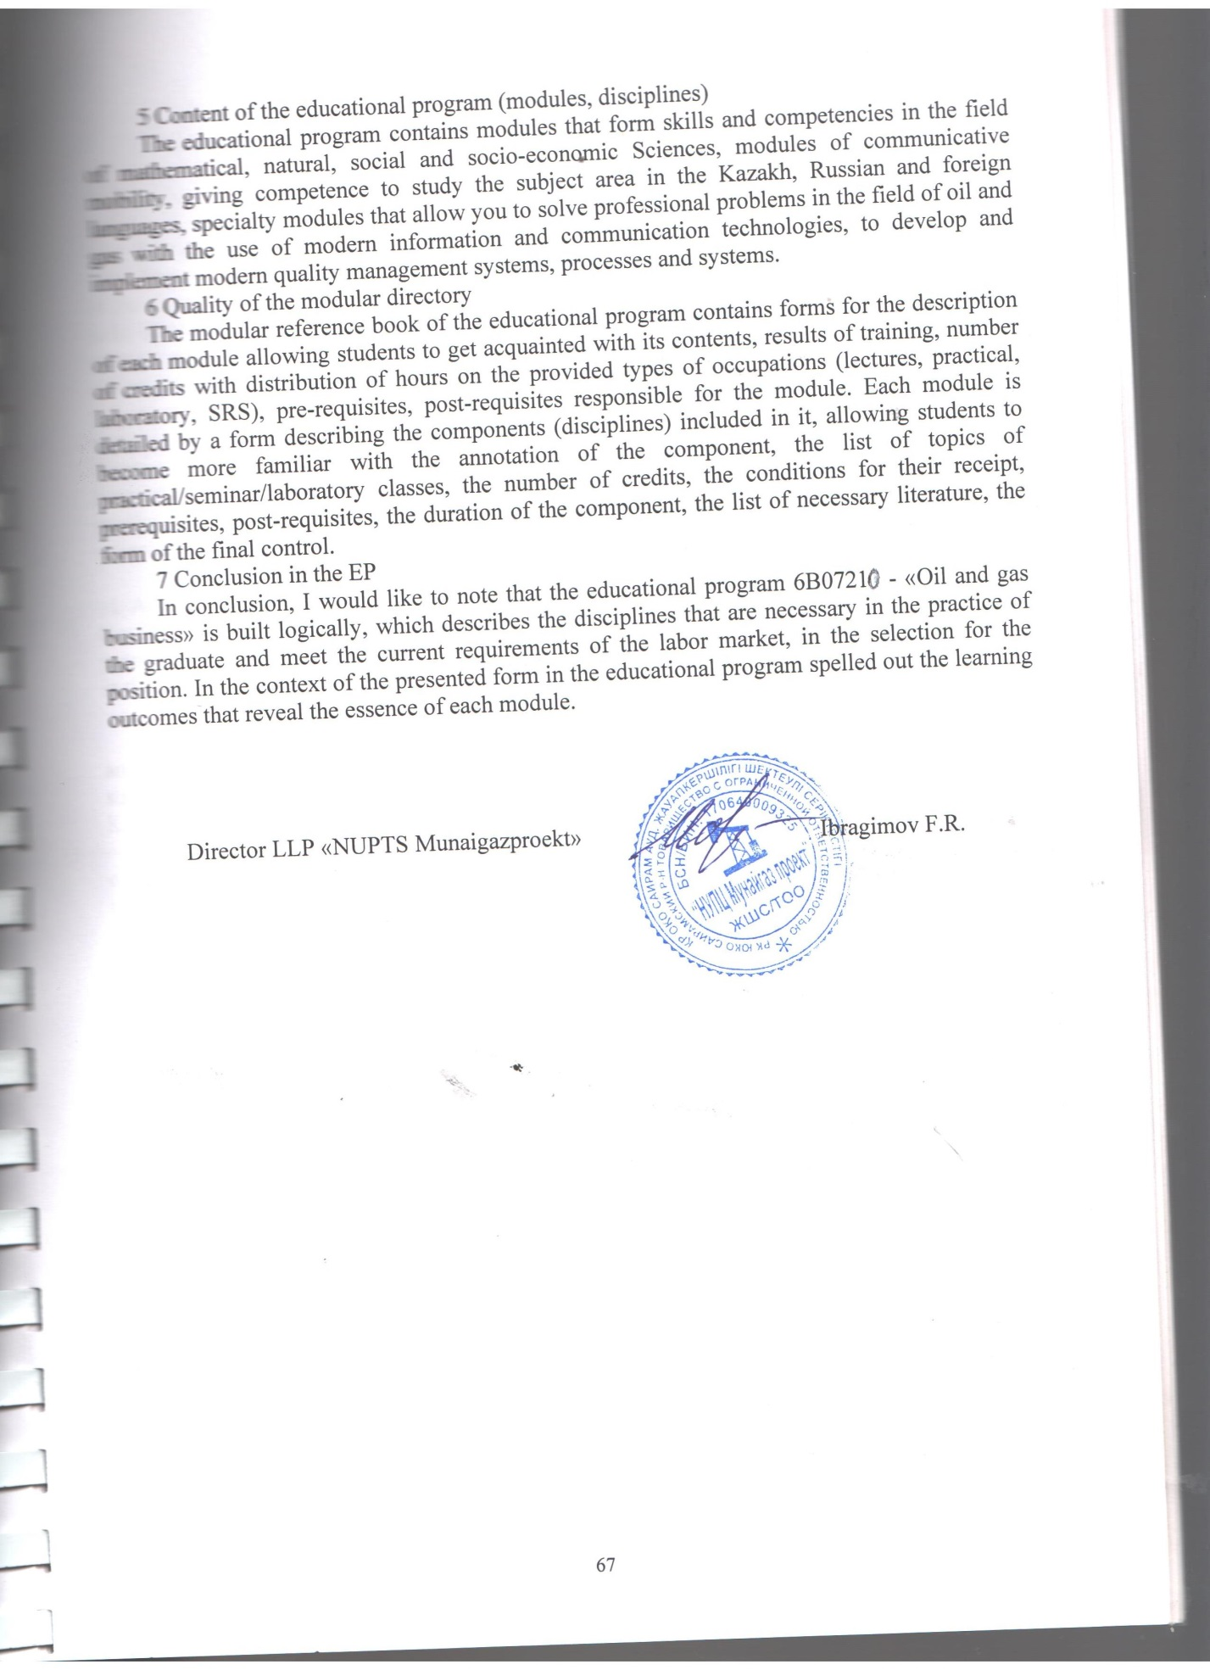
REVIEW of
the educational program
6B07211-Oil and gas business,
developed at the SKU named after M. Auezov, Shymkent

1 Brief description of the company and the profile of its activities.
The oil and gas industry provides significant contributions to the economy of Kazakhstan. In the oil and gas industry, the career path of an engineer working in the fields may include the tasks of drilling, developing and operating oil and gas wells. The constantly growing demand for energy carriers and the increase in the population of our republic has a significant impact on the annual volumes of oil and gas production, and, consequently, increases the demand for training personnel for the oil and gas industry. That is why the Bachelor of Engineering and Technology specialty in the educational program 6B07211-Oil and Gas business is very popular among future students. Future young professionals are attracted by a relatively high salary, it is quite interesting to climb the career ladder and develop in such a promising industry. In this industry, specialists always have a chance to show their abilities, the latest world developments of scientists are constantly being introduced here.
Bachelor's degree training in the specialty "Oil and gas business" has been conducted at the M. Auezov SKU since 2004. After such a serious and versatile training, a graduate of the Oil and Gas Business direction has sufficient qualifications to work in the industry on the technological processes of drilling oil and gas wells. This is facilitated by the skills that young people acquire in the learning process.
2 Relevance and relevance of the EP.
The relevance of the EP is due to the need to train competitive specialists in the field of oil and gas business, who are able to independently perform technical solutions and implement strategic programs for the development of strategy in the oil and gas industry of the Republic of Kazakhstan.
The educational program is in demand in the modern conditions of increasing the volume of hydrocarbon production. The demand for EP is connected with the need to increase the competitiveness of domestic specialists in the labor market, who possess a complex of necessary knowledge and skills that can evaluate information, set and solve scientific and practical tasks. These trends show the importance of EP for the training of competitive specialists in higher educational institutions of our country.
3 Learning outcomes and competencies, their relationship to the demands of the labor market
The educational program contains the results of training and competencies, namely: to be able to solve problems related to the operation of equipment, drilling wells and operation of oil and gas fields using modern methods; to be ready to acquire new knowledge and technologies in the professional field, to set goals and formulate tasks related to the implementation of professional functions; to justify the choice of technological schemes and design equipment for the oil and gas industry; participate in the development of the structures of production and technological, service and operational, installation and commissioning units for oil and gas drilling.
The results of training and competencies are closely related to the demands of the labor market, since the external examination and review of the EP goes through employers who study the EP comprehensively, on the basis of this they give a review of the EP for the approval of the program.
4 Availability of components that develop practical skills
The content of the EP is aimed at preparing intellectual capital that meets the needs of the individual and society, based on the principles of "education throughout life" and self-education, mobility, development of creative thinking and a competence approach. This educational program includes components that form professional competencies, develop practical skills by 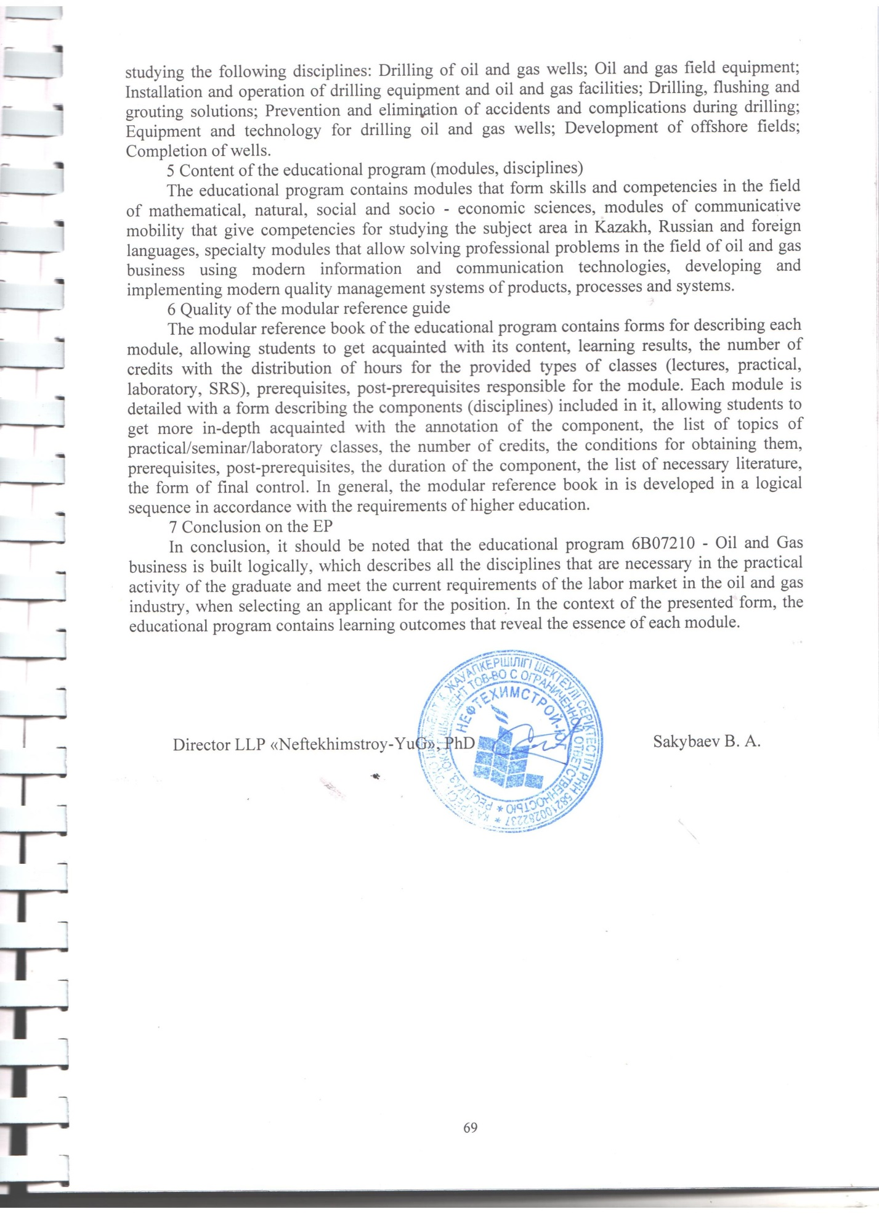

REVIEW of
the educational program
6B07211 - "Oil and gas business",
developed at the M. Auezov SKU, Shymkent

1 Brief description of the company and the profile of its activities.
The fuel and energy complex is one of the key factors of the socio-economic development of Kazakhstan. The oil industry is of paramount importance for the economy of Kazakhstan.
Therefore, great attention is paid to the preparation of shifts for oil and gas workers and professional development. Despite the fact that wages in oil and gas companies are attractive and stable due to the high demand for hydrocarbons and the implementation of large projects in the oil and gas sector, there is currently a shortage of domestic engineering and technical personnel in oil companies in the country. The solution of this task will allow: to activate new directions of development of the industry; to strengthen fundamental and applied scientific research in the field of energy-saving "green" technologies; to increase the role and level of domestic engineering and provide personnel for energy projects of the Republic of Kazakhstan
Bachelor's degree training in the specialty "Oil and gas business" has been conducted at the M. Auezov SKU since 2004.
The bachelor's degree program in the direction of "Oil and Gas business" was created at the request of employers in accordance with the professional standards of NCE RK "Atameken". The program is aimed at training highly professional personnel in the field of oil and gas well drilling.
2 Relevance and relevance of the EP.
The relevance of the educational program lies in the specifics of the goals of the educational training of bachelors who have critical thinking, possess advanced training technologies, are able to integrate in modern conditions, as well as the implementation of a new approach to training specialists who are able to effectively carry out the processes of drilling oil and gas wells.The EP in the direction of "Oil and gas business" was developed taking into account innovations in the oil and gas industry.
3 Learning outcomes and competencies, their relationship to the demands of the labor market
Successful training in the EP allows you to form the following learning outcomes and competencies
-Communicate freely in the professional environment and society in Kazakh, Russian and English.
-Demonstrate natural-scientific, mathematical, social, socio-economic and engineering knowledge in professional activities, methods of mathematical data processing, theoretical and experimental research, regulatory documents and elements of economic analysis.
-Have information and computing literacy, the ability to generalize, analyze and perceive information, set goals and choose ways to achieve it.
Be able to solve problems related to the operation of equipment, drilling of wells and the operation of oil and gas fields using modern methods.
-Participate in the development of organizational and technical documentation and preparation of documentation on the quality management of technological processes at production sites, as well as understand the need to work in a team in accordance with professional ethics.
-Be able to organize and control the performance of the main types of routine maintenance work on the operation, overhaul of wells using modern achievements of science and technology.
- Conduct tests on the installation and operation of drilling equipment, oil and gas facilities and their elements for reliability according to the latest methods.
-- Justify the choice of technological schemes and design equipment for the oil and gas industry.
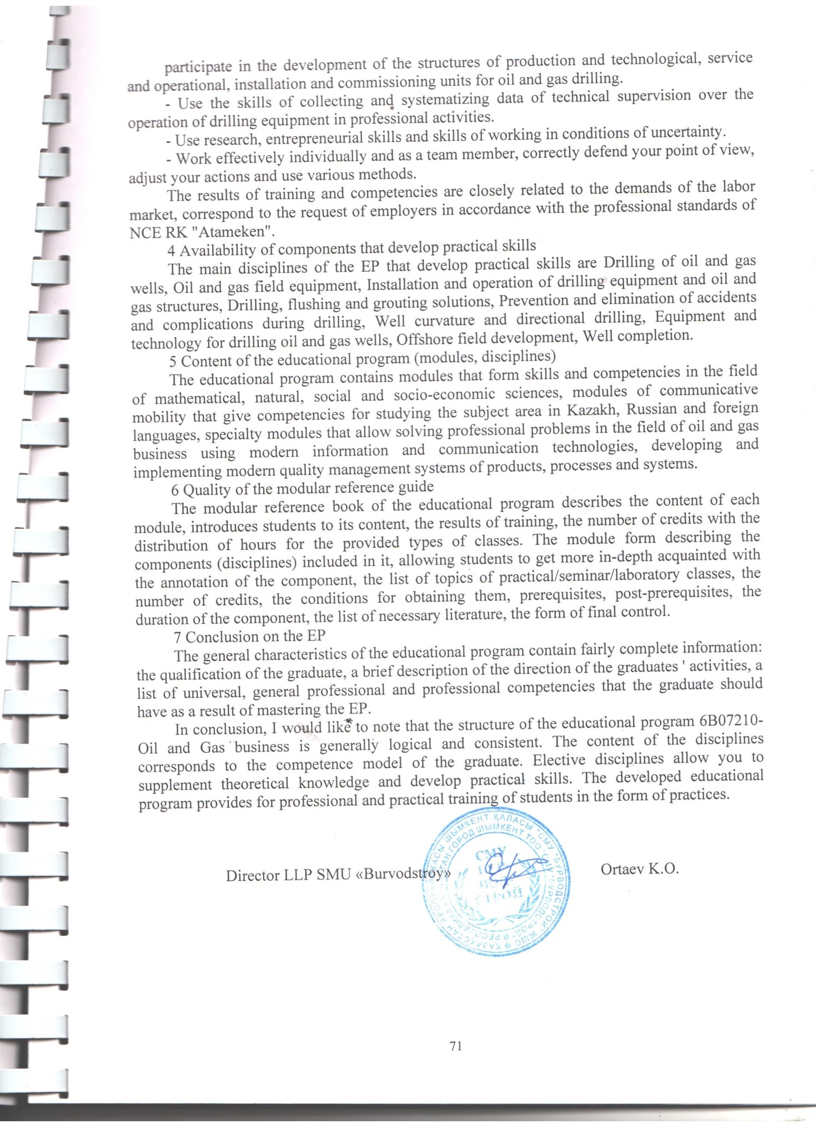

REVIEW of
the educational program
6B07211-Oil and gas business ,developed at the M. Auezov SKU, Shymkent

1 Brief description of the company and the profile of its activities.
The oil and gas industry will determine the state of our country's economy in the foreseeable future and provides significant tax revenues to the state treasury. In the industry, the career path of an engineer working in the fields can include tasks both in Kazakhstan as a whole and around the world. Due to the appearance of new production facilities, indicated in the strategy of Kazakhstan, the demand for energy carriers will increase annually. This applies mainly to the annual volumes of oil and gas production. Hence, consequently, the demand for trained personnel for the oil and gas industry is increasing. Therefore, the Bachelor of Engineering and Technology specialty under the educational program 6B07211-Oil and Gas business is very popular among future students. In the oil and gas industry, future young specialists are attracted by relatively high wages. It is quite promising for young specialists to work and climb the career ladder, to develop in such a promising industry. Thus, young specialists in the industry always have the opportunity to show their abilities, as the latest scientific developments in the technology of drilling and development of wells for the production of hydrocarbons are constantly being introduced here.
The Department of "Oil and Gas Business" has been training bachelors at the M. Auezov SKU in the specialty "Oil and Gas Business" since 2004. After an in-depth and versatile training, a graduate of the Oil and Gas Business direction will have a high qualification to work in the industry on the technological processes of drilling oil and gas wells. This is facilitated by the skills that young people acquire in the process of training in this EP.
2 Relevance and relevance of the EP.
The developed EP is undoubtedly relevant, which is due to the need to train competitive specialists in the field of oil and gas business, who are able to perform technical solutions and implement strategic programs for the development of strategy in the oil and gas industry under field conditions of drilling and well development.
The educational program is in demand in modern conditions of drilling wells and their operation. The demand for EP follows from the need to increase the competitiveness of domestic specialists in the labor market, who must possess a set of necessary knowledge and skills, the ability to evaluate information, set and solve scientific and practical tasks. These provisions show the importance of the EP for the training of competitive specialists in higher educational institutions of our country.
3 Learning outcomes and competencies, their relationship to the demands of the labor market
The educational program contains the results of training and competencies, namely: to be able to solve problems related to the operation of equipment, drilling wells and operation of oil and gas fields using modern methods; to be ready to acquire new knowledge and technologies in the professional field, to set goals and formulate tasks related to the implementation of professional functions; to justify the choice of technological schemes and design equipment for the oil and gas industry; participate in the development of the structures of production and technological, service and operational, installation and commissioning units for oil and gas drilling.The results of training and competencies are closely related to the demands of the labor market, since the external examination and review of the OP goes through employers who study the OP comprehensively, on the basis of this they give a review of the OP for its approval of the program.
4 Availability of components that develop practical skills
In general, the content of the EP is aimed at preparing intellectual capital that meets the needs of the individual and society, based on the principles of "education throughout life" and 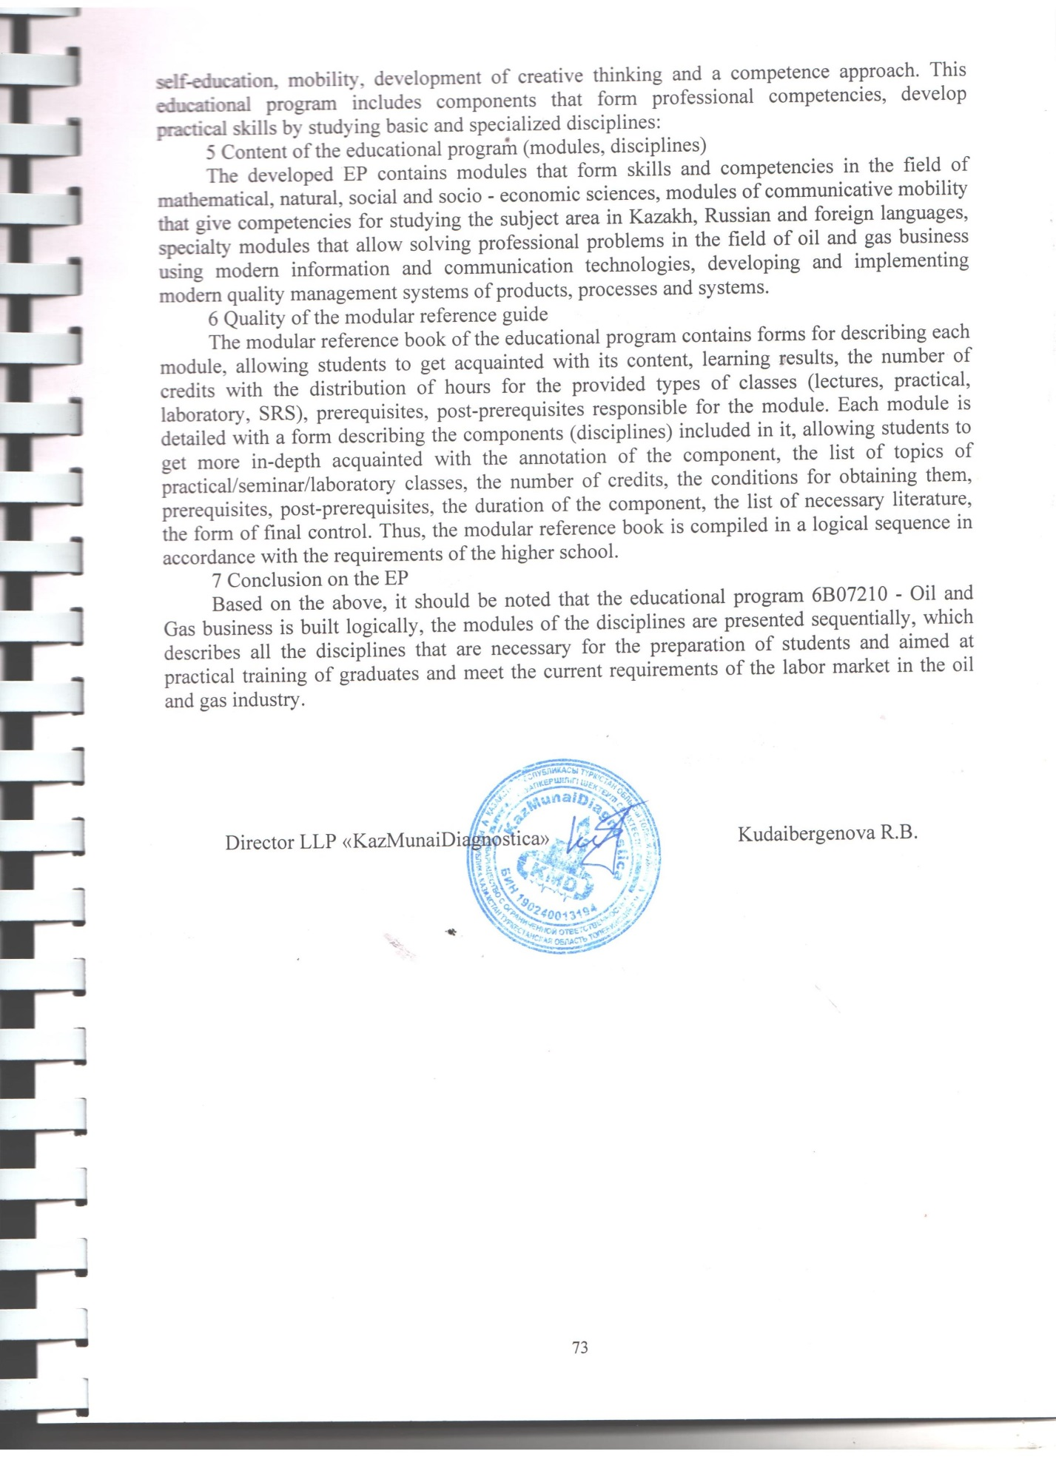

REVIEW of
the educational program
6B07211 - "Oil and Gas business" ,developed at the M. Auezov SKU, Shymkent

1 Brief description of the company and the profile of its activities.
The oil and gas industry is the most competitive industry and the main taxpayer providing a significant part of the budget of the Republic of Kazakhstan. The oil and gas business includes all the stages that oil and gas go through from detection in the subsurface to receipt to the consumer. The oil and gas industry is experiencing an acute shortage of highly qualified personnel. Therefore, the training of highly professional personnel in the field of drilling oil and gas wells is the most important task of the industry. Bachelor's degree training in the specialty "Oil and gas business" has been carried out at the M. Auezov SKU since 2004.
The program was developed taking into account the professional standards of the National Chamber of Entrepreneurs of the Republic of Kazakhstan "Atameken" and the opinion of employers and is interdisciplinary in nature. The program is aimed at training highly professional personnel in the field of oil and gas well drilling.
2 Relevance and relevance of the EP.
The relevance of the EP Oil and Gas business is aimed at ensuring the expanded reproduction of intellectual resources of the oil and gas complex of the Republic of Kazakhstan, to become the locomotive of scientific and technical progress of oil and gas production as the most important factor of sustainable development of the country, i.e. to form a highly qualified, competent specialist in demand on the labor market. Training in the OP Oil and Gas Business is aimed at practical and research activities in solving current problems in the oil and gas industry.
3 Learning outcomes and competencies, their relationship to the demands of the labor market
Successful training in the EP allows you to form the following learning outcomes and competencies:
- Communicate freely in the professional environment and society in Kazakh, Russian and English.
- Demonstrate natural science, mathematical, social, socio-economic and engineering knowledge in professional activities, methods of mathematical data processing, theoretical and experimental research, regulatory documents and elements of economic analysis.
- Possess information and computational literacy, the ability to generalize, analyze and perceive information, set goals and choose ways to achieve it.
- Be able to solve problems related to the operation of equipment, drilling wells and the operation of oil and gas fields using modern methods.
- Participate in the development of organizational and technical documentation and preparation of documentation on the quality management of technological processes at production sites, as well as understand the need to work in a team in accordance with professional ethics.
- Be able to organize and control the performance of the main types of routine maintenance work on the operation, overhaul of wells using modern achievements of science and technology.
- Conduct tests on the installation and operation of drilling equipment, oil and gas structures and their elements for reliability according to the latest methods.
- To justify the choice of technological schemes and design equipment for the oil and gas industry.
- Participate in the development of the structures of production and technological, service and operational, installation and commissioning units for oil and gas drilling.
- To use the skills of collecting and systematizing data of technical supervision over the operation of drilling equipment in professional activities.
- Use research, entrepreneurial skills and skills of working in conditions of uncertainty.
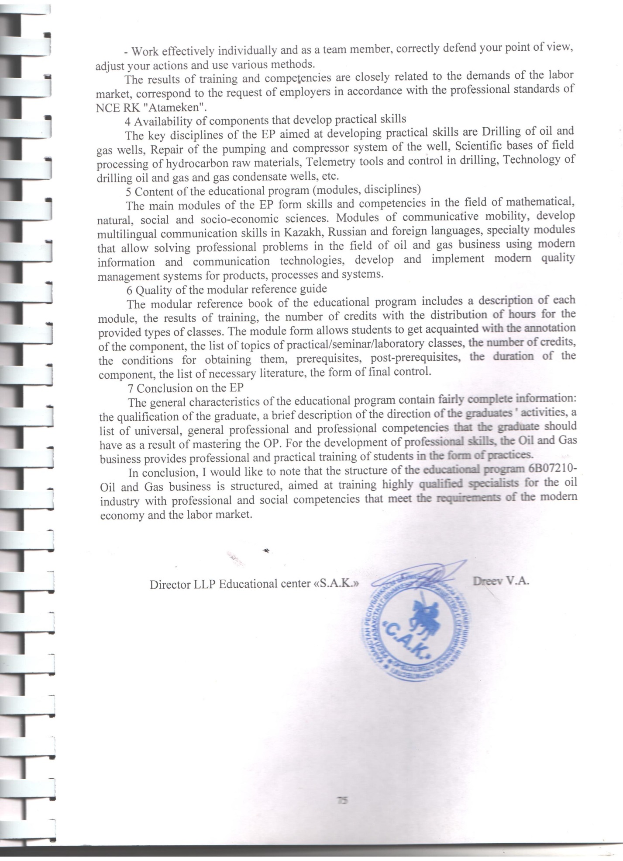

Annex 2

Expert opinion
to the educational program
6В07210 - "Oil and gas business»

1. The relevance of the EP. An optional parameter of the Bologna process is a modular system of training, which is of great importance in the planning and organization of the educational process, taking into account the interests of employers and the needs of society.
Modular system and associated with its introduction intensification of information-active learning process, knowledge control system and professional suitability will improve the efficiency and quality of training, ensuring the focus of creative activity of the individual. In this regard, the development of the educational program 6B07211 - "Oil and gas business" is an urgent task.

2. Compliance EP formulated goals consistent with the mission of the University, the needs of employers and students. The educational program 6B07211 - "Oil and gas business" meets the objectives agreed with the mission of the University, the needs of employers and students. This is confirmed by the training of specialists with theoretical and practical knowledge in the field of transportation and storage of oil and gas, owning methods and tools for assessing and analyzing the current state of production development, as well as being able to apply the acquired knowledge and skills to effectively solve production problems.

3. Compliance with the National qualifications framework of the Republic of Kazakhstan. The national qualifications framework, along with industry frameworks and professional standards, is part of the National qualifications framework. On its basis, the sectoral framework of qualifications in the fields of education and science, labor, agriculture has been developed. The national qualifications framework in Kazakhstan was developed and approved by the RTC Protocol of 16.03.2016. The national qualification framework is the harmonization of the national education system with the European one. Educational program 6В07210
- "Oil and gas business" corresponds to the sectoral qualifications framework in oil and gas, refining and petrochemical industries (Protocol № 2 from 27.12.2016 g).

4. The EP reflected in learning outcomes and competences based on the Dublin descriptors laid down in professional standards and industry framework. The learning outcomes and competencies are reflected in accordance with the Dublin descriptors, the 1st cycle of the Qualification Framework of the European higher Education Area (A Framework for Qualifications of the European Higher Education Area), and the 6th level of the European qualification framework for lifelong learning. According to the Dublin descriptors, the General competences of a University graduate are formed on the basis of the requirements for General education, social and ethical competences, economic, organizational and managerial competences, and special competences.

5. Content of the educational program (modules, disciplines). The educational program 6B07211 - " Oil and gas business" was developed in accordance with the SES of higher education, approved by the government of the Republic of Kazakhstan dated August 23, 2012 № 1080 with amendments and additions dated may 13, 2016. № 292, the standard curriculum of specialty 5B070800 - Oil and Gas business approved by the order of MES №425 from 05.07.2016, professional standard / industry qualification framework.

6. Structure and content of EP, application of the modular principle of construction. The educational program contains General and interdisciplinary modules, including the basics of engineering and technical Sciences, chemical engineering, vocational training. Each module of the educational program is focused on achieving a certain learning result, that is, competence.

7. The EP has components for training for professional activities, developing key competencies, intellectual and academic skills, reflecting the changing requirements of society, including the implementation of the presidential program for mastering three languages: Kazakh, Russian and English. The educational program 6B07211 - "Oil and gas business" is developed in the context of the competence model of training. The competencies are divided into core and professional competencies. Competencies include knowledge and understanding (theoretical knowledge of the academic field, the ability to know and understand), knowledge of how to act (practical and operational application of knowledge and skills to specific situations) and knowledge of how to be (the value aspect as an integral part of living with others in a social context).
Within Russian presidential program on multilingualism, i.e. mastering three languages (Kazakh, Russian and English) there is a Module of communicative mobility, including such disciplines as Professional Kazakh (Russian) language and Professionally-oriented foreign language.

8. Logical sequence of disciplines and reflection of the basic requirements in curricula and training programs. In the educational program 6B07211 - "Oil and gas business" clearly traced the logical sequence of the study of disciplines, which is reflected in the table "Content of the educational program". Modules of the educational program are logically interrelated components of the training program in specific areas or disciplines.

9. The reflection of EP in the accounting system of an academic load of students and teachers in the loans, compliance with the parameters of the credit system of study. In the educational program 6B07211 - "Oil and gas business" the system of accounting of the academic load of students and teachers in loans is presented in the summary table, reflecting the volume of loans in the context of the modules of the educational program.
The volume of one module is 3 or more Kazakhstan credits, or 8 or more ects credits and includes two or more academic disciplines.

10. The presence in the programs of practical training to consolidate the theoretical material expressed in the workload in loans. The educational program provides for practical training in 2 and 3 courses, which are included in the relevant module of the educational program. The purpose of practical training is to obtain practical and consolidate theoretical knowledge on the educational program 6B07211 - "Oil and gas business" in the field of technology of transportation and storage of oil and gas, the equipment used, as well as measures for safety and environmental protection.

11. Information on PPP involved in the implementation of the EP. In the educational program 6B07211 - " Oil and gas business" information on PPP involved in the implementation of OP, presented in the form of a modular directory. The modular reference book is a necessary component of the credit technology of training, which ensures the selectivity of the teacher and the learning pathway. The modular Handbook presents data on the teacher, the distribution of loans, types of classes, the level of the module, the number of credits, the form of training, prerequisites and post-requisites of the module, the content of the module, the results of training, the form of final control.

12. Qualifications obtained as a result of the development of EP. Students who have successfully passed the final certification for the development of educational programs 6В07210- 