Department of Scientific Projects and Programs of the South Kazakhstan University. M. Auezova reports that, based on the results of the competition for grant funding for young scientists under the Zhas Galym project for 2022-2024, project AP15473295 "Development of a technology for obtaining an activated sorbent based on fruit canning waste" won a grant.
PhD grant holder, doctoral student Yesenbek Asylbek Sagyntayuly.
Priority "Rational use of water resources, flora and fauna, ecology".
The aim of the project is to develop and implement a new technology for the production of an activated sorbent, as well as a thermal activation process for the production of an activated sorbent with a high adsorption capacity.
The novelty and importance of the technology for obtaining an activated sorbent with established properties, a developed porous structure and a greater adsorption capacity for wastewater treatment is determined, first of all, by the creation and development of high-performance projects.
Congratulations
Yesenbek Asylbek Sagyntaevich!
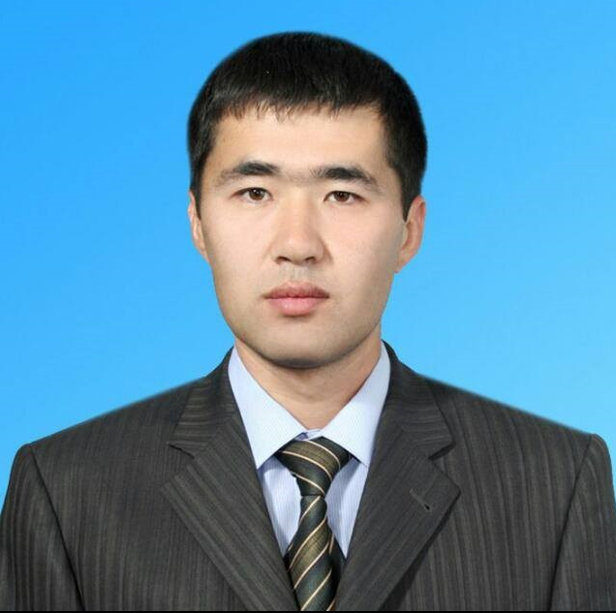

(Kazakh National Technical Research University named after K.I. Satbayev) non-profit joint-stock company, by the decision of the Dissertation Council, on May 30, 2022, according to the order No. 760d, Mirzabayev Berik Islambekuly, a teacher of the Department of Science and Technology, received the title of PhD. Congratulations!

