From June 13 to June 25, 2022 at the South - Kazakhstan University. M.Auezov, the grand opening of the international summer school "Auezov University - 2022", organized by the Center for the Bologna Process and Academic Mobility and the Department of "Philosophy" of the Faculty of Law, took place.
At the opening of the summer school, Iskakova A.T., Vice-Rector for Strategic Development and Internationalization, Dean of the Faculty of Law, Ph.D. Sarykulov K.R., head of Department of "Philosophy", Ph.D. in Philosophy, Associate Professor Spanov M.Zh., as well as invited speakers of partner universities:
- Prilukova E.G. – Ph.D. Sciences, Professor of the Department of Philosophy (Russia) South Ural State University,
- Safarova N.O. Doctor of Philological Sciences, Professor, Head. Department of Social Sciences, Navoi State Pedagogical Institute (Uzbekistan)
- Madaeva Sh.A. d.ph.s., head. Department of Philosophy and Logic. National University of Uzbekistan named after M. Ulugbek (Uzbekistan).
For 10 days, classes were held at the summer school, where leading experts from near and far abroad gave lectures, highlighting the pressing problems of modern society.
At the end of the international summer school, the head of the department
"Philosophy" Spanov M.Zh. thanked all the guests - participants, teachers, doctoral students, undergraduates and students for their active participation and expressed his deep gratitude to the leadership of the South Kazakhstan University. M. Auezov, Center for the Bologna Process and Academic Mobility for the opportunity to organize a summer school.
Special thanks to all the speakers of the summer school, lecturers, whose lectures aroused genuine interest and a huge number of questions, a team of top professionals who united to share their knowledge, discuss and find solutions to pressing problems in the field of jurisprudence, philosophy, and social disciplines. As well as words of gratitude to the organizers were expressed by the speakers and participants of the summer school.
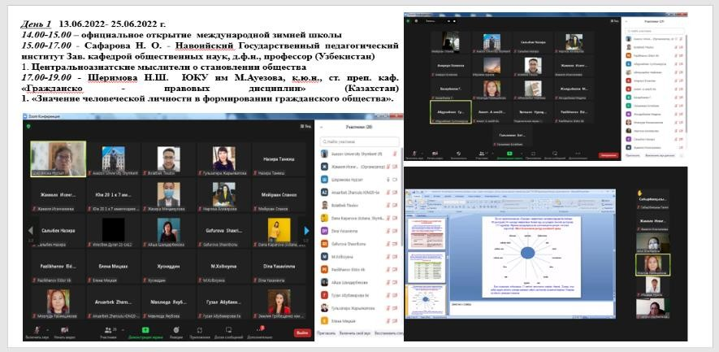
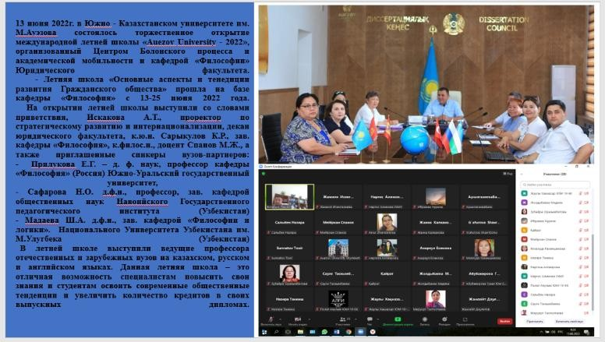
Leading professors of domestic and foreign universities spoke at the summer school in Kazakh, Russian and English. This summer school is an excellent opportunity for specialists to improve their knowledge and for students to master modern social trends and increase the number of credits in their graduation diplomas.

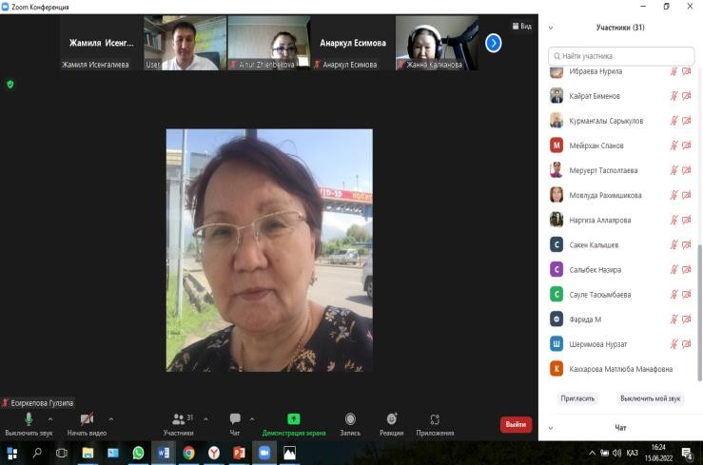
\
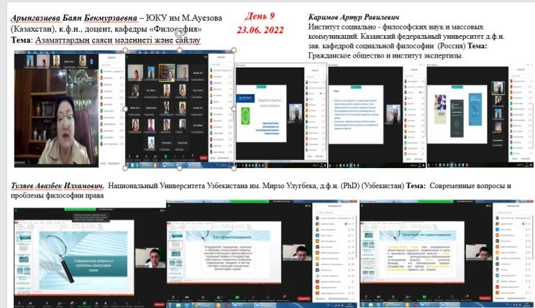
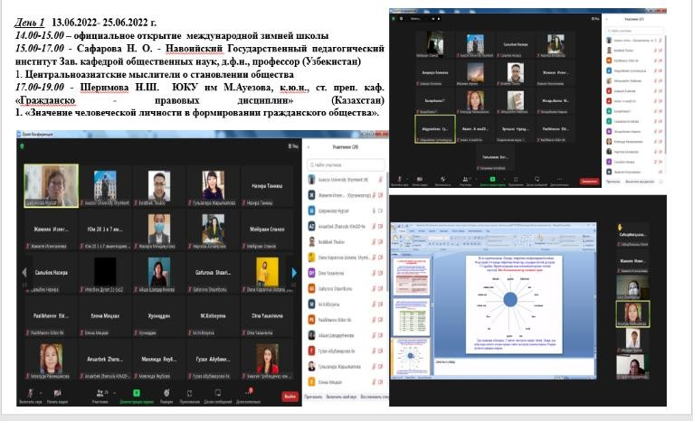

In the period from 20.02.23-20.03.23 at the Department of "Philosophy" of the South Kazakhstan University. M. Auezov, together with the International University of Tourism and Hospitality, within the framework of the academic mobility program of the teaching staff, online exchange classes were held. Joint lectures were held, teachers of the department Aryngaziev B.B. took part in the program. and Tankish N.P. and Maldybek A.Zh. and Karatyshkanova K.Р.

