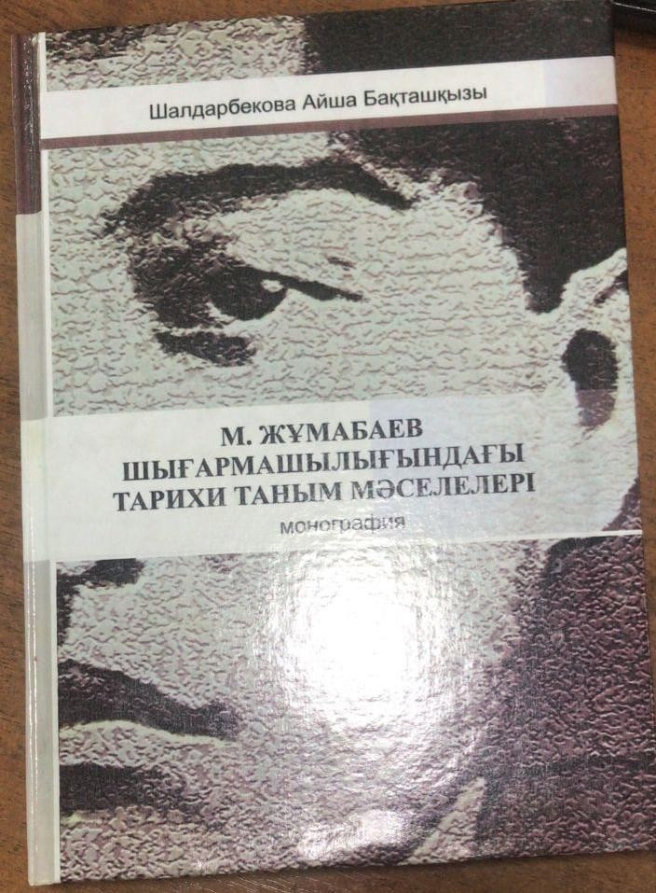
The monograph "Problems of historical knowledge in the work of M. Zhumabaev" by the senior lecturer of the Department of Philosophy, candidate of philosophical sciences, was published. A.B. Shaldarbekova.
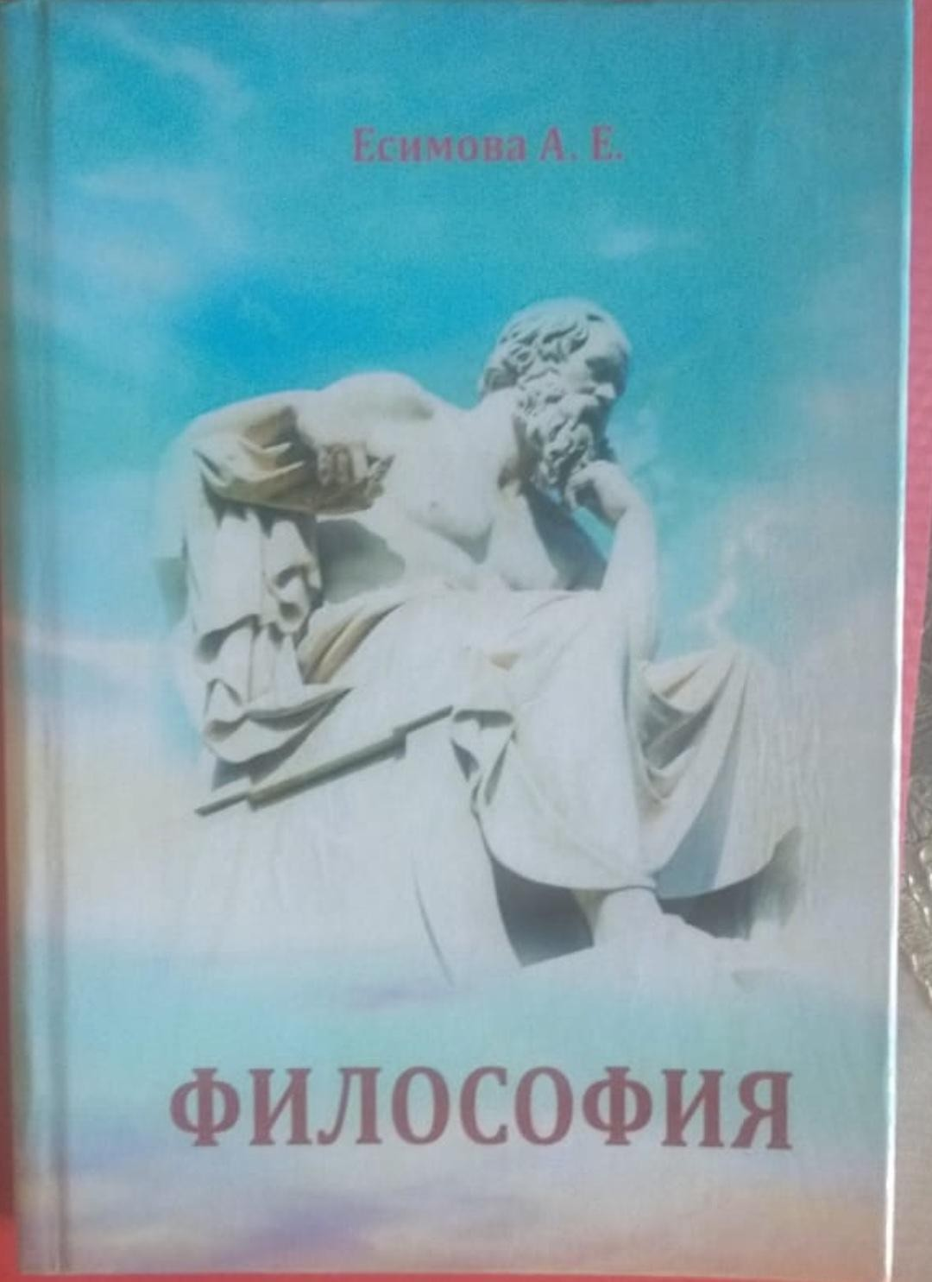
Senior Lecturer of the Department of Philosophy Yesimova A.E. in the 2022-2023 academic year, an educational and methodological manual on the subject "Philosophy" was published.
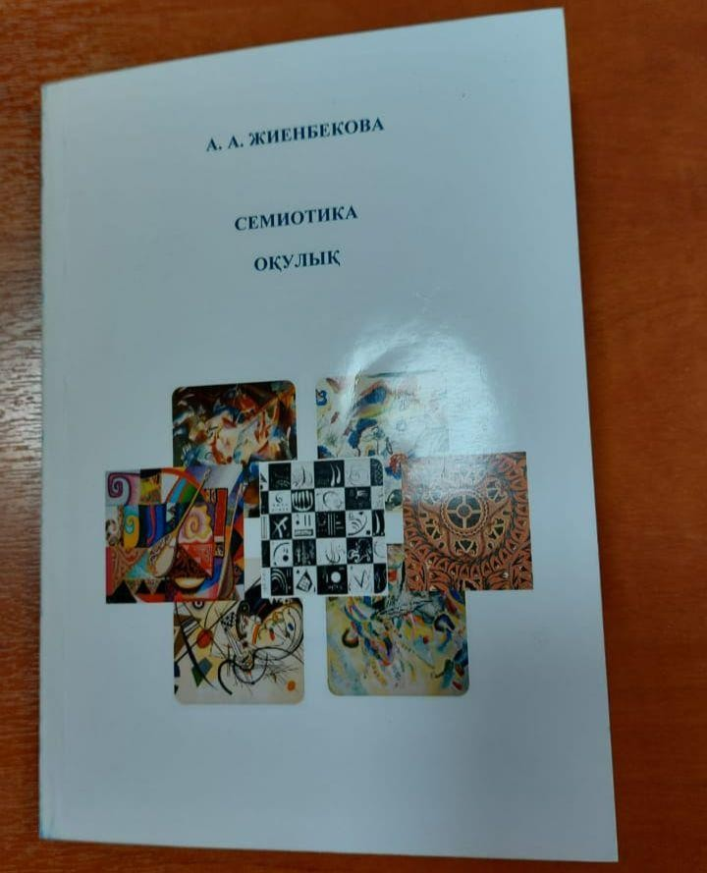
In the 2022-2023 academic year, the textbook "Semiotics" was published by the Associate Professor of the Department of Philosophy, Candidate of Philosophical Sciences. A. A. Zhienbekova.
In the 2022-2023 academic year, Ibraeva N.A., senior lecturer of the Department of Philosophy, Candidate of Philosophical Sciences. the textbook "Uly dala oyshyldary" was published.
