January 19-21, 2023 Associate Professor of the Department of Philosophy, Ph.D., Rakhimshikova M.K. together with a foreign scientist Khodzhaev M.I. for the 2nd year students of the Faculty of Religious Studies of the International Islamic Academy of Uzbekistan in Tashkent, a master class was held on the topic “Philosophy of Religion”.

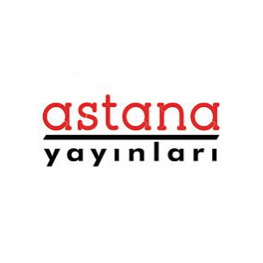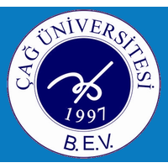

November 13-14, 2021 in Antalya, Turkey, an international SYMPOSIUM ON SOCIAL SCIENCES AND INTERNATIONAL LAW was held, organized by Ankara State University (Ankara, Turkey), CAG University (Adana, Mersin Province, Turkey), and also by the international publishing house ASTANA PUBLICATIONS. In which, at the invitation, the senior lecturer of the department "Philosophy" Yesimova A.E. took an active part. The symposium covered various problems in the field of social sciences and law. Scientists from various countries such as Azerbaijan, Iran, UAE, Russia, Kazakhstan, Uzbekistan, etc. took an active part in the work of the symposium. The participants of the symposium were presented with informative and interesting reports on modern problems of social sciences and law. And also various offline-online presentations, video presentations, etc. were offered. A report by Yesimova A.E. “Mangilik el-turkіtіldes khalyktarynyn ruhani құndylygy” (Mangilik el - the spiritual value of the Turkic-speaking countries) was received with great interest and attention. The speeches were accompanied by a constant exchange of opinions and dialogues on the most acute and pressing problems of education and the modern world in general.
Report of Yesimova A.E. were awarded a certificate. She also underwent an international scientific internship in the amount of 72 hours. Which is also confirmed by a certificate. At the symposium, reports were presented in English, Arabic, Turkish, Russian, Kazakh, Uzbek. Proceedings will be published in the Proceedings of the Symposium by ASTANA PUBLICATIONS, which is an internationally recognized publishing house. As well as articles and reports of the conference are additionally planned to be published in ASEAD and Public Law Archive journals.

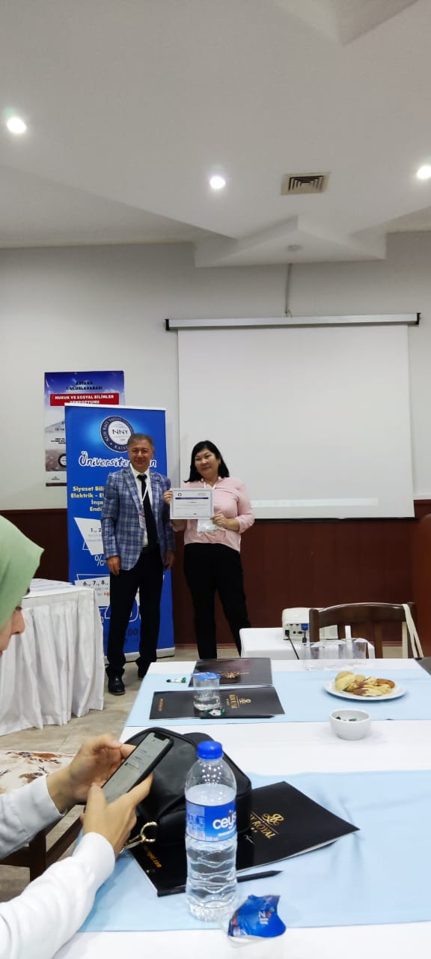
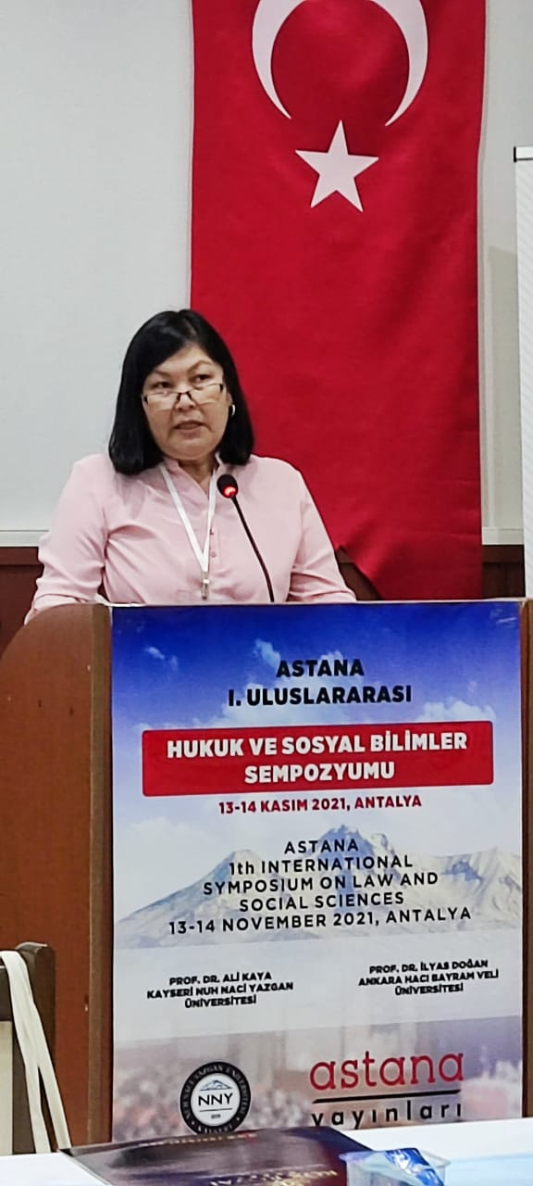

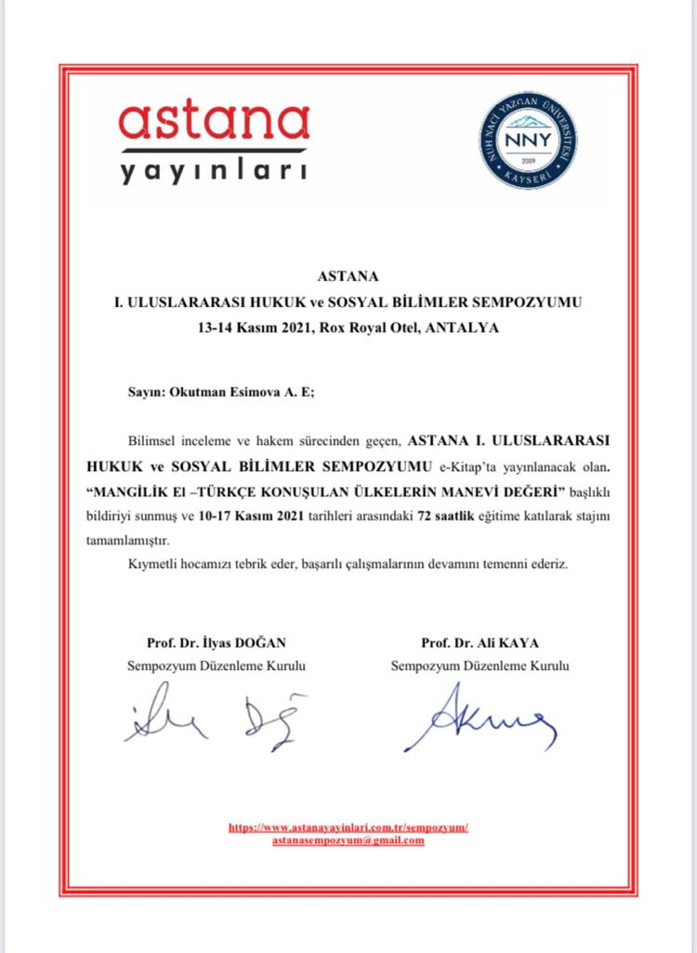
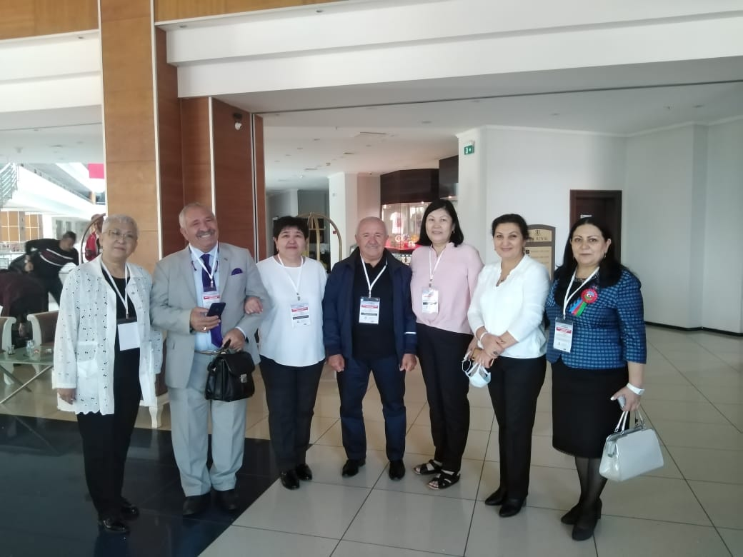
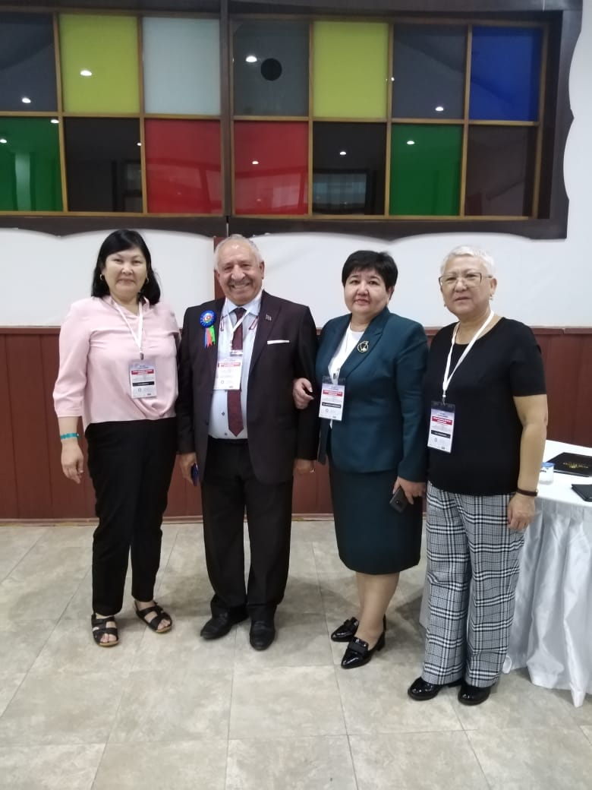

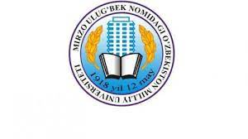
From 23.02.23-07.03.2023 in Uzbekistan, teachers of the department "Philosophy" Aryngaziev B.B., Ibraeva N.A. and Baltabaev N.K. headed by the head of the department Spanov M.Zh. passed an internship and advanced training courses at the National University of Uzbekistan named after. Mirzo Ulugbekan. As part of the advanced training course, lectures were read in the amount of 72 hours on the topics “History of Philosophy of the Peoples of Central Asia”, “History of Philosophy”, “Philosophical Foundations of Social Information”, “Ontology of Ancient and Ancient Philosophy”. Internships and advanced training courses are confirmed by certificates.

