On April 29, 2022, teachers of the Department of Philosophy of the Faculty of Law B.B. Candidate of Philological Sciences, Associate Professor, A.B. Shaldarbekova Senior Lecturer, Ph.D. and teacher M. Tangatarova, made a presentation at the international scientific-practical conference under the leadership of the Department of "Ethics and Aesthetics" of the Faculty of Humanities at the National University of Uzbekistan. Mirzo Ulykbek, on the topic "Actual issues of social and humanitarian sciences" in Tashkent.

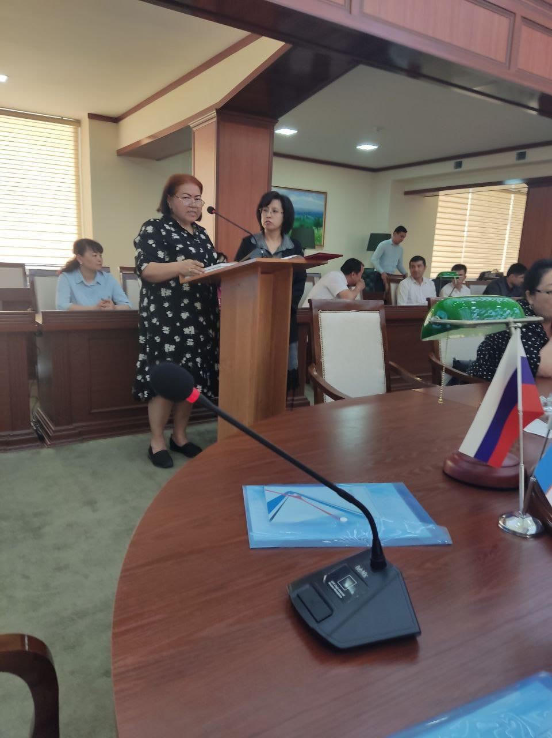

SKU named M. Auezov together with the National University of Uzbekistan named after. M. Ulugbek, held a joint Memorandum of Cooperation. Within the framework of the Memorandum, the teachers of the department gave lectures. Spanov M.Zh., Rakhimshikova M.K., Kaparova D.D. 05.17-21.05.2022 passed a foreign scientific internship at the "Faculty of Social Sciences" of the National University of Uzbekistan named after M. Ulugbek, each of which gave 12-hour lectures on philosophy, have certificates and letters of thanks from the rector of the National University of Uzbekistan.
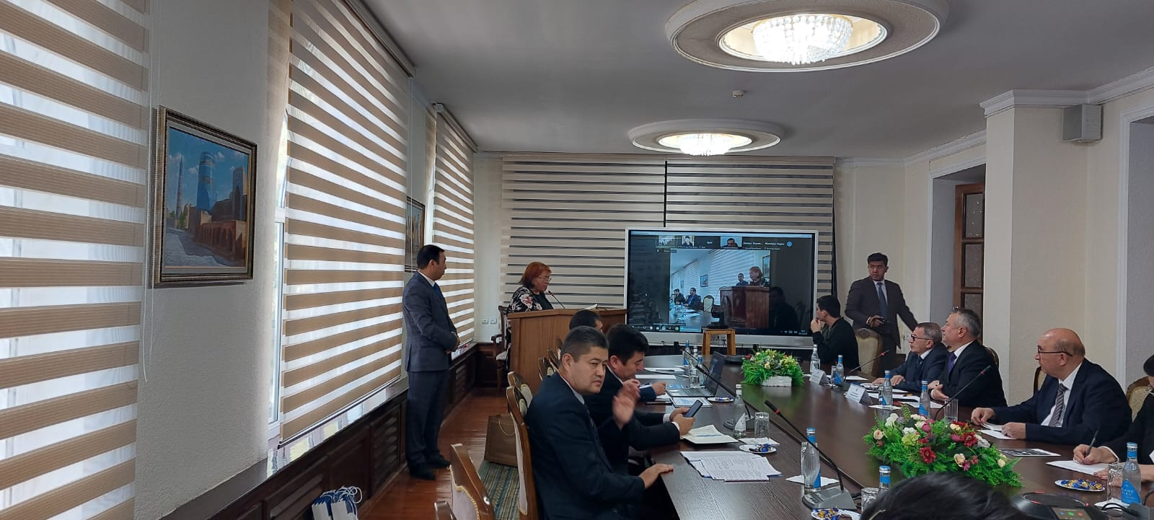

The teaching staff of the department "Philosophy" on the basis of the Memorandum of Cooperation concluded between the University. M. Auezov and Navoi State Pedagogical University of the Republic of Uzbekistan. Spanov M.Zh., Candidate of Philological Sciences, Associate Professor, Ibrayeva N.A. Candidate of Philological Sciences, Associate Professor and Senior Lecturer Yesimova A.E., at the Faculty of Social Sciences of the Navoi State Pedagogical University of the Republic of Uzbekistan from May 25 to May 28, 2022 for 1st year students in the module "Philosophical Heritage and Religious Studies of Central Asian Thinkers" in the specialty "Russian Language and Literature" held lectures and seminars in the amount of 24 hours. Approval certificates are attached.

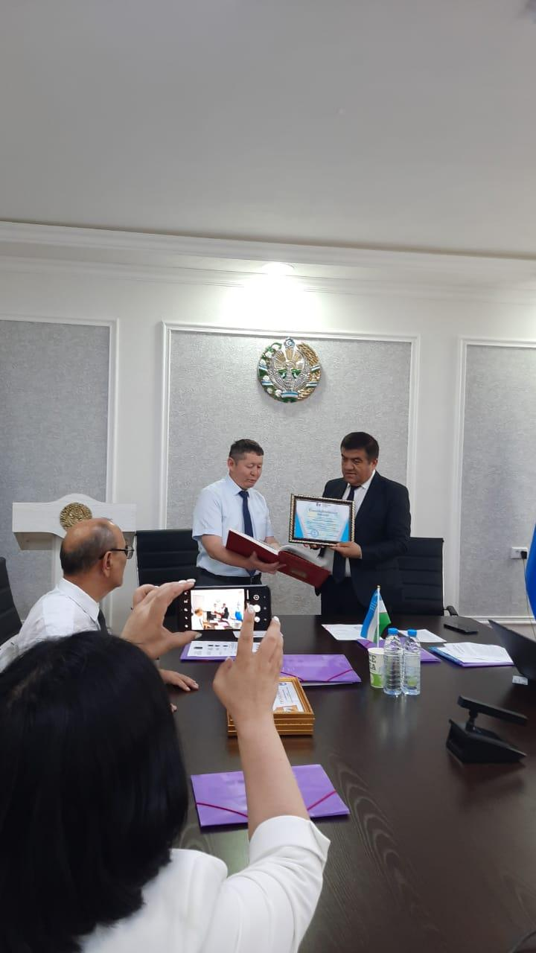

Spanov M.Zh. Candidate of Philological Sciences, Associate Professor, Ibraeva N.A. Candidate of Philological Sciences, Associate Professor, and Senior Lecturer Yesimova A.E. attended the International Scientific Conference "Islamic Scientific, Cultural and Philosophical Heritage in the Context of Modern Methodology", held at the State Pedagogical University of the Republic named after A. Navoi in Uzbekistan, where they made presentations, and also received letters of thanks from the rector of the Navoi State Pedagogical University.

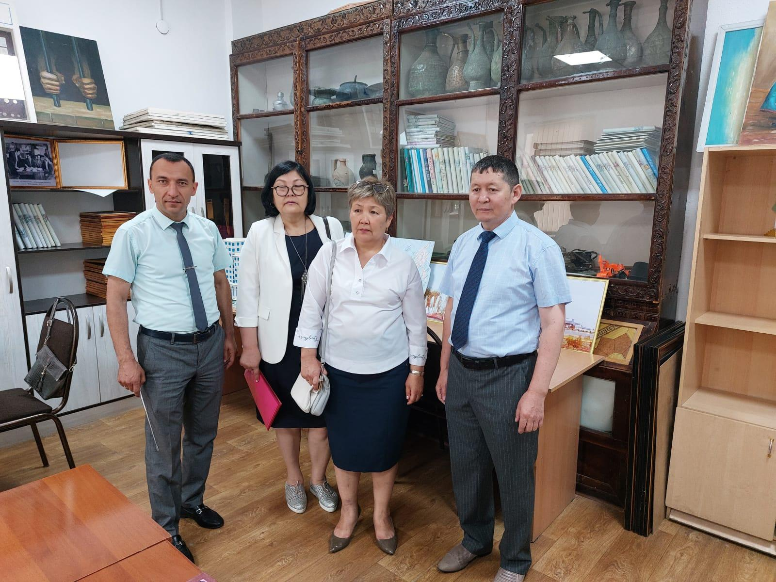

June 28, 2022 at the South Kazakhstan University. M. Auezov, the International Scientific and Educational Round Table was held, organized by the structure "Scientific work and innovations" and the department "Philosophy" of the Faculty of Law. The round table was organized to study and promote the heritage of Khoja Ahmet Yasawi.
The event was attended by teachers from leading universities of the Republic of Kazakhstan, in particular KhKTU named after. K.A.Yasavi, KazNU named after. Al-Farabi and Kastamon University from the Turkish state. During the meeting, questions were discussed about the essence of Yasawi's stories, about the role of this person in philosophy, about the problems of mastering the knowledge necessary for a person to achieve "maturity". The issues of achieving a high concept of reason in science, the moral status of a person and the human in the context of the concept of "insani kamil" on the way to overcome human passions were discussed.
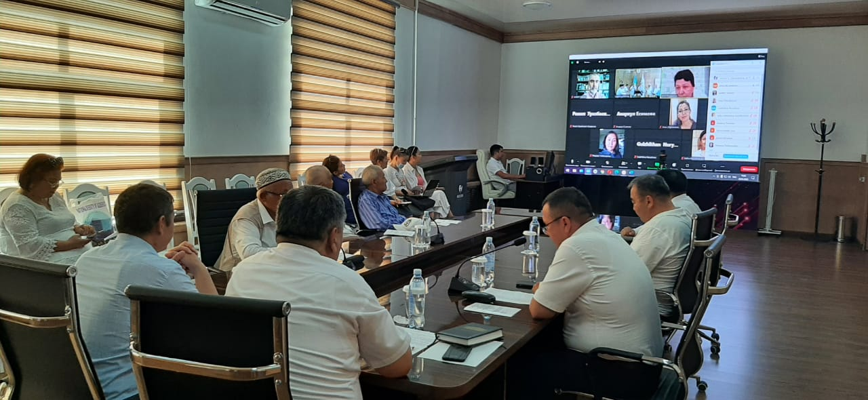

On October 15, 2022, Tashkent hosted the III International Symposium “Communication of Philosophy, Culture, History of the Turkic Peoples: Present and Future”, organized by the Department of Philosophy, the International Islamic Academy of Uzbekistan and the Departments of International Relations and Humanities.
The symposium was attended by teachers - professors from Egypt, Kyrgyzstan, Tajikistan, Kazakhstan and Uzbekistan, raised issues of cultural interaction between Turkic-speaking states, paid attention to interethnic, interstate relations, intercultural dialogue. Presentations were made by candidates of sciences from the University. M.Auezov, department "Philosophy" A.B.Shaldarbekov, M.K.Rakhimshikov.
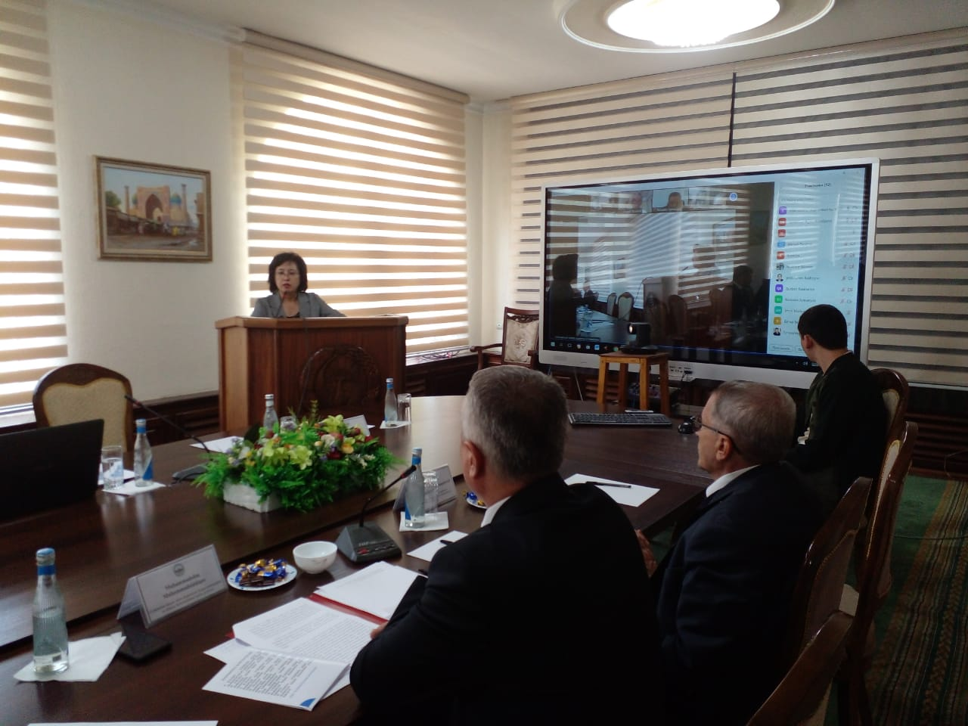

On December 14, 2022, an International Scientific Seminar was held on the topic: "The role of religion in the sustainable development of modern society." It was attended by the teaching staff of our educational institution, professor of the Kastamon University of the State of Tur, Ph.D. Kaji Ahmet Shimshek, Professor of the National University of Uzbekistan named after. M. Ulykbek. K.A.Madayeva, Professor of the State Pedagogical Institute named after. A.Novoi, Ph.D. N.O. Safarova delivered very important reports on the development of religion in the development of modern society.

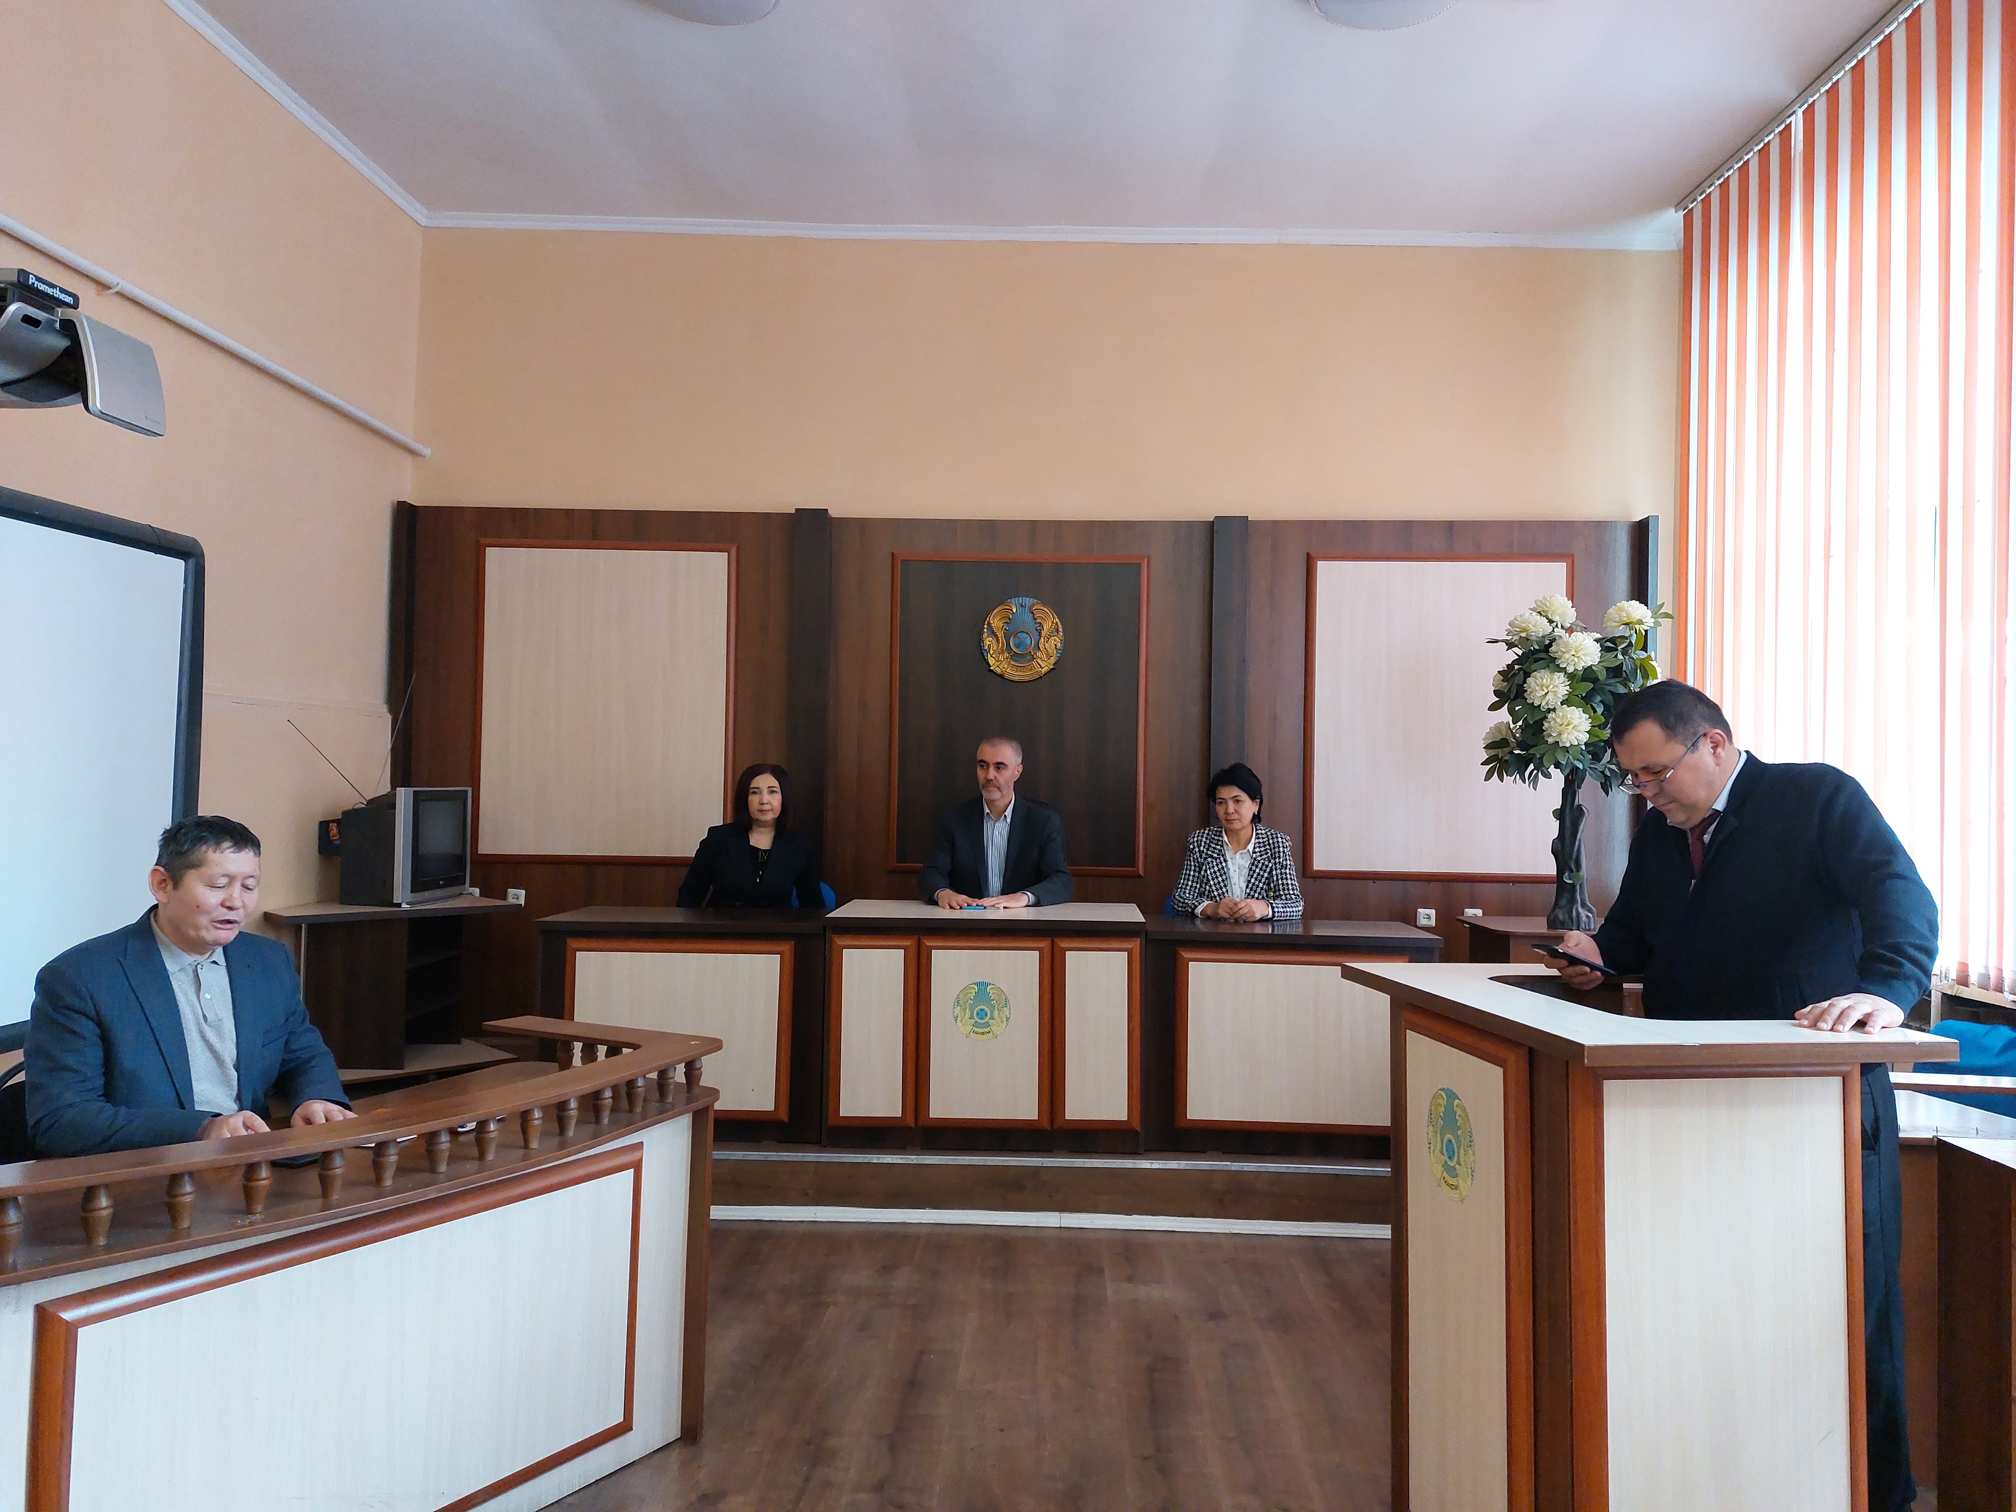

Advanced training of teachers of the Department of "Philosophy" of the Faculty of Law of the South - Kazakhstan University. M. Auezov.

In Almaty, at the Kazakh National University named after Al-Farabi, our teachers undergo advanced training. In ASTANA JOBALARY, advanced training is also held at the Center for the Organization of International and Republican Projects. Certificates indicating academic hours in the amount of 72 hours.
In Turkestan, in the Center for Advanced Studies and Additional Education "Galymnur" received Certificates of Advanced Training
In Tashkent. Refresher courses were held at the National University named after Mirzo Ulugbek. Certificates are attached.
Teaching staff of the department SKU im. M.Auezova annually attend refresher courses for teachers and receive Certificates of 72 academic hours. The teacher of the department has completed advanced training courses at the University of Khojaeli, in the city of Izmit, Turkey, and also has a Certificate for 72 hours.

