Educational work

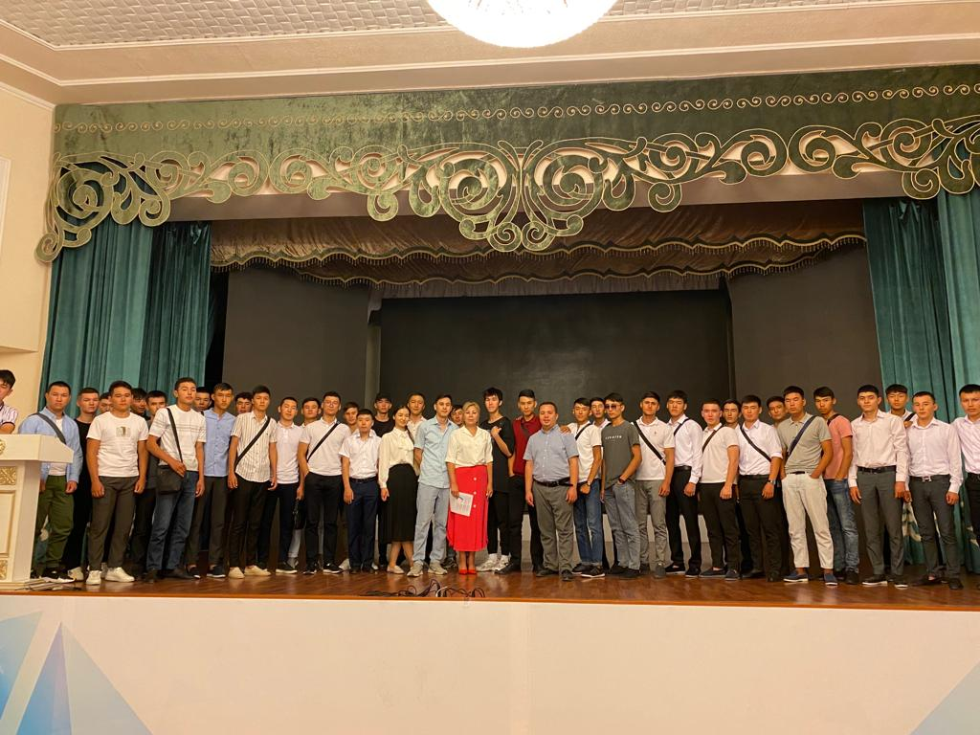
Photo report from the "Open Day" for 1st year students organized by PhD, associate professor Sakhmetova G.E., PhD, senior lecturer Faiz N.S. and senior curator, teacher Smagulov K.Zh.

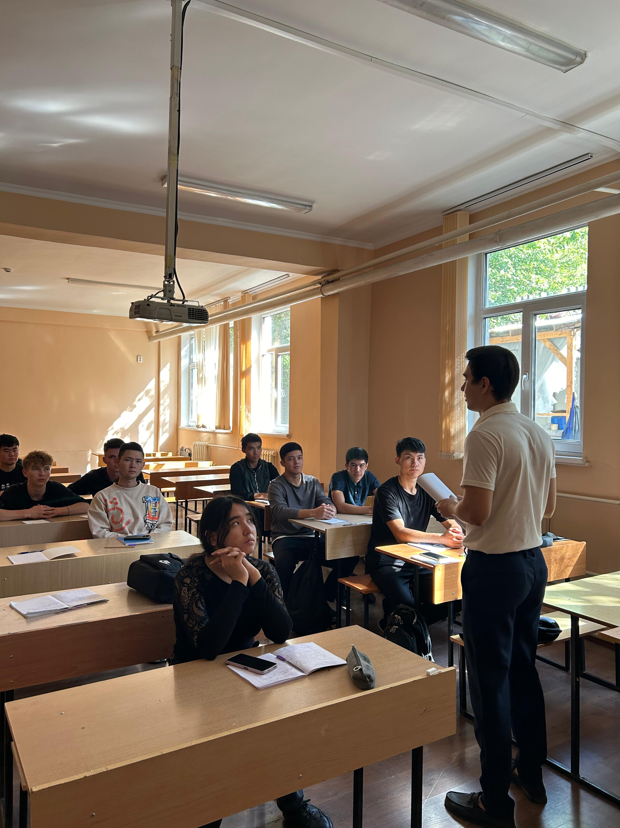
Conducting a curatorial hour in an open format with 2nd year students on the topic "The League of Academic Integrity, its principles and implementation"

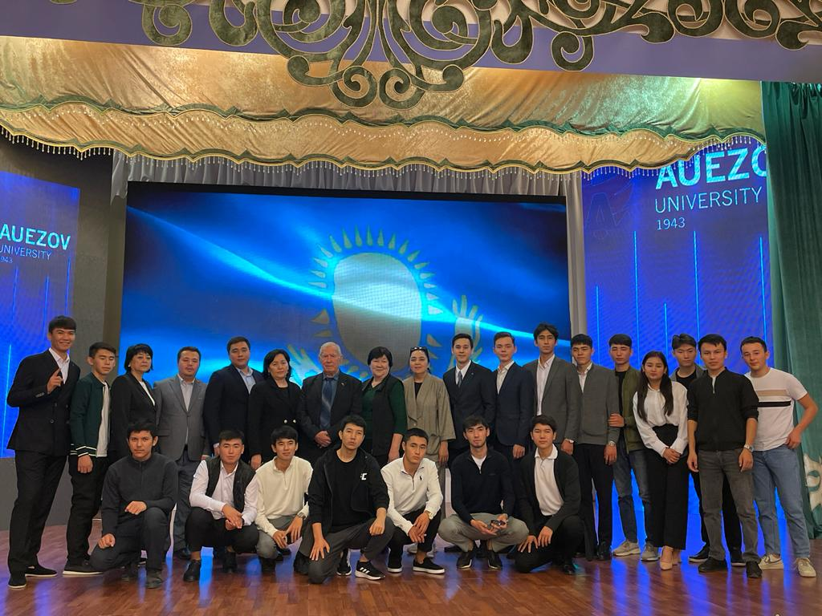
A solemn event organized by senior lecturer Ilyasova K.U. and senior curator Smagulov K.J. on the topic "Prospects for the development of the energy industry"

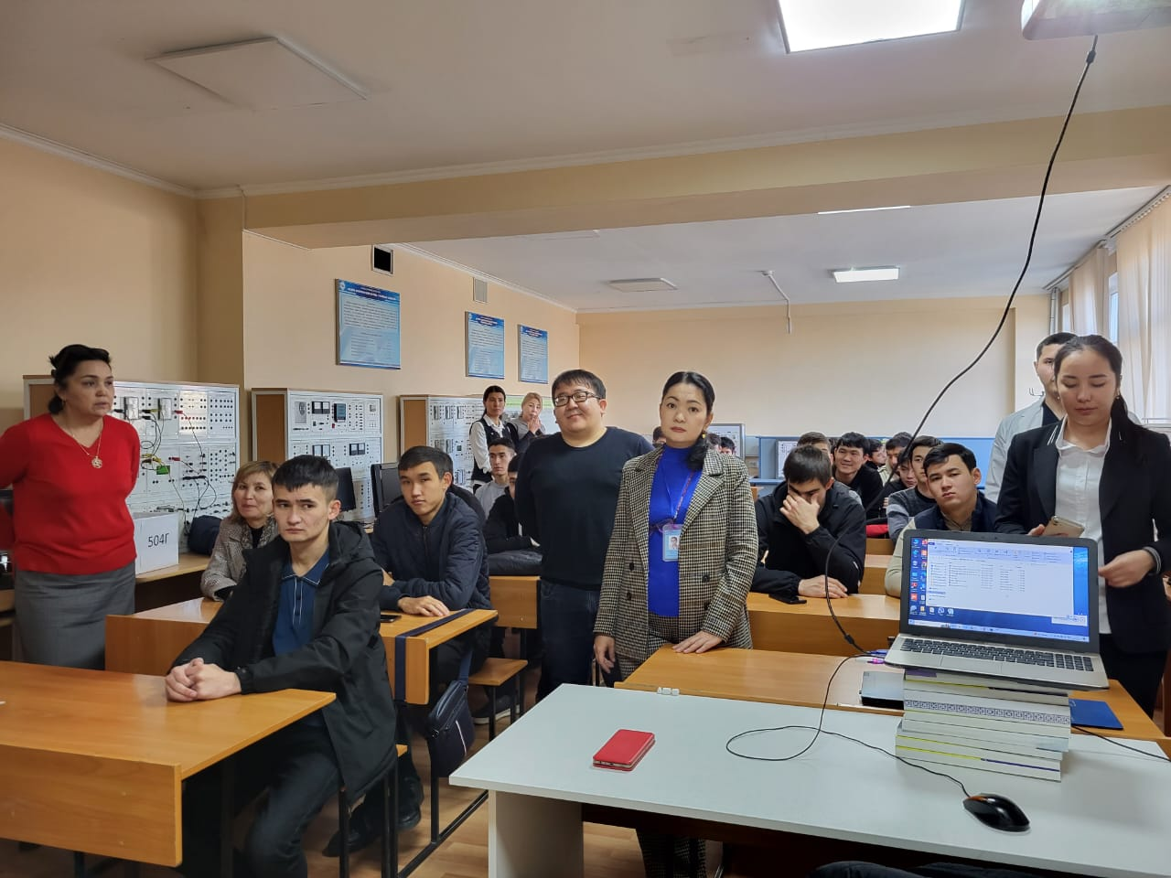
Conducting an open curatorial hour by senior lecturer Kulmakhanova I.K. and senior curator, teacher Smagulov K.Zh. together with specialists of the UCMA on the topic "Preventive measure of infectious measles"

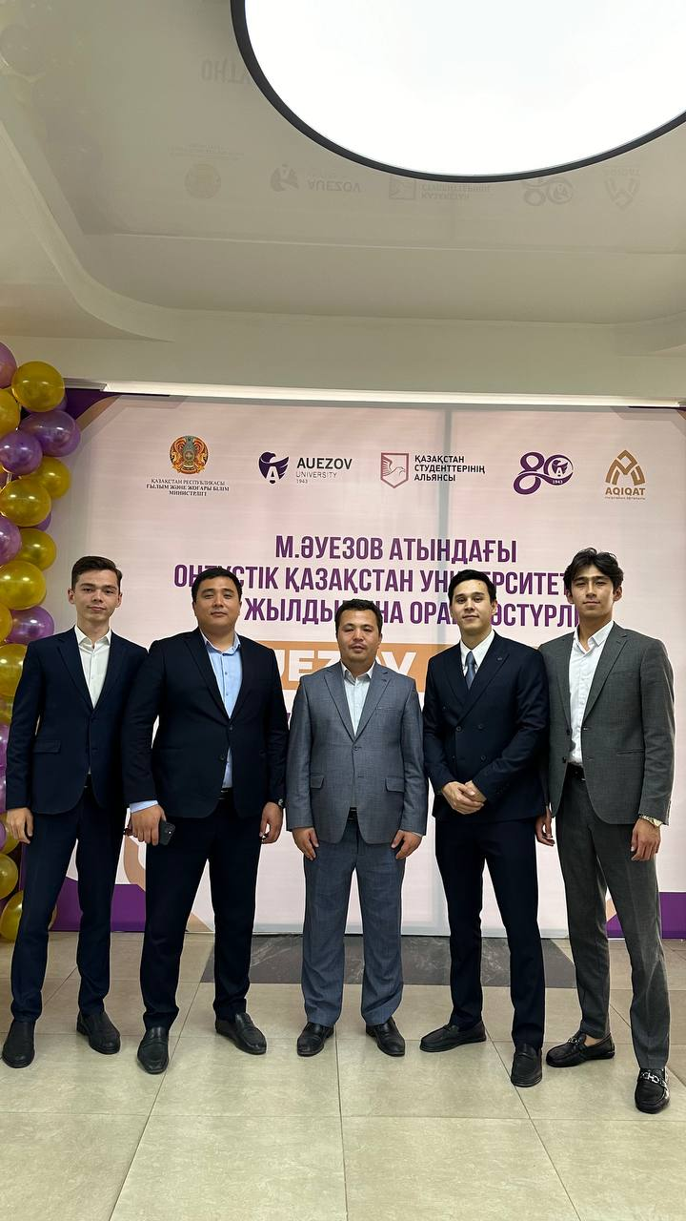
Since participating in the Auezov Fest debate in honor of the 80th anniversary of the University with the participation of Kazmin Timur, a student of the IP 20-9p group, and Taekeyev, a student of the IP 21-4k3 group, and

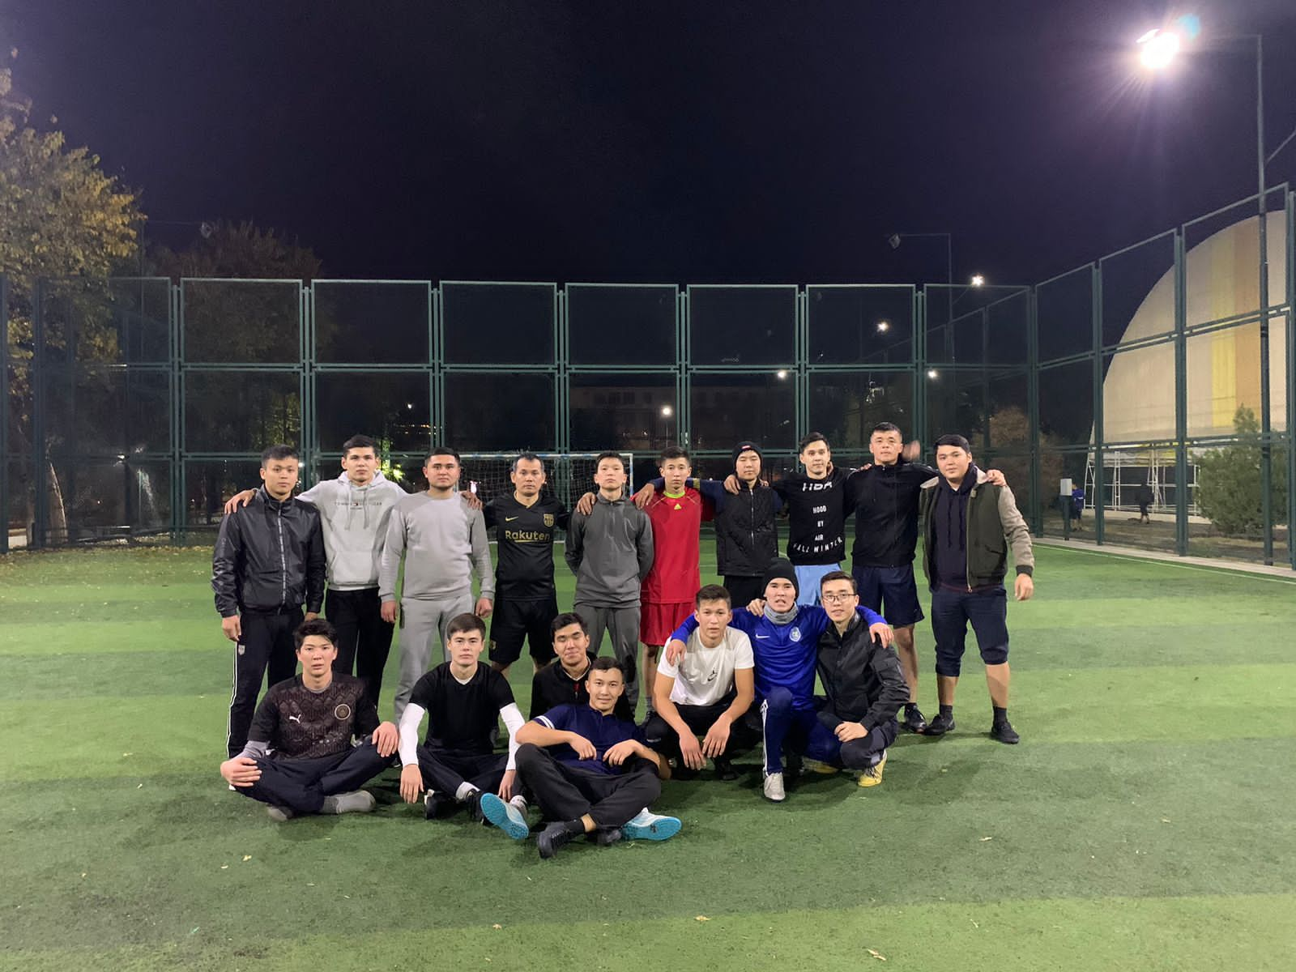
Since the football competitions on the formation of a healthy lifestyle were held on the initiative of the senior lecturer of the department "Energy and non-traditional energy systems" Tokenov N.P. and teacher Smagulov K. Zh.

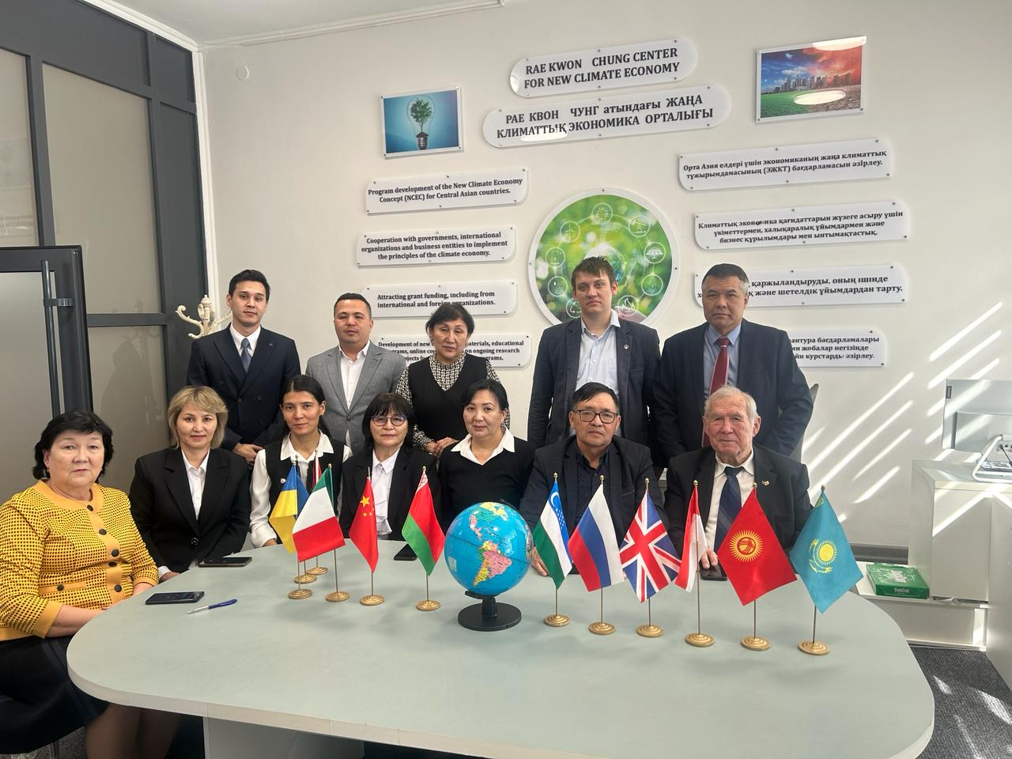
Since the grand opening of the international winter school "Sustainable Energy Development in Modern Realities" on the initiative of the Department of Energy and Non-traditional Energy Systems

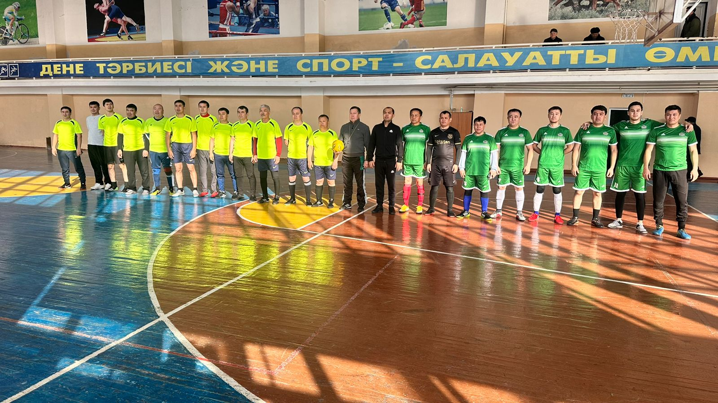
Since the performance at the final competitions in the University Spartakiad

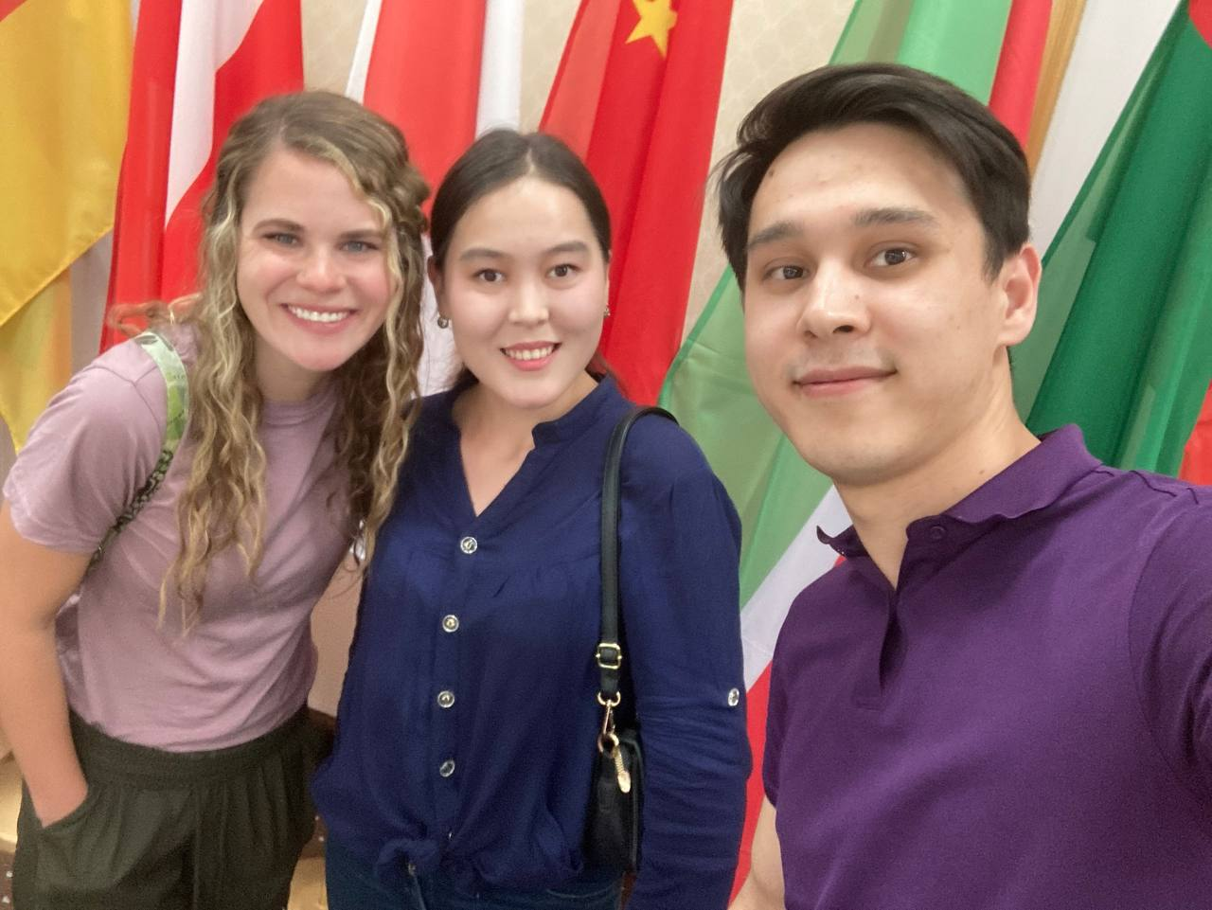
Since the moment of participation in the conference of the teacher Smagulov K. Zh, organized by the Center for the Development of Languages,

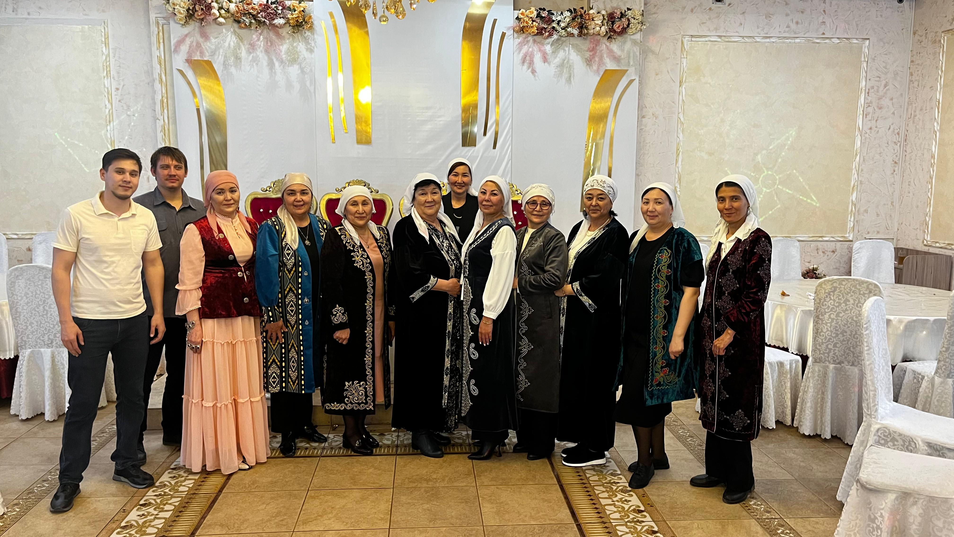
Since the event dedicated to the Nauryz holiday, organized by the Department of Energy and Non-traditional Energy Systems

