The teachers of the Department of Information and Communication Technologies:
- Tastanbekova Bayan Omirzakhovna – Lecturer
- Turganbekova Madina Myrzabekkyzy – Senior Lecturer
- Mombekova Sandugash Seisembayevna – Senior Lecturer
- Bibulova Dana Abdusattarovna – Senior Lecturer
- Karzhaubekova Samal Seilbekovna – Lecturer
together with the students of group IP-25-11K1 organized The main purpose of the event was to promote kindness and compassion in society, to develop students’ moral values, and to support people who are in need of help.Charity is not only about providing material assistance, but also about showing care, attention, and warmth of heart. During the event, the students demonstrated unity, respect for elders, and care for others.The joint work of teachers and students became a vivid example of kindness, solidarity, and humanity. Being caring toward society and extending a helping hand to those in need is the duty of every person.Such educational events help develop responsibility, compassion, and moral values among young people. May our hearts always be filled with kindness and mercy! 🤝✨
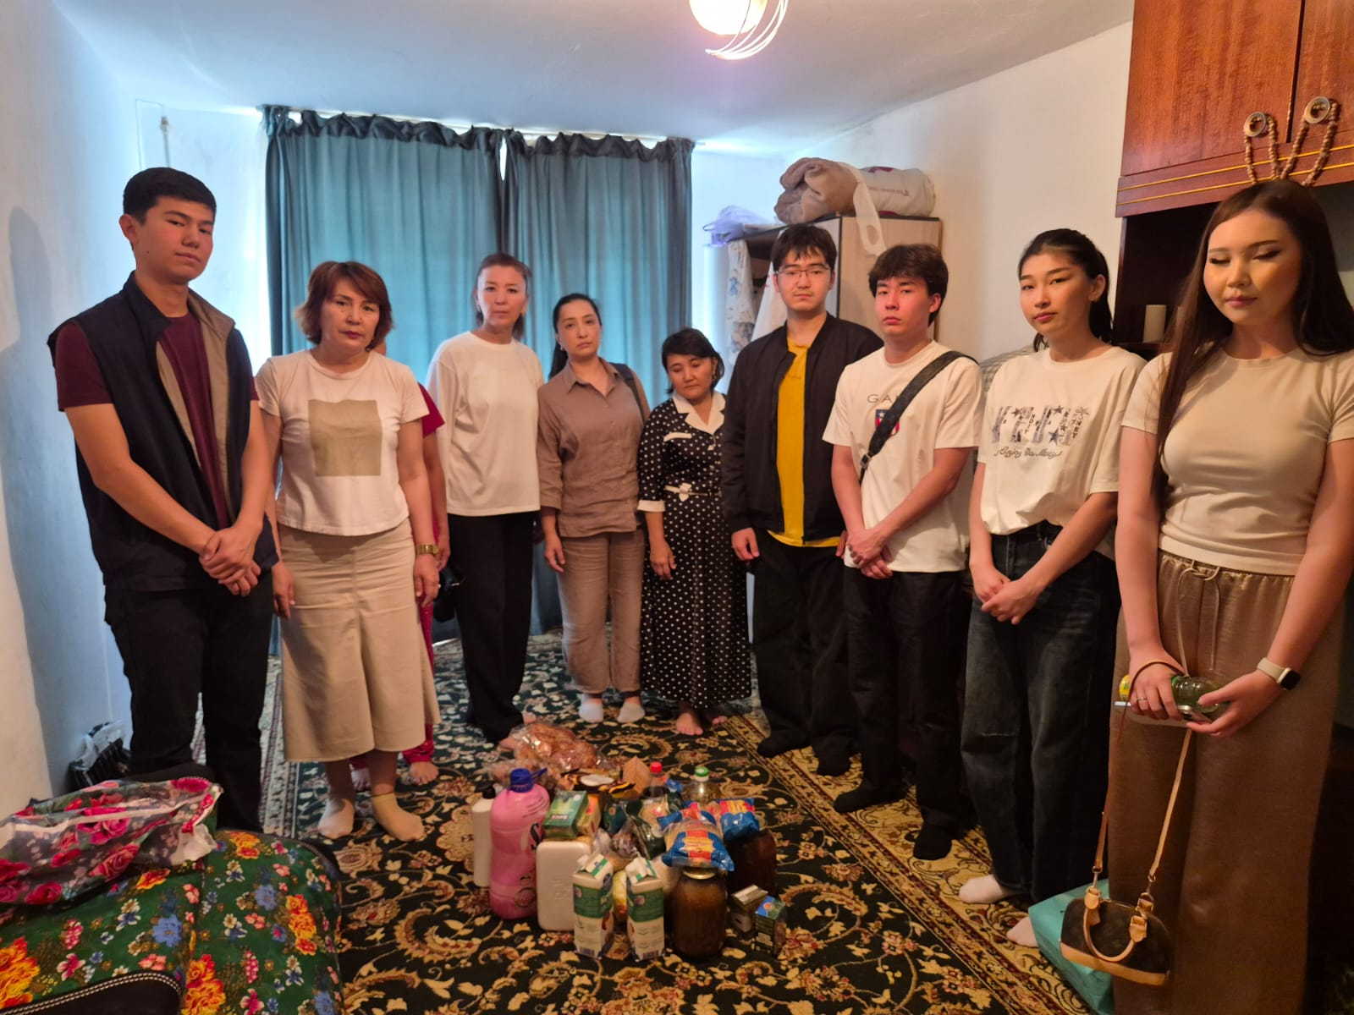

窗体顶端



