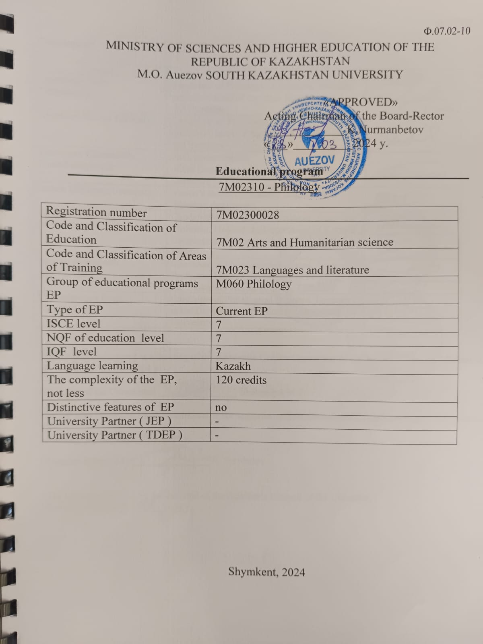
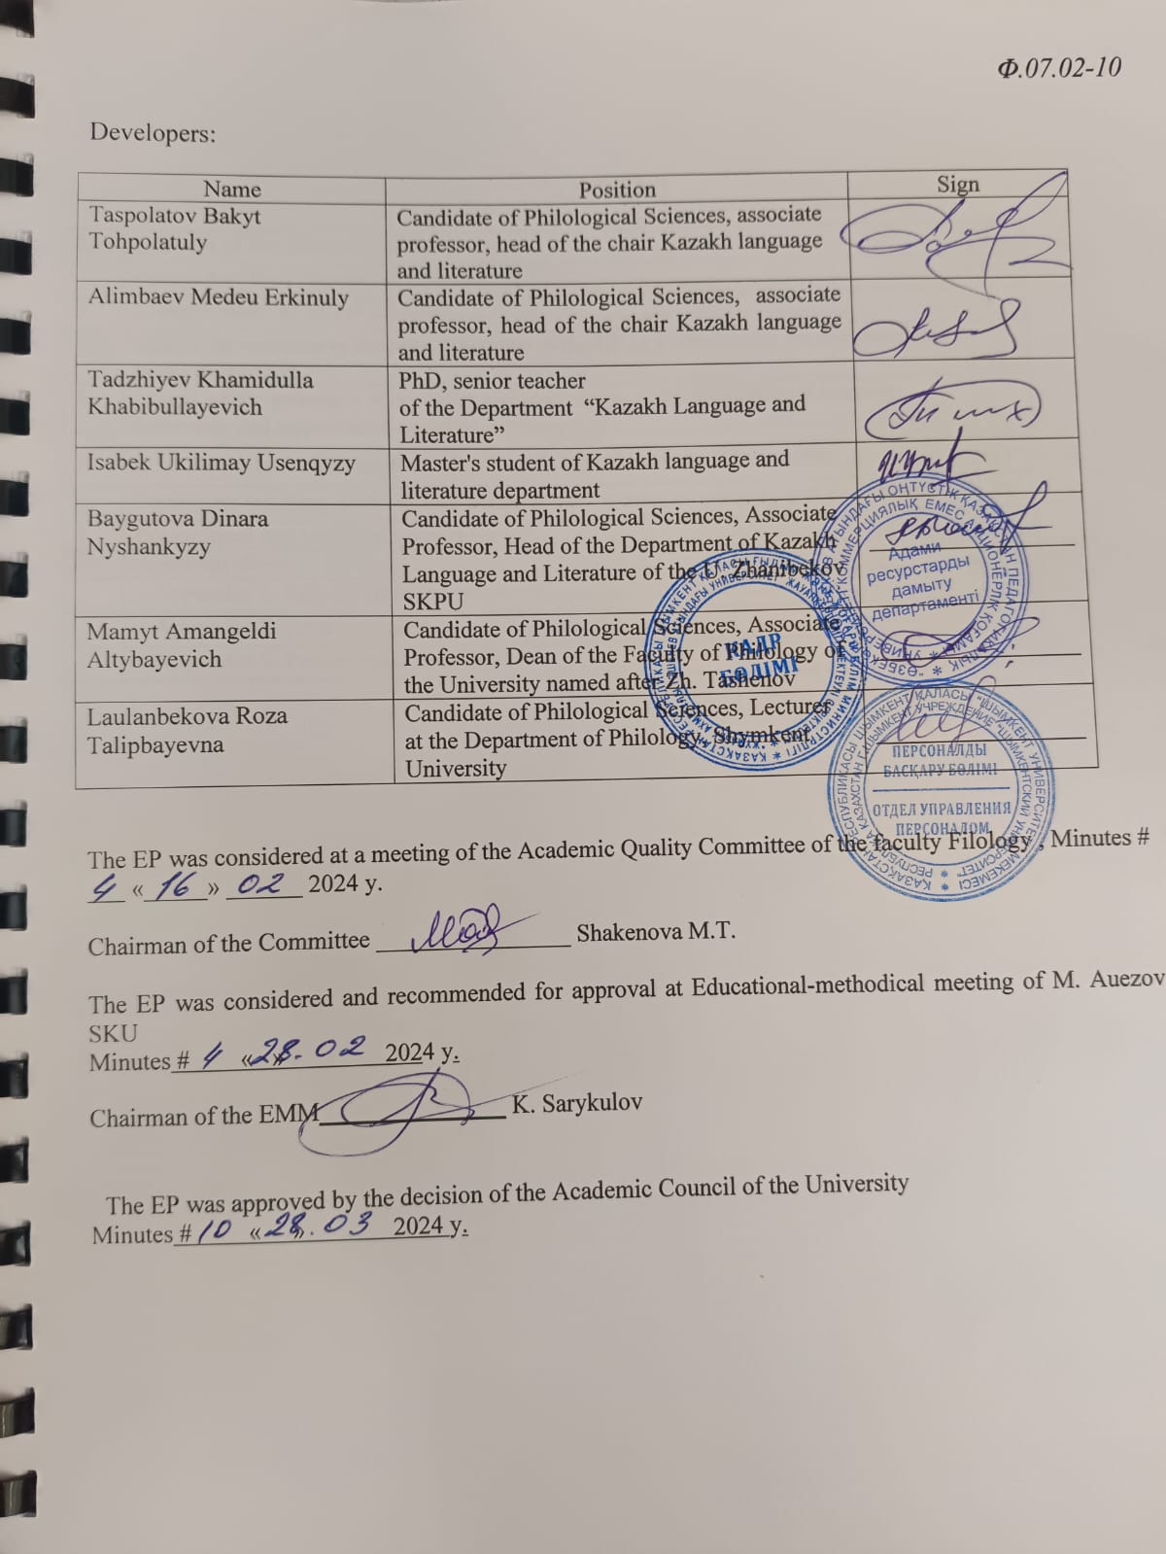

CONTENT

 | CONCEPT OF THE EDUCATIONAL PROGRAM................................................. | 4
 | PASSPORT OF THE EDUCATIONAL PROGRAM..................................................... | 6
 | Competencies of an EP graduate................................... | 9
3.1 | Matrix for correlating learning outcomes in the EP as a whole with the competencies being developed
4. | Matrix of the influence of modules and disciplines on the formation of learning outcomes and information on labor intensity.......................... | 12
5. | Summary table reflecting the volume of disbursed loans by EP modules............................................................................. | 34
6. | Strategies, teaching methods and artificial intelligence, monitoring and assessment.... | 35
7. | Educational and resource support for EP……………………....................................... | 36
 | Approval sheet...................................................................................................... | 37
 | Appendix 1. Review from the employer ....................................................................
 | Appendix 2. Expert opinion.........................................................................................
 | Appendix 3. Professional standards

1 Concept of The Educational program

Mission of the University | We are focused on generating new competencies, training a leader who translates research thinking and culture.
University Values | - Openness - open to change, innovation and cooperation.  - Creativity - generates ideas, develops them and turns them into values  - Academic freedom - free to choose, develop and act.  - Partnership - creates trust and support in a relationship where everyone wins.  - Social responsibility - ready to fulfill obligations, make decisions and be responsible for their results.
Graduate Model | - Deep subject knowledge, their application and continuous expansion in professional activity  - Information and digital literacy and mobility  - Research skills, creativity and emotional intelligence  - Entrepreneurship, independence and responsibility for their activities and well-being  - Global and national citizenship, tolerance to cultures and languages
Uniqueness of the EP | Тhe program was developed in accordance with the Atlas of New Professions and Competencies, and is aimed at training competent specialists for transport and logistics and scientific and pedagogical structures who are able to organize and manage the activities of a structural enterprise, independently determine the goals of professional activity, choose and justify methods and means to achieve them.
Academic Integrity and Ethics Policy | The university has taken measures to maintain academic integrity and academic freedom, protection from any type of intolerance and discrimination:  • Rules of academic integrity (order No. 212 of October 10, 2022);  • Anti-corruption standard (order No. 221 n/a dated 12/07/2021).  • Code of Ethics (Order No. 212 of October 10, 2022)
Regulatory and legal framework for the development of EP | 1.Law of the Republic of Kazakhstan “On Education”;  2. Model rules for the activities of educational organizations implementing educational programs of higher and (or) postgraduate education, approved by order of the Ministry of Education and Science of the Republic of Kazakhstan dated October 30, 2018 No. 595 with amendments and additions dated December 29, 2021. No. 614  3. Standard rules for admission to training in educational organizations implementing educational programs of higher and postgraduate education, approved by order of the Ministry of Education and Science of the Republic of Kazakhstan dated October 31, 2018 No. 600 with amendments and additions dated 06/02/2023. No. 252  4. State mandatory standards for higher and postgraduate education, approved by order of the Ministry of Education and Science of July 20, 2022 No. 2;  5. Rules for organizing the educational process in credit technology of education, approved by order of the Ministry of Education and Science of the Republic of Kazakhstan dated April 20, 2011 No. 152; with changes and additions from 09/23/2022. No. 79  6. Qualification reference book for positions of managers, specialists and other employees, approved by order of the Minister of Labor and Social Protection of the Population of the Republic of Kazakhstan dated December 30, 2020 No. 553.  7. Methodological recommendations for introducing ECTS principles into the educational process and expanding academic freedom. Appendix to the order of the Minister of Science and Higher Education. of the Republic of Kazakhstan dated February 12, 2024 No. 57  8. Guidelines for the development of educational programs for higher and postgraduate education, Appendix 1 to the order of the Director of the National Center for the Development of Higher Education of the Ministry of Education and Science of the Republic of Kazakhstan dated May 4, 2023 No. 601 н/қ
Organization of the educational process | - Implementation of the principles of the Bologna Process  - Student-centered learning  - Availability  - Inclusivity
Quality assurance of EP | - Internal quality assurance system  - Involvement of stakeholders in the development of the EP and its evaluation  - Systematic monitoring  - Updating the content (updating)
Requirements for applicants | They are established in accordance with the Standard Rules for admission to training in educational organizations implementing educational programs of higher and postgraduate education by order of the Ministry of Education and Science of the Republic of Kazakhstan No. 600 dated October 31, 2018, with changes and additions dated June 2, 2023. No. 252
Conditions for the implementation of educational programs (EP) for persons with disabilities and special educational needs(SSN) | For students with SEN (special educational needs) and persons with disabilities (PSI), tactile PVC tiles, specially equipped toilets, a mnemonic diagram, and shower bars have been installed in educational buildings and student dormitories. Special parking spaces have been created. Crawler lift installed. There are desks for people with limited mobility (PLM), signs indicating the direction of movement, ramps. In the educational buildings (main building, building No. 8) there are 2 rooms with six working places adapted for users with disorders of the musculoskeletal system (DMS).For visually impaired users, the SARA™ CE Machine (2 pcs.) is available for scanning and reading books. The library website is adapted for the visually impaired. There is a special NVDA audio program with a service. The JIC website http://lib.ukgu.kz/ is open 24/7.  An individual differentiated approach is provided for all types of classes and in the organization of the educational process.

2. Passport of The Educational program

Purpose of the EP | Preparation of masters linguistics corresponding to high standards of education and science, in demand the market, with critical thinking, able to navigate the information environment, solve problems in scientific, educational sphere.
Tasks of the EP | - the formation of systemic skills associated with solving problems of generalization and analysis of scientific information, as well as the generation of new philological knowledge in the context of humanitarian knowledge.  - providing to master new research technologies and methods.  - formation of students the ability to consciously choose the direction of future professional activity, where optimal employment and career growth are possible.  - acquisition of in-depth knowledge in modern philology and the ability to carry out a critical analysis of the state of modern scientific research.  - implementation of scientific projects, which requires in-depth theoretical knowledge, the ability to plan and carry out scientific research within the framework of modern scientific paradigms and research technologies that provide an original result.  - the formation of socially responsible behavior in society, understanding the importance of professional ethical standards and adherence to these standards;  - providing skills and abilities for lifelong learning that will allow them to successfully adapt to changing conditions throughout their professional career;  - providing conditions for acquiring a high general intellectual level of development, mastering a competent and developed speech, culture of thinking and skills of the scientific organization of labor in the field of linguistics and literary criticism.  - the formation of the competitiveness of graduates in the field of philology, to ensure the possibility of their fastest possible employment in their specialty or continuing their studies at the next stages of education;  -Establishing conditions for the development of in-demand knowledge and skills, as well as a conscious attitude towards enhancing the welfare of society and conserving the planet within the framework of the SDGs
Harmonization of EP | • 7 th level of the National Qualifications Framework of the Republic of Kazakhstan;  • Dublin descriptors of the 7th level of qualification;  • 2 cycle of a Framework for Qualification of the European Higher Education Area);  • 7th Level of European Qualification Framework for Life long Learning).
Connection of the EP with the professional sphere | Areas of professional activity include research, practical and entrepreneurial activities
Name of the degree awarded | After successful completion of this educational program, the graduate is awarded the degree of Master of the educational program 7M02310 - "Philology".
List of qualifications and positions | A graduate in this EP is awarded the degree of Master of Arts in the educational program 7M02310 - "Philology". Master in the specialty 7M02310 - "Philology" can hold primary positions in the field of journalism, as a teacher in universities, research institutions, design organizations without presenting requirements for work experience in accordance with the qualification requirements of the Qualification Directory for the positions of managers, specialists and other employees, approved by the order of the Minister of Labor and Social Protection of the Population of the Republic of Kazakhstan dated May 21, 2012 № 201-ө-м
Field of professional activity | - teaching philological disciplines in educational institutions;  - carrying out research work in the field of philology;  - management of office work in the state and Russian languages ​​in institutions;  - making transfers;  - conducting trainings on the culture of speech; master classes in negotiation;  - carrying out a forensic linguistic examination;
Objects of professional activity | - the organization of secondary education of all types and types, regardless of the form of ownership and departmental subordination;  - the organization of vocational education.  - higher education institutions;  - research institutes;  - institutes for advanced training and retraining of employees of the education system;  - authorized and local executive bodies in the field of education.
Subjects of professional activity | - organization of training and education of students using innovative psychological and pedagogical methods and means;  - organization of research activities in the framework of the educational process of the university, the organization of secondary education, the organization of vocational education;  - activities of authorized and local executive bodies to support innovative processes in the management of the educational system.
Types of professional activity | - organizations of higher and secondary vocational education,  - research centers,  - editorial offices of newspapers, radio and TV,  - government authorities
Learning outcomes | LO1. To design and carry out comprehensive research based on a systematic scientific worldview and the use of knowledge in the field of history and philosophy of science. Integrate accumulated knowledge on the basis of various scientific directions, implements research positions in interdisciplinary communication, based on an understanding of contradictions and socio-economic consequences of globalization processes;  LO2. Communicate in a professional environment in a foreign language, use original literary sources, communicate your original ideas to the scientific community on the basis of the principle of academic honesty;  LO3. Analyze the basics of the methodology of scientific cognition using basic techniques of comparing the methods of nomination in different languages, current trends, current problems, including linguistic aspects of language, innovative approaches in teaching, demonstrating fundamental knowledge in the field of philology;  LO4. Conduct linguistic expertise and analysis of the socio-economic context using general and particular methods of analysis, modeling and information generation. orient yourself in the directions of modern linguistics;  LO5. To systematize modern trends of linguistic, psychological and pedagogical sciences in professional activity. To qualify language material using various research methods focused on a particular new linguistic direction, concept.  LO6. Critically evaluate external and internal factors affecting the development of semantics and linguistics, languages of the world, including the Kazakh language, as well as apply in practice semantic and structural features, critical evaluation, modal, connotation functions of phraseological units used in linguistics.
3.Competences оf an EP graduate
GENERAL COMPETENCES (SOFT SKILLS) (Behavioral skills and personal qualities)
GC 1. Competence in managing one's literacy | GC 1.1. Strive for professional and personal growth throughout your life.  GC 1.2. Constantly update their knowledge within the chosen trajectory and in the conditions of interdisciplinarity, carry out further training with a high degree of independence and self-regulation.  GC 1.3. To be capable of reflection, an objective assessment of one's achievements, an awareness of the need to form new competencies and continue education in doctoral studies.
GC 2. Language competence | GC 2.1. The ability to possess a sufficient level of communication in the professional field in the state, Russian and foreign languages for negotiating and business correspondence.  GC 2.2. The ability of mastering the skills of mediation and intercultural understanding.
GC 3. Mathematical competence and competence in the field of science | GC 3.1. The ability to interpret the methods of mathematical analysis and modeling for solving applied problems in the field of study.  GC 3.2. The ability to plan the setting of scientific experiments, integrate and implement the results of scientific research in the professional field.  GC 3.3. The ability to analyze and comprehend modern methods of pedagogical and psychological science and apply them in pedagogical activity.
GC 4. Digital competence, technological literacy | GC 4.1. The ability to confidently use modern information and digital technologies, artificial intelligence systems for work, leisure and communications.  GC 4.2. Proficiency in the use, recovery, evaluation, storage, production, presentation and exchange of information in a wide range of digital devices.  GC 4.3. Ability to confidently use global information resources and apply technological literacy in research and computational and analytical activities.
GC 5. Personal, social and academic competencies | GC 5.1. Possession of the norms of business ethics, social and ethical values and focus on them in professional activities.  GC 5.2. Formation of a personality capable of mobility in the modern world, critical thinking and physical self-improvement.  GC 5.3. Ability to work in a team, correctly, clearly and reasonably defend one's position during discussions and make decisions of a professional nature.  GC 5.4. Ability to adequately navigate in various social spheres of activity and in conditions of uncertainty  GC 5.5. Ability to find compromises, correlate your opinion with the opinion of the team.
GC 6. Entrepreneurial competence | GC 6.1. The manifestation of leadership qualities and the ability to have a positive impact on others, to lead a team.  GC 6.2. The ability to create conditions for the development of creative and entrepreneurial skills of the team.  GC 6.3. The ability to work in a mode of uncertainty and rapidly changing task conditions, make decisions, respond to changing working conditions, allocate resources and manage your time.  GC 6.4. Ability to work with consumer needs.
GC 7. Cultural awareness and ability to express yourself | GC 7.1. The ability to show worldview, civil and moral positions.  GC 7.2. The ability to be tolerant of the traditions and culture of the peoples of the world, to have high spiritual qualities.
PROFESSIONAL COMPETENCIES (HARD SKILLS)
Theoretical knowledge, practical skills and abilities specific to this field | PC1 the ability to be able to identify the individual abilities of undergraduates and build an educational process taking them into account;
 | PC2 the ability to formulate and solve tasks related to the implementation of organizational and managerial functions, the ability to use the methods of the studied sciences for their implementation;
 | PC3 the ability to organize the work of performers, make management decisions;
 | PC4 the ability to prepare analytical information for decision-making for the topic of the thesis;
 | PC5 the ability to understand the main problems in their subject area, choose methods and means of solving them;
 | PC6 ability to prepare and conduct scientific seminars, conferences, prepare and edit scientific publications;
 | PC7 the ability to demonstrate in-depth knowledge in a selected specific area of ​​philology;
 | PC8 the ability to demonstrate knowledge of the modern primary paradigm in the field of philology and the dynamics of its development, the system of methodological principles and methodological techniques of philological research.

3.1 Matrix for correlating learning outcomes in the EP as a whole with the competencies
being developed

 | LO 1 | LO 2 | LO 3 | LO 4 | LO 5 | LO 6
GC 1 | + |  | + |  | +
GC 2 |  | + |  | + |  | +
GC 3 | + |  | + |  | + | +
GC 4 |  | + | + |  | +
GC 5 | + |  |  | + |  | +
GC 6 |  | + |  | + |  | +
GC 7 | + | + | + |  |  | +
PC1 |  |  | + | + | + | +
PC 2 | + |  | + |  | +
PC 3 | + | + |  | +
PC 4 |  |  | + | + | + | +
PC 5 | + |  | + |  | + | +
PC 6 | + |  |  | +
PC 7 |  |  | + | + | + | +
PC 8 | + |  | + | +

4.MATRIX THE INFLUENCE OF DISCIPLINES ON THE FORMATION OF LEARNING OUTCOMES AND INFORMATION
ON LABOR INTENSITY

№ | Module name | cycle | compo nent | Name of discipline | Brief description of the discipline | Quan-ty loans | The formed educational outcomes (codes)
 |  |  |  |  |  |  | LО1 | LО2 | LО3 | LО4 | LО5 | LО6
1 | Module of scientific | BD | UC | History and Philosophy of Science | The aim: Forms knowledge about the history and theory of science, about the laws of the development of science and thestructure of scientific knowledge, about the methods ofconducting scientific research, about the role of science in the development of society.  Content:  Examines the problems of the  phenomenon of science as a  subject of philosophical analysis.  Raises and characterizes the philosophical problems of specific sciences, the essence of communication technologies of the XXI century and their role in modern science. | 4 | ѵ
 | and pedagogical
 | training
2 |  | BD | UC | Foreign Language | The aim:  Possession of the main types of reading original foreign sources with varying degrees of content coverage.  Content:  Knowledge of the main types  of reading foreign-language  original sources with varying  degrees of content coverage.  Production of written reports  on scientific topics in the  specialty: abstracts on the  topic of scientific research, the implementation of abstracting original sources in a foreign language, annotation of scientific text, summary | 4 |  | ѵ
 |  |  |  | (Professional)
3 |  | BD | UC | Psychology of Management | The aim: It characterizes the main approaches and principles of modern psychological science, which are necessary for highly qualified specialists in their professional activities.  Content:  Fundamental psychological concepts, scientific understanding of  psychological science, methods of psychological research are systematized. Application of methods and trends of psychological personality research. | 4 |  |  |  |  | ѵ
4 | Methodological foundations of teaching | BD | UC | Higher School Pedagogy | Purpose: Formation of master's students' skills of planning and organization of the educational and scientific process based on the principles of extrapolation of student-centered, innovative (including circus) and practice-oriented teaching methods and technologies, preparing them for academic and scientific-pedagogical activity at WIPO  Content: Forms ideas on designing and realization of scientific and pedagogical activity in higher education institution on the basis of knowledge about modern paradigms of higher education in Kazakhstan. Understands the peculiarities of teaching and education of students with the use of innovative technologies. Characterizes the system of higher professional education in Kazakhstan. Possesses the methodology of pedagogical science. Understands the importance of professional competence of a teacher in scientific and pedagogical activity, analyzes its structure. Demonstrates the skills of analysis, planning, organization of the educational process on the basis of credit technology of teaching. Uses methods and forms of teaching, educational technology in higher school. Higher school is considered as a social institute of education and formation of specialist's personality. | 4 |  |  | ѵ |  | ѵ
5 |  | PD | UC | Teaching Metods of Special Disciplines | The aim: To give the opportunity to formalize training as a productive professional activity.  Content:  Analyzes a set of knowledge, skills and techniques, rules that allow to increase the effectiveness of solving tasks aimed at teaching special disciplines of linguistics. Applies methodological aspects and innovative approaches of student-centered learning as a complex of active and interactive methods that allow you to design learning as a productive professional activity. | 5 |  |  | ѵ |  | ѵ
6 |  |  |  | Pedagogical Practice | The aim: The combination of new experience gained in theoretical knowledge in the educational process with practical skills in professional activities.  Content:  It consolidates theoretical knowledge, new methods obtained in the course of training, acquisition of practical skills, competencies and experience of professional activity in philology, as well as the development of best practices. Demonstrates fundamental knowledge and skills of working with the media by preparing analytical materials and publications in  various journals. | 4
7 | The main problems of linguistics | PD | EC | Functional Grammar | The aim: A comprehensive analysis of the work of language tools that serve to convey the meaning of a word.  Content:  Analyzes the modern functions of the units of the language structure, the study of grammar of this type in a single system of means belonging to different language levels, the classification of the laws of interaction of grammatical units, vocabulary and context, the functioning of linguistic means serving to convey the meaning of the utterance. Using the possibilities of integration of structural- system and communicative aspects of the problem of language function. | 6 |  |  | ѵ |  | ѵ
8 | The main problems of linguistics | PD | EC | Semasiology and Onomasiology | The aim: The study of the basic scientific concepts and linguistic materials of semasiology and onomasiology.  Content:  The study of the basic scientific concepts of semasiology and methods of analysis of linguistic material, onomasiology at the level of language-system and onomasiology at the level of language-speech.  Identification of the features of methodological principles and methodological techniques in theparadigm of onomasiological knowledge.  Analysis of the fundamentals of the methodology of scientific cognition by the basic techniques of comparing the methods of nomination in different languages. | 7 |  |  | ѵ |  | ѵ
9 |  | BD | EC | New Directions of Linguistics | The aim: Analysis of new directions of Kazakh language education and their place in the history of linguistics.  Content:  Analyzes the principles of modern linguistics and the specifics of their implementation in linguistics, the essence of new directions of Kazakh linguistics of the XX-XXI centuries and their place in the history of Kazakh philology. Compares the basic concepts of new linguistic disciplines in various directions and concepts of modern philology in order to further apply this knowledge when choosing initial theoretical positions in dissertation research | 6 |  |  | ѵ | ѵ | ѵ
10 |  | BD | EC | History of Aesthetic Thought and Linguistics | The aim: Analysis of the problems of the aesthetic field of thinking and the aesthetic properties of consciousness.  Content:The study of modern theoretical and applied problems of the Kazakh language as an expression of national thinking. Considers the problems of the aesthetic field of thinking as the need to analyze the aesthetic properties of consciousness, the process of the birth of thought from the personal understanding of the possibilities and the development of the rules of the art of thinking. | 6 |  |  | ѵ |  | ѵ
11 |  | РD | EC | Cognitive grammar of the Kazakh language. | The aim: Chronological review from the period of formation to the present. Show the anthropotopic nature of grammatical categories in the Kazakh language.  Content:  The formation of grammatical categories is influenced by a person's personality, attitude, anthropocentricity of participants in a communicative act, and an objective situation. As a result, grammatical categories are formed by linguistic units in different forms. | 5 |  |  |  |  | ѵ
12 |  | РD | EC | Cognitive vocabulary of the Kazakh language. | The aim: Explanation of the conceptual image of the world based on the semantic relationships of lexical units in the language.  Content:  The conceptual image of the world is also explained on the basis of semantic connections of lexical units in the language. For example, human walking, clock walking; heartbeat stops, clock stops.  Linguistic knowledge is stored together with extralinguistic knowledge in a semantic network, since conceptual connections are made on the basis of lexical meanings.
13 |  |  |  | Research Practice | The aim: The combination of new experience gained in theoretical knowledge in the educational process with practical skills in professional activities.  Content:  Forms the mastery of the skills of independent research and scientific and pedagogical activity, which require a broad understanding and the ability to operate with the methodology of scientific creativity. Evaluates the ability to formulate and solve problems that arise in the course of research and teaching activities and require in-depth professional knowledge. Makes the choice of the necessary methods based on the tasks of a specific study. | 6 | ѵ |  |  |  |  | ѵ
14 | Theoretical and methodological foundations of linguistics | PD | EC | Phraseological Semantics of the Kazakh Language | The aim: Assessment of the semantic structure and grammatical nature of phraseological units of the Kazakh language.  Content:  Evaluates the semantic structure,grammatical character, system of formation and transformation, creation of phraseological units. Practical application of semantic and structural features, critical evaluation, modal, connotational functions of phraseological units used in  linguistics. Focuses on the surveys of the development, replenishment of the vocabulary of the Kazakh language, draws attention to the change in the meaning of the word, the composition, types of phraseological units, the principles of compiling dictionaries and ways of compiling them. | 6 |  |  |  |  |  | ѵ
15 |  | PD | EC | Linguistic Experiment in Semantics | The aim: Determination of the laws of semasiology in linguistics and features of the Kazakh language, ways of conveying meaning in the Kazakh language.  Content:  The use of the main method of studying the signified word in lexical semantics as  introspection, the semasiologist's observation of those mental objects and processes that are associated with this word in his own consciousness. An experiment in semantics serves to confirm or refute semantic hypotheses put forward on the basis of observations of usages that are recognized as correct. Identification of linguistic patterns of semasiology and features of the Kazakh language from theoretical and practical studies, ways of transmitting meaning in the Kazakh language. | 6 |  |  |  |  |  | ѵ
16 |  | BD | EC | Directions and Types of Development of Modern Kazakh Stylistics | The aim: Comparison of stylistic norms of modern linguistics, stylistic resources of the Kazakh language at all levels of the language system.  Content:  The use of classical and new methods of stylistic analysis of the text and the development of the Kazakh language. The ability to edit texts of intercultural communication, language analysis, compares interpretations of texts of various functional styles, classifies types of speech, performs stylistic analysis by model, skills of high intellectual honesty in research activities. | 4 |  |  |  |  | ѵ | ѵ
17 |  | BD | EC | Problems of Graphic Linguistics and Latin Graphics | The aim: The study of the history of graphic linguistics and Latin graphics of writing, written signs and written language.  Content:  Evaluates the main areas of graphic linguistics and Latin graphics as a general science of writing – epigraphy, paleography, graphics, spelling and graphemics. Classifies the distinctive features of each direction, their object, subject, goals and objectives of linguistic research. | 4 |  |  |  |  | ѵ | ѵ
18 |  | BD | EC | Kazakh culture of the word. | The aim: Determination of communicative-pragmatic, linguistic and cultural foundations of Kazakh literature as a theoretical subject. And also to look for the theoretical foundations of an objective definition of the communicative qualities of words.  Content:  The current state of the subject of Kazakh verbal culture is primarily connected with the past and the level of development of Kazakh linguistics, with the tendency of traditional paradigms in general linguistics to shift into new paradigms. He makes a great contribution to the development of the people, relying on its traditional norms, on the age-old language. | 5 |  |  |  |  | ѵ
19 |  | BD | EC | The culture of using words. | The aim: The study of the norms of the literary language, characteristic of oral forms  Content:  Mastering the norms of the literary language characteristic of oral forms, the ability to use language techniques in accordance with the goals of the expressed thought, to show culture and ethics in speech.  The use of dialectisms, simple, rude words, barbarities in speech, it is inappropriate to talk a lot, repeat the same opinion, refer to oneself, speak loftily, mix bodily movements does not belong to the "culture of words".
20 |  | BD | EC | Theory and practice of anthroponymy. | The aim: The study of the theory and practice of the anthroponymic system in linguistics  Content:  A scientific review of the historical and linguistic nature of the study of the system of anthroponymy in Kazakh linguistics is given. Special attention is paid to the linguocultural, social orientation of the definition of the national nature of Kazakh anthroponyms. | 6 |  |  |  |  | ѵ
21 |  | BD | EC | Theory and practice of toponymy. | The aim: The study of the theory and practice of the thoponymic system in linguistics  Content:  The results, theoretical conclusions and principles of onomastic research are considered. The place of onomastics in linguistics, its features, their word-forming properties and trends in the formation of toponyms are considered.
22 | Linguistics- grammatical foundations of the language | PD | EC | General Semantics and Meaning of Language Units | The aim: Clarification of the concept of meaning in linguistics. Systematization of the main semantic trends and schools.  Content:  Clarifies the concept of meaning existing in linguistics. Systematizes the typology and the main semantic directions and schools. Defines new methods of studying semantics develope in  psycholinguistics, cognitive linguistics, etc. Understanding of language units in terms of the specifics of their pragmatics. Forms an idea of the linguistic meaning and components of lexico-semantic information (significative, denotative, virtual component) | 5 |  |  |  |  | ѵ
23 | Linguistics- grammatical foundations of the language | PD | EC | Pragmatics of Language Units | The aim: The study of topical issues of linguistics and pragmatics, semiotic aspects of the language.  Content:  Analyzes the current problems of linguistics and pragmatics as one of the semiotic aspects of language, as well as the interaction of speaking people, reveals the role of the speaker and listener in the communication process, examines the theory of relevance of linguistic and semiotic units, the pragmatics ofintercultural  communication. Forms an idea of the specifics of various linguistic units due to their pragmatics, considers the allocation of various components of meaning: significative, denotative, pragmatic | 7 |  |  |  |  | ѵ
24 |  | PD | EC | Organization and Planning of Linguistic Research | The aim: Identification of promising areas of scientific research in the field of linguistics, determination of the theoretical and practical significance of the organization and planning of scientific research.  Content:  Forms methodological support for scientific research, selects such techniques and research methods that allow solving the task set for research. Identifies promising areas of scientific research, substantiates the relevance, theoretical and practical significance of the problem under study. Analyzes hypotheses, conducts applied research. Introduces the methodology and methodology of scientific research. | 4 |  |  | ѵ | ѵ
25 |  | PD | EC | Linguo-Cultural Analysis of the Language | The aim: Analysis of the language as a cultural code of the nation, a means of communication and knowledge in the linguistics of the XXI century.  Content:  Studies linguistics of the XXI century, analyzing language as the cultural code of the nation, a means of communication and cognition. Illustrates the history of the formation of linguoculturology as a science. Forms an idea of the interaction of language and culture, influencing the development of language, revealing the mentality of the people and their culture  through language on the basis of artistic and expressive means. | 4 |  |  | ѵ | ѵ
26 | Linguistics and scientific discourse | BD | EC | The Text Syntax | The aim: The study of the syntactic (including intonational-rhythmic) organization of the text based on the laws of thinking  Content:  Studies the syntactic organization of the whole text: the relationship between independent sentences, text units (sentence, prose stanza – a complex syntactic whole, fragment, etc.), the whole speech work. The syntactic text explores the syntactic (including intonation- rhythmic) organization of the text, relying, of course, on the laws of thinking. | 5 |  |  |  |  |  | ѵ
27 | Linguistics and scientific discourse | BD | EC | Theory of Intertextuality | The aim: Definition of the phenomenon of intertextuality in modern culture.  Content:  Defines the phenomenon of intertextuality in modern culture. Studies techniques of intertextual analysis. Comparison of modern theoretical concepts of the phenomenon of intertextuality. Examines the modern language in the context of intertextual connections, the phenomenon of types of inter- and intra-textual interactions, the terminology of modern literary criticism, forms the skills of scientific research. | 5 |  |  |  |  |  | ѵ
28 |  | PD | EC | The Language Structure of Scientific Discourse | The aim: Consideration of the features of oral and written types of scientific discourse, linguistic aspects of scientific communication.  Content:  Examines the features of the oral and written varieties of scientific discourse; linguistic aspects of scientific communication, constructs models of scientific communication to solve problems in the field of professional activity, analyzes modern theoretical and applied problems, formulates the basics of dialogical and monological scientific speech (in oral and written versions), techniques of speech activity for scientific communication. | 6 |  |  | ѵ |  | ѵ | ѵ
29 |  | PD | EC | Language Units and Categories in Diachrony and Synchrony | The aim: Formation of a scientific understanding of the basics of grammar in diachrony, criteria for distinguishing between synchronic and diachronic factors of the Kazakh language  Content: Forms a scientific understanding of the basics of grammar in diachrony, about the criteria for identifying synchronous and diachronic factors of the Kazakh language; analyzes the results of historical and philological research; systematizes knowledge, skills and abilities necessary for conducting professional activities, expands linguistic horizons, applies an analytical approach to the consideration of issues of a problematic nature; uses modern trends in understanding facts the history of language and the practical application of the skills of diachronous-synchronous analysis | 6 |  |  | ѵ |  | ѵ | ѵ
 | Module of scientific- research work and Final Certification |  |  | Research work of a master student, including passing an internship and completing a master's thesis | Be able to clearly state the research methods of research work and draw conclusions that correspond to the goals of practice. | 24 |  |  |  |  | ѵ | ѵ
 | Module of scientific- research work and Final Certification |  |  | Execution and Defense of Master`s Thesis | The doctoral student is able to manage the process of completing the dissertation work and achieving the goal, to achieve the goal, results and conclusions. He is able to correctly design a dissertation work. He has the theoretical foundations of linguistics, systematization of the information received; the structure and content of teaching lessons in accordance with the updated program; methods of developing indicators and criteria for evaluating the phenomenon under study. | 8 |  |  |  |  | ѵ | ѵ

5. Summary table reflecting the volume of disbursed loans by EP modules
Course of training | Semester | Amount of the mastered modules | Amount of the studied disciplines |  |  | Amount of KZ credits |  |  |  |  | Total in hours | Total creditsKZ | Amount
Course of training | Semester | Amount of the mastered modules | Compulsory component | University component | Optional component | Theore tical trainin g | Physic al Cultur e | Educat ional practic e | Industrial/ pedagogical/ research practice | final examinati on | Total in hours | Total creditsKZ | exa m | dif. cre dit
1 | 1 | 5 | - | 5 | 2 | 29 | - | - | - | - | 900 | 30 | 7 | 1
1 | 2 | 5 | - | 1 | 4 | 27 | - | - | 1 | - | 900 | 30 | 4 | 2
2 | 3 | 4 | - | - | 3 | 28 | - | - | 1 | - | 900 | 30 | 3 | 2
2 | 4 | 1 | - | - | - | 0 | - | - | - | - | 900 | 30 | - | 1
Total |  |  | - | 6 | 9 | 84 | - | - | 2 | - | 3600 | 120 | 14 | 6

6.Strategies, teaching methods and artificial intelligence, monitoring and assessment

Learning strategies | Student–centered learning: The student is the center of teaching/learning and an active participant in the learning and decision-making process.  Practice-oriented training: orientation to the development of practical skills.
Teaching methods | Conducting lectures, seminars, various types of practices with:  • the use of innovative technologies:  • problem-based learning;  • case study;  • work in a group and creative groups;  • discussions and dialogues, intellectual games, olympiads, quizzes;  • reflection methods, projects, benchmarking;  • Bloom's taxonomies;  • presentations;  • * rational and creative use of information sources:  • * multimedia training programs;  • * electronic textbooks;  • * digital resources.  • * machine learning methods  Organization of independent work of students, individual consultations.
Monitoring and evaluation of the achievability of learning outcomes | Current control on each topic of the discipline, control of knowledge in classroom and extracurricular classes (according to syllabus). Assessment forms:  • survey in the classroom;  • testing on the topics of the discipline;  • control works;  • protection of independent work;  • discussions;  • trainings;  • colloquiums;  • essays, etc.  Boundary control at least twice during one academic period within the framework of one academic discipline.  Intermediate certification is carried out in accordance with the working curriculum, academic calendar.  Forms of conducting:  • exam in the form of testing;  • oral examination;  • written exam;  • combined exam;  • project protection;  • protection of practice reports.  Final state certification.

7. Educational and resource support for EP

Information Resource Center | The structure of the Educational Information Center in cludes 6 subscriptions, 16 reading rooms, 2 electronic resourcecenters (ERC). The basis of the net work in frastructure of the Educational and Information Centeris 180 computer swith Internet access, 110 work stations, 6 interactive white boards, 2 video doubles, 1 video conferencing system, 3 A-4 format scanners, JIC software - AIBS "IRBIS-64" under MS Windows (basic set of 6 modules), stand-alone server for uninterruptedoperationin the IRBIS system.  The library fundisreflected in the electronic catalog a vailablet ousersonthesite http://lib.ukgu.kz on-line 24 hours 7 days a week.  The maticdatabasesoftheirowngeneration: "Almamater", "Proceedingsof SKSU scientists", "Electronicarchive" havebeencreated. Online access from any device 24/7 viathe external linkhttp://articles.ukgu.kz/ru/pps.  Catalog sare processe delectronically. EC consists of 9 databases: "Books", "Articles", "Periodicals", "Proceedings of the teaching staffof SKSU", "RareBooks", "Electronic Fund", "SKGU in Print", "Readers" and "SKU".  The EI Cprovidesitsusers with 3 options for accessing its own electronic information resources: from the “Electronic Catalog” terminal sinthecataloghallandin the EIC subdivisions; through the information network of the university for faculties and departments; remote lyon the library web site http://lib.ukgu.kz/.  Open access to international and republican resources: "Springer Link", "Polpred", "Web of Science", "EBSCO", "Epigraph", to electronic versions of scientific journal sin the public domain, "Zan", "RMEB", "Adebiet", Digitallibrary "Aknurpress", "Smart-kіtаr", "Kitаr.кz", etc.  For people with special need sand disabilities, the library web site has been adapted to the work of visually impairedusers
Material and technical base | Undergraduates of the specialty 7M02310 - Philology study in the academic building . №8 at 2 Tazhibaeva Street.  The total area of the academic building is 9506.2 sq.m., the usable area is 5627.2 sq.m.,  lecture halls - 3 (№.201- 125.82 sq.m., №.301-124,70 sq.m., №. 10 - 57.37 sq.m.),  classrooms for practical, seminar classes - 6 (№. 206 -31.72 sq.m., №. 207 - 14.76 sq.m., №. 407-31.08 sq.m., №. 314-33.32 sq.m., №. 104 – 35.50 sq.m., №. 106 – 50.12 sq.m.),  multimedia room 2 (№. 407 -31.08 sq.m., №. 206 -31.72 sq.m.),  computer classes - 2 (№. 106 - 50.12 sq.m, №. 409 - 32.14sq.m, ERC-118.8 sq.m).



