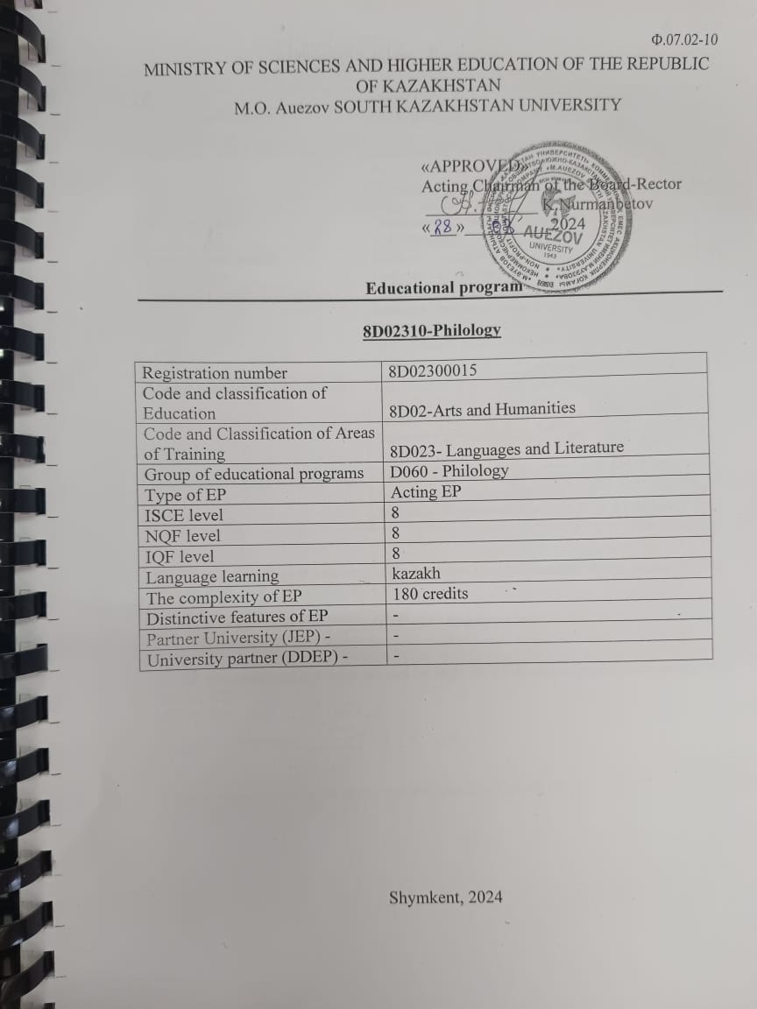

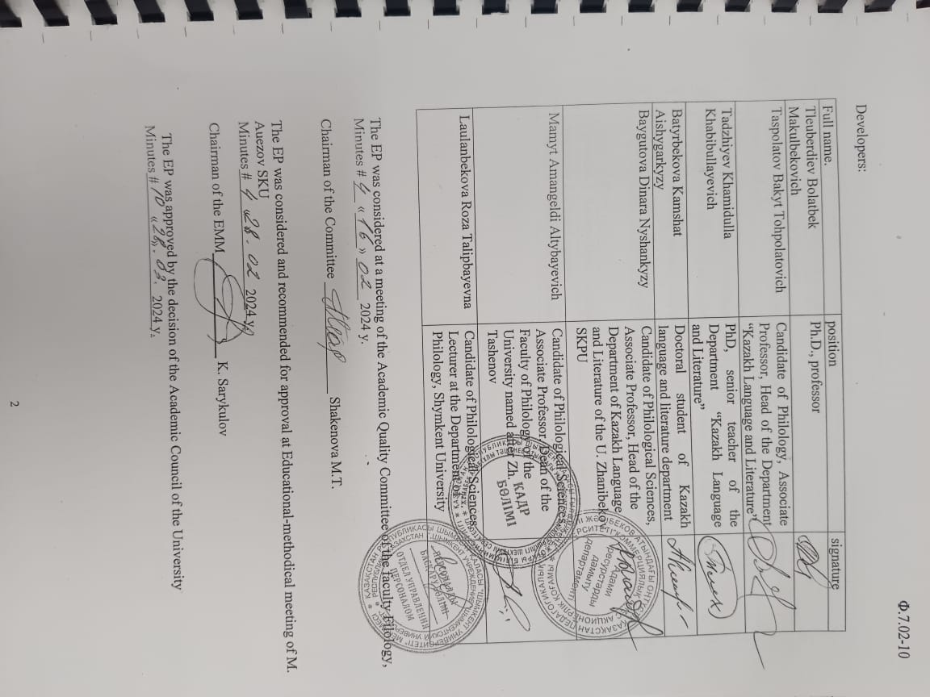

CONTENT

 | Concept of the Educational program............................................................................ | 4
 | Passport of the Educational program............................................................................ | 6
 | Competencies of Ep graduate ……………………................ | 9
3.1 | Matrix for correlating learning outcomes in the EP as a whole with the competencies being developed................................................................................................ | 12
4. | Matrix of the influence of modules and disciplines on the formation of learning outcomes and information on labor intensity.......................... | 13
5. | Summary table reflecting the volume of disbursed loans by EP modules...................... | 14
6. | Strategies, teaching methods and artificial intelligence, monitoring and assessment..................................................................................................................... | 18
7. | Educational and resource support for EP…………………........................................ | 19
 | Approval sheet………………........................................................................... | 20
 | Appendix 1. Review from the employer .........................................................................
 | Appendix 2. Expert opinion............................................................................................
 | Appendix 3. Professional standards

1 Concept of the Educational program

Mission of the University | We are focused on generating new competencies, training a leader who translates research thinking and culture.
University Values | - Openness - open to change, innovation and cooperation.  - Creativity - generates ideas, develops them and turns them into values  - Academic freedom - free to choose, develop and act.  - Partnership - creates trust and support in a relationship where everyone wins.  - Social responsibility - ready to fulfill obligations, make decisions and be responsible for their results.
Graduate Model | - Deep subject knowledge, their application and continuous expansion in professional activity  - Information and digital literacy and mobility  - Research skills, creativity and emotional intelligence  - Entrepreneurship, independence and responsibility for their activities and well-being  - Global and national citizenship, tolerance to cultures and languages
Uniqueness of the EP | the program was developed in accordance with the Atlas of New Professions and Competencies, and is aimed at training competent specialists for transport and logistics and scientific and pedagogical structures who are able to organize and manage the activities of a structural enterprise, independently determine the goals of professional activity, choose and justify methods and means to achieve them.
Academic Integrity and Ethics Policy | The university has taken measures to maintain academic integrity and academic freedom, protection from any type of intolerance and discrimination:  • Rules of academic integrity (order No. 212 of October 10, 2022);  • Anti-corruption standard (order No. 221 n/a dated 12/07/2021).  • Code of Ethics (Order No. 212 of October 10, 2022)
Regulatory and legal framework for the development of EP | 1.Law of the Republic of Kazakhstan “On Education”;  2. Model rules for the activities of educational organizations implementing educational programs of higher and (or) postgraduate education, approved by order of the Ministry of Education and Science of the Republic of Kazakhstan dated October 30, 2018 No. 595 with amendments and additions dated December 29, 2021. No. 614  3. Standard rules for admission to training in educational organizations implementing educational programs of higher and postgraduate education, approved by order of the Ministry of Education and Science of the Republic of Kazakhstan dated October 31, 2018 No. 600 with amendments and additions dated 06/02/2023. No. 252  4. State mandatory standards for higher and postgraduate education, approved by order of the Ministry of Education and Science of July 20, 2022 No. 2;  5. Rules for organizing the educational process in credit technology of education, approved by order of the Ministry of Education and Science of the Republic of Kazakhstan dated April 20, 2011 No. 152; with changes and additions from 09/23/2022. No. 79  6. Qualification reference book for positions of managers, specialists and other employees, approved by order of the Minister of Labor and Social Protection of the Population of the Republic of Kazakhstan dated December 30, 2020 No. 553.  7. Methodological recommendations for introducing ECTS principles into the educational process and expanding academic freedom. Appendix to the order of the Minister of Science and Higher Education. of the Republic of Kazakhstan dated February 12, 2024 No. 57  8. Guidelines for the development of educational programs for higher and postgraduate education, Appendix 1 to the order of the Director of the National Center for the Development of Higher Education of the Ministry of Education and Science of the Republic of Kazakhstan dated May 4, 2023 No. 601 н/қ
Organization of the educational process | - Implementation of the principles of the Bologna Process  - Student-centered learning  - Availability  - Inclusivity
Quality assurance of EP | - Internal quality assurance system  - Involvement of stakeholders in the development of the EP and its evaluation  - Systematic monitoring  - Updating the content (updating)
Requirements for applicants | They are established according to the Standard Rules of admission to training in educational organizations implementing educational programs of higher and postgraduate education Order of the Ministry of Education and Science of the Republic of Kazakhstan No. 600 dated 31.10.2018, with changes and additions dated June 2, 2023. No. 252

2. Passport of the Educational program
Purpose of the EP | The main goal of the educational program for the preparation of doctoral students in the specialty 8D02310-Philology: the training of highly skilled and internationally competitive labor market humanitarian personnel with professional and scientific competencies and skills to implement them in practical and scientific activities.
Tasks of the EP | - the formation of socially responsible behavior in society, understanding the importance of professional ethical standards and following these standards;  - providing skills and lifelong learning skills that will allow them to successfully adapt to changing conditions throughout their professional career;  - providing conditions for acquiring a high general intellectual level of development, mastering a competent and developed speech, a culture of thinking and skills of the scientific organization of labor in the field of vocational and humanitarian educational institutions;  - the formation of competitiveness of graduates in the field of philological science, to ensure the possibility of their fastest possible employment in their specialty or to continue their education at the next levels of study;  - Establishing conditions for the development of in-demand knowledge and skills, as well as a conscious attitude towards enhancing the welfare of society and conserving the planet within the framework of the SDGs.
Harmonization of EP | • 8 th level of the National Qualifications Framework of the Republic of Kazakhstan;  • Dublin descriptors of the 8 th level of qualification;  • 3 cycle of a Framework for Qualification of the European Higher Education Area);  • 8 ^{th} Level of European Qualification Framework for Life long Learning).
Connection of EP with the professional sphere | The scope of professional activity of 8D02310-Philology are:  - educational activities in higher, vocational and humanitarian educational institutions;  - scientific and managerial activity in pedagogical, research educational institutions;  - managerial activity in the structural subdivisions of the Ministry of Education and Science of the Republic of Kazakhstan, departments of education at the city and regional levels.
Name of the degree awarded | After successful completion of this educational program, the graduate is awarded the degree are awarded the PhD degree on the educational program 8D02310 - Philology
List of qualifications and positions | A graduate of the educational program 8D02310 - Philology is awarded the degree of Doctor of Philosophy (PhD) in the educational program 8D02310 - Philology.  Doctor of Philosophy (PhD) in the educational program 8D02310 - Philology may hold primary scientific and managerial positions in (research institutions, design and design organizations) without presenting requirements for work experience in accordance with the qualification requirements of the Qualification Directory of the positions of managers, specialists and other employees, approved by order of the Minister of Labor and Social Protection the population of the Republic of Kazakhstan dated May 21, 2012g.№ 201.
Field of professional activity | The scope of professional activity 8D02310-Philology are:  - educational activities in higher, vocational and humanitarian educational institutions;  - scientific and managerial activities in pedagogical, research educational institutions;  - management activities in structural divisions of the Ministry of Education and Science of the Republic of Kazakhstan, education departments of the city and regional level.
Objects of professional activity | The objects of professional activity 8D02310-Philology are:  In scientific and humanitarian training:  - Higher and special educational institutions;  - Research institutes and centers in the specialty profile;  - The organization of secondary, humanitarian and vocational education, regardless of ownership and departmental subordination.
Subjects of professional activity | The subject of professional activity 8D02310-Philology are: the educational process in educational institutions and organizations of higher, general secondary education, vocational and humanitarian education, secondary special education, as well as after-school institutions and organizations of further education and upbringing.
Types of professional activity | 8D02310-Philology can perform the following professional activities:  - Educational (pedagogical);  - Educational;  - Research;  - Organizational and management;  - Socio-pedagogical.
Learning outcomes | LO 1 To apply the methodological apparatus of modern philological and pedagogical sciences in their scientific and teaching activities.  LO 2 To integrate knowledge in solving a scientific problem in the field of philology, using the achievements of modern science and information technology, apply new methods and means of scientific knowledge.  LO 3 To apply the methodological apparatus of modern philological and pedagogical sciences in their scientific and teaching activities.  LO 4 Forms an initiative thinking system and original creative culture by effectively using innovative educational and digital technologies, artificial intelligence capabilities;  LO 5 Communicate freely in the professional environment and society in Kazakh, Russian and English in the conditions of intercultural dialogue.  LO 6 Conduct an examination of textual material, identifying the presence of language problems using the method of comparative studies in a comparative and historical context;  LO 7 Develop and manage scientific and scientific-methodological projects in the field of philology at a high theoretical and methodological level.  LO 8 Organize pedagogical experiments with the introduction of their results in the educational process, possession of the algorithm of research activities;  LO 9 Carry out psycholinguistic and linguocognitive research, revealing the linguocultural nature of the language, taking into account language contacts.  LO 10 Classify and interpret the internal and external factors of language evolution, take them into account in the process of working on scientific research.  LO 11 Analyze and critically evaluate modern linguistic trends, approaches and active processes taking place in modern language and literature.

3. Competencies of an EP graduate

GENERAL COMPETENCIES (SOFT SKILLS). Behavioral skills and personal qualities
GC 1. Competence in managing one's literacy | Successful completion of training in the OP contributes to the formation of the following competencies in the graduate:  - key competencies (KC)  - professional competencies (PC)
GC 2. Language competence | (KC1) in the field of the native language  - to interact linguistically appropriately and creatively in all the variety of social and cultural contexts: during study, at work, at home and at leisure;  (KC2) in the field of foreign languages  - the ability to possess basic communication skills in a foreign language - understanding, expressing and interpreting concepts, facts and opinions in the professional field both orally and in writing (listening, speaking, reading, writing) in an appropriate range of social and cultural contexts and intercultural understanding;
GC 3. Mathematical competence and competence in the field of science | - The ability and willingness to apply the educational potential, experience and personal qualities acquired during the study of mathematical, natural science, technical disciplines at the university to solve professional problems.
GC 4. Digital competence, technological literacy | - The ability to confidently and critically use modern information and digital technologies for work, leisure and communication.  - possession of skills of use, recovery, evaluation, storage, production, presentation and exchange of information through a computer, communication and participation in cooperating networks using the Internet in the field of professional activity;
GC 5. Personal, social and educational competencies | - the ability to possess social and ethical values based on public opinion, traditions, customs, norms and to focus on them in their professional activities; to know the cultures of the peoples of Kazakhstan and observe their traditions; to observe the foundations of the legal system and legislation of Kazakhstan, to know the trends of social development of society; to be able to adequately navigate in various social situations; to be able to find compromises, correlate your opinion with the opinion of the team; own the norms of business ethics, ethical and legal norms of behavior; strive for professional and personal growth; work in a team, defend your point of view correctly, offer new solutions; demonstrate tolerance towards other individuals.
GC 6. Entrepreneurial competence | - the ability to possess the skills of critical thinking, interpretation, creativity of analysis, drawing conclusions, evaluation; manage projects to achieve professional goals, manage personnel, demonstrate entrepreneurial skills.
GC 7. Cultural awareness and self-expression | - the ability to know and understand the traditions and culture of the peoples of Kazakhstan, is tolerant to the traditions and culture of other peoples of the world, is aware of the attitudes of tolerant behavior; is not subject to prejudice, has high spiritual qualities, is formed as an intelligent person.
PROFESSIONAL COMPETENCIES (HARDSKILLS).
Theoretical knowledge and practical skills specific to this field | PC1 Level of knowledge  - to use the possibilities of the transition of the form of work to low expenditure in a situation of updating knowledge, providing an active search and application of scientific information, professional growth, dynamics of social, economic and professional roles; to plan, implement and regulate the processes of philological research.
PC2 Scientific culture
- to form one's own scientific principle when summarizing philological problems, assessing the state of preparation and implementing them taking into account changing socio-economic situations; to know the existence of a culture of systematic scientific thinking, scientific creativity and service skills of innovative training.
PC3 Educational and methodological culture
of applying theoretical and methodological principles of modern Kazakh, Russian philology, the system of metalanguage and meta-dictionaries and scientific schools of philology; mastering traditional, innovative methods of teaching philological disciplines and conducting scientific work in universities.
PC4 Culture of educational activity
- define the goals and objectives of education, create the necessary conditions for the realization of the goals of education; experience of educational work with masters and student assets.
PC5 Culture of speech
- to select the right and necessary words to express their thoughts, to build phrases from them, etc.; to apply oratory in public speaking at international scientific forums, conferences and seminars.
PC6 Political culture
- to build the right relations between undergraduates and students; the presence of skills in the implementation of communicative, linguistic, discursive, socio-cultural, pragmatic and strategic activities in the scientific industry.

3.1 Matrix for correlating learning outcomes in the EP as a whole with the competencies being developed

 | LO1 | LO 2 | LO 3 | LO 4 | LO 5 | LO 6 | LO 7 | LO 8 | LO 9 | LO 10 | LO 11
GC 1 | + | + |  |  |  |  | + |  | +
GC 2 |  |  |  |  |  |  |  |  | +
PC 3 |  | +
PC 4 |  |  | +
PC 5 |  |  |  |  |  | + |  | +
PC 6 |  |  |  |  | + |  |  | + |  | + | +
PC 7 |  |  |  |  | + |  | +
PC 8 |  |  |  | + |  | + |  |  |  |  | +

4. Matrix of the influence of modules and disciplines on the formation of learning outcomes and information on labor intensity

Module | Cyc  Le | ОК/  КВ | Component Name | Discipline Summary  (30-50 words) | Number of loans | Formed RT (codes)
Research Methods and Semantics | BD | HSC | Academic writing | The aim: Improvement of academic writing skills and coordination of related procedures in the process of scientific communication in accordance with international requirements  Content:  Academic writing as a procedural design of the process of scientific communication. The concept of an academic text. Functions of academic texts: descriptive, persuasive, constructive. Publication of articles in journals with an international impact factor, including publications indexed in the Arts and Humanities Citation Index or the Social Science Citation Index in the Web of Science database or with a CiteScore percentile in the Scopus database. Types of academic texts. Sociocultural features of writing academic texts in English and Russian traditions. The specifics of writing texts in social and humanitarian disciplines. Requirements for academic texts. Academic language requirements. Requirements for the design of academic texts. | 3 | LO 1  LO 5  LO 8
Research Methods and Semantics | BD | HSC | Scientific research methods | The aim: Generalization of the system of knowledge about modern methods of research work and improvement of skills for their application in philological research.  Content:  The methodology of scientific research - from the creative concept to the finalization of scientific work, carried out individually in the scientific sense - means: conduct research, as if looking into the future, the most important factors of scientific research: imagination, fantasy, dream, based on real set of methods used to study the objective reality of a research technique . | 4 | LO 3  LO 6  LO 7
Research Methods and Semantics | BD | EC | Cognitive semantics | The aim: Deepening the system of knowledge about the patterns of formation and development of cognitive paradigms of Kazakh linguistics from the standpoint of cognitive semantics  Content:  Cognitive semantics (cognitive semantics) is part of cognitive linguistics. The basic principles of cognitive semantics are as follows: firstly, grammar is conceptualization; secondly, the conceptual structure is fixed in speech and motivated by it; thirdly, the ability to use the language is based on shared cognitive resources, and not on a special language module. | 6 | LO 2  LO 4  LO 11
Research Methods and Semantics | BD | EC | Comparative studies | The aim: Formation to be able to conduct comparative research in the field of private and general philology in a historical context.  Content:  Analyze the paradigm of language cognitive" Etudes" in Kazakh linguistics. Language structural - cognitive factor. To analyze the linguocognitive and ethnocultural bases of the Kazakh toponymy.  Understand and use the linguocultural characteristics of ethnosocial names in a Kazakh country. |  | LO 4  LO 11
Research Methods and Semantics |  |  | Pedagogical practice | The aim: The practice is carried out in order to form practical skills of scientific, scientific-pedagogical and professional activities.  Content:  Consolidation of theoretical knowledge gained in the learning process, acquisition of practical skills, competencies and experience of professional activity in philology, as well as mastering advanced experience. The objectives of the discipline are aimed at assimilating modern concepts and methodological principles of organizing and planning scientific research, which are directly tested, both in the implementation of their own scientific products and in future professional activities. | 10 | LO 4  LO 11
Linguistic processes | ChD | HSC | Psycholinguistic aspects of verbal communication | The aim: Generalization of the conceptual foundations of psycholinguistic theory in Kazakh linguistics, the formation of skills for applying psycholinguistic methods in the study.  Content:  To practice the appearance of comparative studies in Kazakh linguistics. Analyze new language learning schools of 20 c. To develop the cognitive sphere in teaching the Kazakh language. Relations paradigm – theory - results in linguistics. Use the allusion in linguistics. Distinguish the concept of adaptation in compravistics.  Disassemble the language structure in the cognitive factor. Memorize cognitive internal relationships in Kazakh linguistics. Describe the  elements of linguocognitive research. Linguocultural characteristics of national ethno-social names. Investigate linguistic typology and  anaology. Design a historical comparative school in linguistics. | 6 | LO 2  LO 8  LO 9
Linguistic processes | ChD | EC | Language and culture in aspect of modern scientific paradigms | The aim: Expansion of ideas about the syncretism of language and culture in modern scientific paradigms  Content:  Quote and apply synchronous and diachronic aspects of the language. To investigate the recognition of a language as a system is the task of showing its sign nature. Maintain and rank the founders of the Copenhagen School. To study the idea of the works of Louis Elmelev. | 6 | LO 7  LO 11
Linguistic processes | ChD | EC | Linguoculturological text analysis: methods and techniques | The aim: Development of skills in conducting philological research in the aspect of the relationship between language and culture, analysis of linguistic units and text using modern methods of linguoculturology as a science  Content: Directions in modern linguistics. Scientific paradigms of linguistic science Comparative-historical paradigm. System-structural paradigm. Anthropocentric paradigm. Scientific paradigm. “Scientific revolutions” in paradigms and linguistics. General theory of the method. Methods of empirical research. Methods of theoretical research. New paradigm and methodology of social and human sciences. Heuristic methods. Descriptive methods. Requirements for scientific research. Research methodology and methodology. |  | LO 7  LO 11
Linguistic processes |  |  | Research practice | The aim: Studying the latest theoretical, methodological and technological achievements of domestic and foreign science, as well as consolidating practical skills, applying modern methods of scientific research, processing and interpreting experimental data in dissertation research.  Content:  Stages and content of preparation of linguistic research. Requirements for scientific research. Research methodology. Setting the purpose of the research, identifying clear research objectives, identifying the object and subject of research, the criteria for finding it in the material, taking into account the achievements of science in the issue under study. Application of a complex of modern research methods that ensure the reliability of the research. | 10 | LO 7  LO 11
Module of scientific research and final certification |  |  | Research Work of a Doctoral students including passing and internship and completing a doctoral dissertation | Knowledge of the theoretical foundations of linguistics requirements for completing a dissertation work; ways to present research results. Planning the research in accordance with the topic of the dissertation. Ability to plan, collect and analyze data. The ability to work with the received material, analyze and sift out the material obtained during practice. Application of scientific methods in research, generalization of research results, formulation of conclusions in accordance with the goals and objectives of practice. | 123
Module of scientific research and final certification |  |  | Writing and defending a doctoral thesis | Application of theoretical foundations of linguistics.  innovative technologies used in philology lessons, methods for developing indicators and criteria for assessing the phenomenon being studied, a combination of theoretical knowledge and practical skills. Dissertation work and goal achievement, achieving goals, results and conclusions.  Demonstrate theoretical knowledge and practical ability to substantiate the relevance, theoretical and practical significance of the topic of the thesis. Collection and analysis of material, its relevance and adequacy. Managing the graduation work process and achieving goals, results and conclusions. Presentation style (academic writing). Compliance with instructions for writing a doctoral dissertation. | 12

5. Summary table reflecting the volume of disbursed loans by EP modules

Course of training | Semester | Amount of the mastered modules | Amount of the studied disciplines |  |  | Amount of KZ credits |  |  |  |  | Total hours | Totalloans KZ | amount
Course of training | Semester | Amount of the mastered modules | Compulsory component | University component | Optional component | Theoretical training | Pedagogikal practice | Training practice | Researchwork | Writing and defending a doctoral thesis | Total hours | Totalloans KZ | ex | differential.  offset
1 | 1 | 3 | 3 |  | 3 | 25 |  |  | 5 |  | 900 | 30 | 6
1 | 2 |  |  |  |  |  |  | 10 | 20 |  | 900 | 30 |  | 1
2 | 3 |  |  |  |  |  | 10 |  | 20 |  | 900 | 30 |  | 1
2 | 4 |  |  |  |  |  |  |  | 30 |  | 900 | 30
3 | 5 |  |  |  |  |  |  |  | 30 |  | 900 | 30
3 | 6 |  |  |  |  |  |  |  | 18 | 12 | 900 | 30
total |  | 3 | 3 |  | 3 | 25 | 10 | 10 | 123 | 12 | 5400 | 180 | 6 | 2

6. Strategies, teaching methods and artificial intelligence, monitoring and assessment

Learning strategies | Doctoral-oriented learning: The student is the center of teaching/learning and an active participant in the learning and decision-making process.  Practice-oriented training: orientation to the development of practical skills.
Teaching methods | Conducting lectures, seminars, various types of practices:  • using innovative technologies:  • problem-based learning;  • case study;  • work in a group and creative groups;  • discussions and dialogues, intellectual games, olympiads, quizzes;  • reflection methods, projects, benchmarking;  • Bloom's taxonomies;  • presentations;  • rational and creative use of information sources:  • multimedia training programs;  • electronic textbooks;  • digital resources.  Organization of independent work of students, individual consultations.
Monitoring and evaluation of the achiev ability of learning outcomes | Current control on each topic of the discipline, control of knowledge in classroom and extracurricular classes (according to syllabus). Assessment forms:  • survey in the classroom;  • testing on the topics of the discipline;  • control works;  • protection of independent work;  • discussions;  • trainings;  • colloquiums;  • essays, etc.  Boundary control at least twice during one academic period within the framework of one academic discipline.  Intermediate certification is carried out in accordance with the working curriculum, academic calendar.  Forms of conducting:  • exam in the form of testing;  • oral examination;  • written exam;  • combined exam;  • project protection;  • protection of practice reports.  Final state certification.

7. Educational and resource support for EP

Educational Information Center | The structure of the Educational Information Center includes 6 subscriptions, 16 reading rooms, 2 electronic resource centers (ERC). The basis of the network in restructure of the Educational and Information Centers 180 computers with Internet access, 110 work stations, 6 interactive white boards, 2 video doubles, 1 video conferencing system, 3 A-4 format scanners, JIC software - AIBS "IRBIS-64" under MS Windows (basic set of 6 modules), stand-alone server for uninterrupted operation in the IRBIS system.  Thelibraryfundisreflectedintheelectroniccatalogavailabletousersonthesite http://lib.ukgu.kz on-line 24 hours 7 days a week.  Thematic data bases of the own generation: "Almamater", "Proceedings of SKSU scientists", "Electronic archive" have been created. Online access from any device 24/7 via the external link http://articles.ukgu.kz/ru/pps.  Catalog sere professedly ectronically.EC consists of 9 databases: "Books", "Articles", "Periodicals", "Proceedings of the teaching staff of SKSU", "RareBooks", "ElectronicFund", "SKGU inPrint", "Readers" and "SKU".  The EIC provides its users with 3 options for accessing its own electronic information resources: from the “Electronic Catalog” terminals in the catalog hall and in the EIC subdivisions; through the information network of the university for faculties and departments; remotely on the library website http://lib.ukgu.kz/.  Open access to international and republican resources: "SpringerLink", "Polpred", "WebofScience", "EBSCO", "Epigraph", to electronic versions of scientific journals in the public domain, "Zan", "RMEB", "Adebiet", Digital library "Aknurpress", "Smart-kіtаr", "Kitаr.кz", etc.  For people with special needs and disabilities, the library website has been adapted to the work of visually impaired users
Material and technical base | Doctoral students of the specialty 8D02310-Philology are trained in the educational building No. 8 on the street. Tazhibaev 2. The total area of ​​the educational building is 9506.2 sq.m., useful area - 5627.2 sq.m., lecture rooms - 3 (No. 201-125.82 sq.m., No. 301-124.70 sq.m.). m., No. 10 - 57.37 sq.m.), auditoriums for practical, seminar classes - 6 (No. 206 - 31.72 sq.m., No. 207 - 14.76 sq.m., No. 407–31 08 sq.m., No. 314–33.32 sq.m., No. 104 - 35.50 sq.m., No. 106 - 50.12 sq.m.), multimedia room 2 (No. 407 -31.08 sq.m., No. 206 - 31.72 sq.m.), computer classes - 2 (No. 106 - 50.12 sq.m., No. 409 - 32.14 sq.m., ERC-118.8 sq.m.).



